Digital Literacy 10 Mr. Aitken and Mr. Prensky
Posting Your Core Competency Reflections

All students in grade nine and ten are required to demonstrate their learning across the core competencies as part of the new curriculum. The good news is that you have, provided you have been writing appropriate reflections, completed a large amount of the work.

Your core competency review will need to be posted into two places. Firstly, you will need to ensure that there is a file of your reflections in your OneDrive Folder – as part of office 365. This document will be shared with Mme. Ferrer mferrer@sd43.bc.ca She will be checking to ensure that you have shared your document with her and completed this part of the core competency review.
Secondly you will need to post that document into a page on your blog. There is already a core competencies page established on your blog, however, as you will be doing this for each grade in your high school career we would like you to publish a NEW PAGE where you will embed your reflection document. This can be titled (Core Competency Reflection – Grade 9) or something similar. You will then need to copy the URL and paste it into your original Core Competencies Page on your blog thereby creating a link to your grade nine core competency reflection. You will then do the same in grade ten, eleven and twelve.
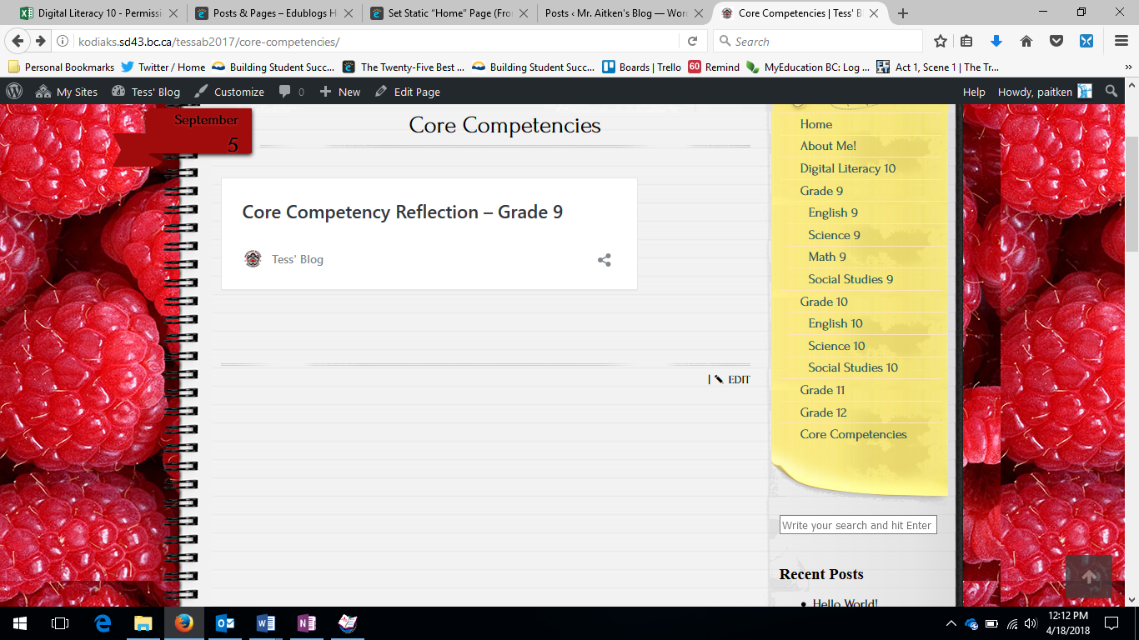
Your Core Competencies Page should look like this when you are finished.
Your original core competencies page where you will store your reflections for the next four years.
This will be your new ‘Grade 9’ page. In it you will post your reflection document. The document will also be placed into your Office 365 Account/OneDrive

To review the PowerPoint that contains the specifics of what you need to do for your Core Competency Review you can follow the link here kodiaks.sd43.bc.ca/assignments – It is listed as number four on the assignments page.
Upoloading to OneDrive and Sharing
If you save your documents on your computer to OneDrive you should have no significant issues sharing. If you save them locally, on your computer, they will need to be uploaded to OneDrive before you can share them with Mme. Ferrer.
The following steps should help you to upload and share your file:
- Open Office 365 and Login
- Open the OneDrive App in Office 365 If your document appears on your Microsoft menu page (at the bottom) you can proceed to step 4.
One Drive App
Your most recent documents appear below this list of apps. If your Core Competency Document is there you ca proceed to step 4.
- You should now see a list of all of your files. If your Core Competency Review has been saved to OneDrive and is here you can proceed to step 4. If not you will need to upload your document. If your document appears on your Microsoft menu page (at the bottom) you can proceed to step 4.
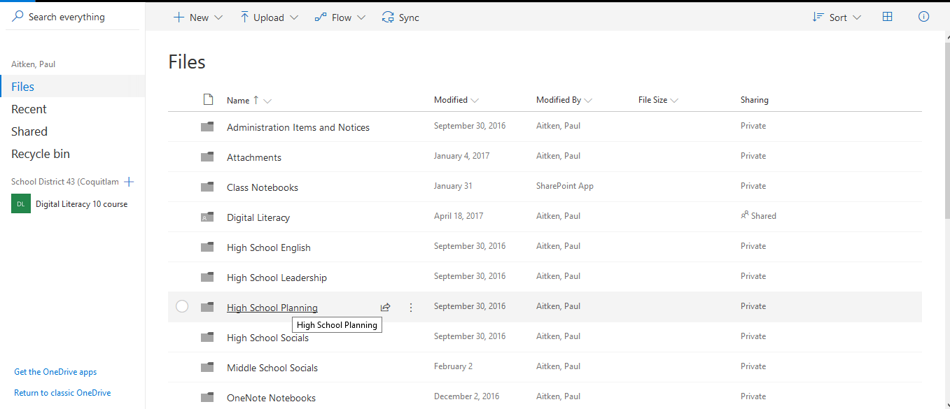
Click the Upload Button and upload your document. It will then appear in the list of documents.

- Once your document has been uploaded to OneDrive you are ready to share – If you hover to the left of the last date modified three dots will appear. Clicking on, or hovering over the three dots will present you with a menu of possible choices. Select share.

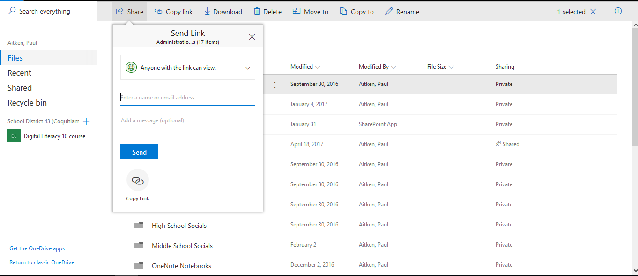
- A dialog box will open that will allow you to enter the email address of the person you wish to share the document with. Type in Mme. Ferrer’s email address mferrer@sd43.bc.ca (careful as there is another person in the district with a similar email). Hit send and you have successfully shared your document and completed your Core Competency Reflection.
Hovering over the three buttons next to the last date modified will bring up the menu.
Clicking share will allow you to enter Mme. Ferrer’s email. Once done hit send.

