3.1 Types of Sets and Set Notation

By the end of the lesson you will be able to:
- Understand sets and set notation
- Use vocabulary related to sets and set notation

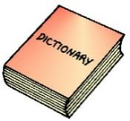
Set is a ____________ of ________________ or distinguishable objects. Sets are defined using brackets and are usually named with a capital letter.
For example, the set of whole numbers is written as$W=\left\{0, 1, 2, 3, 4, 5…\right\}$ or $R=\left\{all the red cards in a deck\right\}$
Element are the objects that make up a set. Each element is ________________.
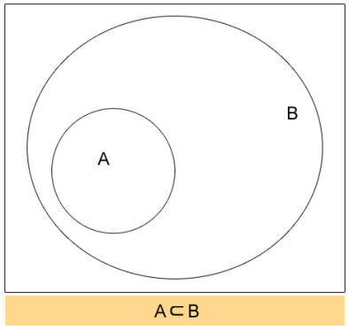
Universal Set is a set of _________________ in a particular context.
For example, the universal set of digits is $D=\left\{0, 1, 2, 3, 4, 5, 6, 7, 8, 9\right\}$

Subset is a set where all elements belong to ____________________.
For example, the set of odd digits $O=\left\{1, 3, 5, 7, 9\right\}$ is a subset of $D$, the set of all digits.
We write this as $O⊂D$, where $⊂$ means “subset of”

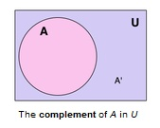
Complement it is the set of all elements of a universal set that do not belong to a subset - is the amount you must add to something to make it "whole.”
For example, $O'=\left\{0, 2, 4, 6, 8\right\}$ is the complement of $O=\left\{1, 3, 5, 7, 9\right\}$, a subset of the universal set of digits, $D$. The prime (‘) tells you that a set is a complement.

Empty Set is a set with _______________________ and is denoted as empty brackets or $⊘$.
Finite Set is a set with a __________________ number of elements.
Infinite Set is a set with ________________ number of elements.

Disjoint is two or more sets having __________________________________________.
Mutually Exclusive means two or more things that ________________ occur at the same time.

Example 1
Indicate the multiples of 5 and 10, from 1 to 50, using set notation. List any subsets.

Represent the sets and subsets in a Venn diagram.

3.2 Exploring Relationships between Sets

By the end of the lesson you will be able to:
- Explore what the different regions of a Venn diagram represent.

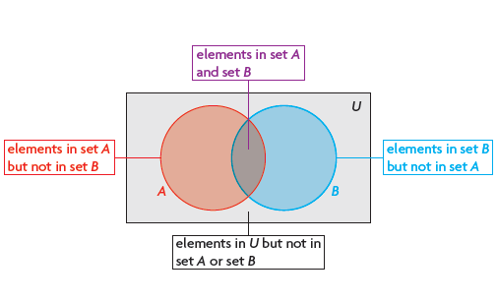
Example 1
In a high school, there are 65 Grade 12 students. Of these students 23 play basketball and 24 play volleyball. There are 31 students who don’t play either sport.
How many students play both basketball and volleyball? Use a Venn diagram to solve.

Assignment: P. 154 #2, 4, 9, 11, 16 and P. 160 #1-5

