3.3 Intersection and Union of Two Sets
By the end of the lesson you will be able to:
- Define intersection and union of sets.
- Use Principle of Inclusion and Exclusion

Intersection |  | Union
“A $∩$ B” reads “intersection of A and B” and represents the elements that are common to A and B, the area where the sets overlap on a Venn Diagram.  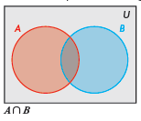 |  | “A $∪$ B” reads “union of A and B” and represents all elements that belong to A or B, the red region on the Venn Diagram.  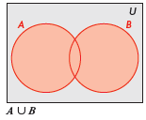
“A/B” reads “A minus B” and denotes that the elements that are in set A are not in set B. This is represented by the red region in each Venn Diagram.
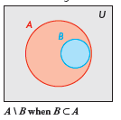 | 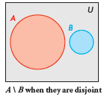 |  | 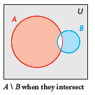

Example 1
The athletics department at a large high school offers 16 different sports:
Badminton  Basketball  Cross-country running  Curling | Football  Golf  Hockey  Lacrosse | Rugby  Skiing  Soccer  Softball | Tennis  Ultimate  Volleyball  Wrestling

Determine the number of sports that require the following equipment:
- a ball and an implement such as a stick, a club or a racquet
- only a ball
- an implement but not a ball
- either a ball or an implement
- neither a ball or an implement

Badminton  Basketball  Cross-country running  Curling | Football  Golf  Hockey  Lacrosse | Rugby  Skiing  Soccer  Softball | Tennis  Ultimate  Volleyball  Wrestling

Venn Diagram

- a ball and an implement such as a stick, a club or a racquet

- only a ball
Principle of Inclusion and Exclusion
The number of elements in a union between two sets is equal to the sum of the elements in each set less the number of elements in both sets (intersections).
We write this as:

- an implement but not a ball

- either a ball or an implement

- neither a ball or an implement

Example 2
Morgan surveyed the 30 students in her mathematics class about their eating habits.
- 18 of these students eat breakfast
- 5 of the 18 students also eat a healthy lunch
- 3 students do not eat breakfast or a healthy lunch
How many students eat a healthy lunch?

Assignment: page 69 #1-10
Quiz Wednesday 3.1 and 3.2

