**3.4 Application of Set Theory**

**By the end of the lesson you will be able to:**

1. Solve problems involving three intersecting sets
2. Use Principle of Inclusion and Exclusion for three intersecting sets

Principle of Inclusion and Exclusion for 2 intersecting sets:

$$n\left(A∪B\right)=n\left(A\right)+n\left(B\right)-n\left(A∩B\right)$$

Principle of Inclusion and Exclusion for 3 intersecting sets:

$$n\left(A∪B∪C\right)=n\left(A\right)+n\left(B\right)+n\left(C\right)-n\left(A∩B\right)-n\left(A∩C\right)n-\left(B∩C\right)+ n(A∩B∩C)$$

**Example 1**

Shannon’s high school starts a campaign to encourage students to use “green” transportation, such as using public transit, walking or cycling. At the end of the semester, Shannon survey’s 750 students in the school to see if the campaign is working. She obtains this data:

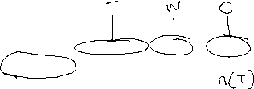

* 370 students use public transit



* 100 students cycle and use public transit



* 80 students walk and use public transit



* 35 students walk and cycle



* 20 students walk, cycle and use public transit

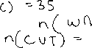

* 445 students cycle or use public transit



* 265 walk or cycle



What percentage of students use “green” transportation?

