**4.3 Permutations When All Objects Are Distinguishable**

**By the end of the lesson you will be able to:**

1. Solve for the number of permutations possible given *n* objects taken *r* at a time

**Example 1 – Solving permutation problem when only some objects are used in each arrangements**

Matt has downloaded 10 new songs. He wants to create a playlist using 6 of the songs arranged in any order. How many different 6-song playlists can be created with his new downloaded songs?



nPr notation commonly used to represent the number of permutations that can be used from a set of ___ objects where only ___ of them are chosen and

nPr =

nPn=

Note: 0! = 1

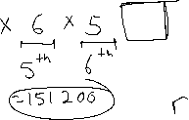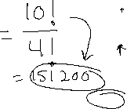

**Example 2 – Permutations involving cases**



Tania is creating a password. The password can use digits from 0 to 9 and/or any letters of the alphabet. The password is not case sensitive. A password must be 5 characters in length to a maximum of 7 characters. Each character can only be used once.

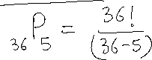

**Example 3 – Permutation problems with conditions**

At a used car lot, seven different car models are to be parked close to the street for easy viewing.

1. There are three red cars, which must be parked so that there is a red car at each end and the third red car exactly in the middle. How many ways can the seven cars be parked?

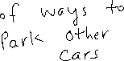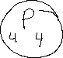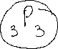

1. The three red cars must be parked side by side. How many ways can the seven cars be parked?

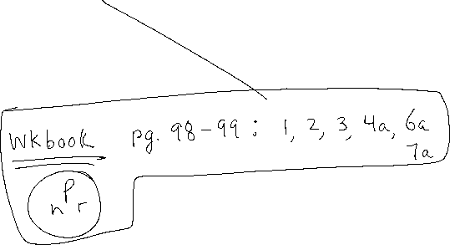

**Practice**: P. 255 #1-2, 5- 8, 10, 12, 15