**Ch 2: Classifying Polynomials (Day 1)**



**Terminology:**



**Terms:**

In a mathematical expression, terms are separated by +’s or –‘s.

**Monomial:**

Mono = __



A monomial is an expression with __ term



Eg:  or, 

**Binomial:**

Bi = __



A binomial is an expression with __ terms



Eg: 



**Trinomial:**

Tri = __



A trinomial is an expression with ___ terms



Eg: 



**Polynomial:**

Poly = many

A polynomial is an expression with one or more terms.

Polynomials include monomials, binomials, trinomials, etc….



All of the above expressions are also polynomials.



**Coefficient**: __________________________________________



**Constant:** ____________________________________________



Ex: Answer the following questions in the chart:



|  |  |  |  |  |  |  |
| --- | --- | --- | --- | --- | --- | --- |
| Polynomial | # of terms | Mono/bi/  Tri/poly | Coefficients | Variables | Constants | Leading Term |
|  |  |  |  |  |  |  |
|  |  |  |  |  |  |  |
|  |  |  |  |  |  |  |
|  |  |  |  |  |  |  |

**Degree:**

The degree of a term is the sum of the exponents on the variables in that term.

The degree of a polynomial is the same as that of the term with the highest degree.



**Like Terms:**



Like terms have the same variables with the same exponents.



**How many terms are in the following expression?**





**What separates each term?**



**Are the following terms like or unlike?**  and 



**Combine the like terms in each expression**.



a) 

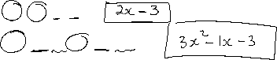

b) 

c) 

**Polynomials** – all variables must have **whole number** exponents. In other words, all variables must be in the ________________!



Which of the following are not polynomials? Circle them.

5, , 3a2 - 2a, , 2x + , x-3 - 3x, , 



**Multiplying Monomials:**



1**. Multiply the coefficients**



**2. Combine the variables**



Examples: Multiply

i) 



ii) 



iii) 



iv) 



vi) The area of a triangle is given by the expression 18. The base of the triangle is represented by 4x. What is the height of the triangle in terms of 



**Area=18**   **Area** = **base x height**

**2**

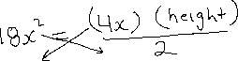

**4x**

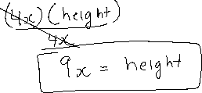

**Dividing Monomials:**

**1. Divide/reduce the coefficients**

**2. Subtract the exponents of the variables**

**Examples: Divide**

|  |  |
| --- | --- |
| i) | ii) |
| iii) | iv) |
|  |  |
|  |  |

v) A rectangular field is 7m long and has an area of 84. Write an equation you can use to determine the field’s width and then solve the width.

**vi) Determine the missing dimension in each figure.**



Area=27 Area=14

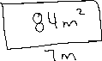

3x 7x



?

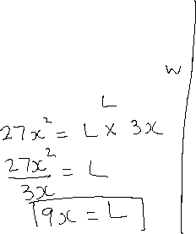

?

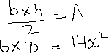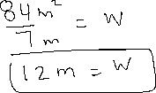

**Multiplying Polynomials by Monomials**

To multiply a monomial by a polynomial we must first remember how to distribute.

**Use the Distributive Property:** 

Examples: Expand (Do Dist. Prop)



i) 



ii) 



i) 



ii) 



iii) 



Evaluate the value of a polynomial when x=-4



1. -3x2 + 2x – 1



1. x2 - 2x - 2



**Find the area of the following shapes**

a)  b)





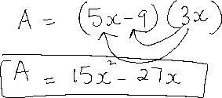

b)

















