3.2 Exploring Relationships between Sets

By the end of the lesson you will be able to:
- Explore what the different regions of a Venn diagram represent.

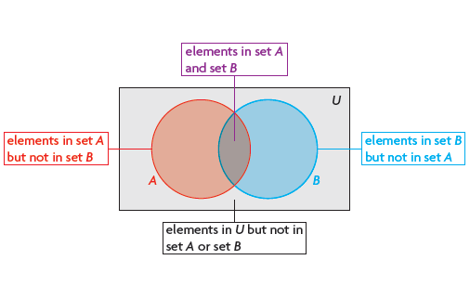
Example 1
In a high school, there are 65 Grade 12 students. Of these students 23 play basketball and 24 play volleyball. There are 31 students who don’t play either sport.
How many students play both basketball and volleyball? Use a Venn diagram to solve.

Type | Number of People Who Like
Horror | 15
Comedy | 20
Neither | 6
Example 2
Chantal asked 36 classmates what type of movies they liked, with results shown in the table. Create a Venn diagram to model the data.

How many students didn’t like only horror?

How many students like only comedy?

Assignment:
P. 160 #1 - 5

