**Squares, Cubes, Square Roots and Cube Roots: Day 3**

**Vocabulary:**

1. **Perfect Square** - a # that results from multiplying a # by itself.



* Ex: 3x3=9, 9 is a perfect square
* 1, 4, 9, 16, 25, 36, 49, 64, 81, 100, 121, 144, 169, 196, 225
* A # that can be represented in the shape of a square

1. **Perfect Cube** - a # that results from multiplying a # by itself **3 times**



* Ex: 3x3x3=27, 27 is a perfect cube
* 1, 8, 27, 64, 125
* A # that can be represented in the shape of a cube

1. **Square Root** – on of two identical factors of a number



1. **Cube Root** – one of three identical factors of a number
2. **Radical, Index and Radicand** -

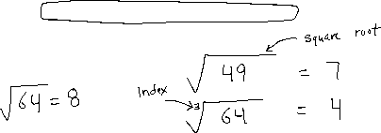

**Example 1: Determine the Square Root of a Whole Number**

**Find Square Root of 1296**



Method 1: Write 1296 as a product of primes

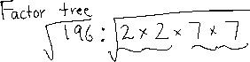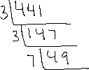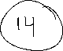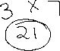

**Example 2: Determine Cube Root of a Whole Number**

**Find the cube root of 1728**

Method 1: Write 1728 as a product of prime factors

**Example 3 Using Roots to Solve a Problem**

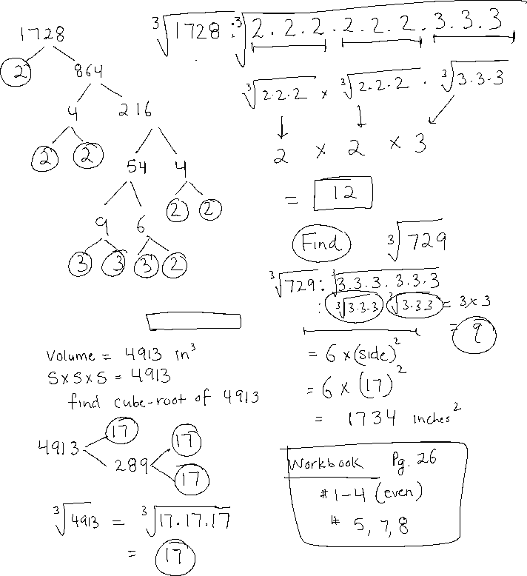

1. A cube has a volume of 4913 cubic inches. What is the surface area of the cube?