4.1 Counting Principles

By the end of the lesson you will be able to:
- Determine the Fundamental Counting Principle and use it to solve problems
- Identify and solve counting problems when the FCP does not apply

Example 1
Hannah plays on her school soccer team. The uniform has:
- Three different jerseys: maroon, grey and black
- Three different shorts: white, black and grey
How many different variations of the uniform can the coach choose for each game?

Method #1: Use a Tree Diagram

Method #2: Use the Fundamental Counting Principle
Fundamental Counting Principle:
When there are ___ ways to do one thing and ____ ways to do another, then there are __________ ways of doing _________.
Note: This principle only applies when things are linked by the word __________.

Example 2 – Extending the Fundamental Counting Principle past 2 tasks
A lock opens with a correct three-number code.
- How many different three-number codes are possible?

- Suppose each number can only be used once in a code. How many different codes are possible when repetition is not allowed?

Example 3 – When the Fundamental Counting Principle does not apply

The Fundamental Counting Principle does not always apply, specifically when tasks are linked by the word _______.
- If task/things are mutually exclusive, they involve ____________________ ________, A and B: then $n\left(A∪B\right)=n\left(A\right)+n(B)$

- If the tasks are not mutually exclusive, they involve two sets that are not disjoint, C and D: then $n\left(C∪D\right)=n\left(C\right)+n\left(D\right)-n(C∩D)$
  - We use the Principle of Inclusion and Exclusion must be used to avoid counting elements in the ________________ of two sets more than once.

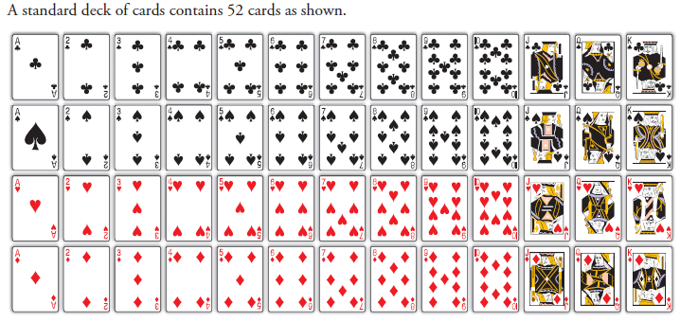
a) What is the probability of drawing a single card and getting a club or a red card?

b) What is the probability of drawing a single card and getting a heart or a 2?

Assignment: P. 235 #1-3, 5-7, 9, 12, 14, 15

