**4.2 Introduction to Permutations and Factorial Notation**

**By the end of the lesson you will be able to:**

1. Define factorial notation
2. Define and calculate permutations
3. Use factorial notation to solve simple permutation problems

Some grade school students are going to play California kickball at recess. They are arguing who will go first to kick the ball.

When they start playing, there are only two students on the team, **A**lice and **B**ob.



How many different ways can Alice and Bob go up to kick?



|  |  |  |
| --- | --- | --- |
| *Tree Diagram* | *List* | *Number of ways* |
|  |  |  |

Another student, **C**arl, joins the team. Now how many ways can all 3 students go up to kick?



|  |  |  |
| --- | --- | --- |
| *Tree Diagram* | *List* | *Number of ways* |
|  |  |  |

**D**evin also wants to play. Now how many different ways can the students go up to kick?



|  |  |  |
| --- | --- | --- |
| *Tree Diagram* | *List* | *Number of ways* |
|  |  |  |

If a fifth student, **E**mily, wants to join, how many different orders can they send the players up to kick? Can you solve this without a tree diagram or list?

**Permutations** are an arrangement of distinguishable objects in a ________________ order. For exam, the objects *a* and *b* have two permutations; _____ and ______.



**Example 1 – Counting Problem Where Order Matters**

If there are 6 students on each team for kickball, how many different orders of students going to bat can they make?

Students can only kick once.

|  |  |  |  |  |  |
| --- | --- | --- | --- | --- | --- |
|  |  |  |  |  |  |
| Kick 1st | Kick 2nd | Kick 3rd | Kick 4th | Kick 5th | Kick 6th |



**Factorial Notations** is a concise representation of the product of consecutive descending, natural numbers:

n! = (n)(n-1)(n-2)…. (3)(2)(1)

For example: 4!

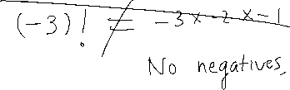

**Example 2 – Evaluating Factorial Notation**

Evaluate:

1. 10! b)

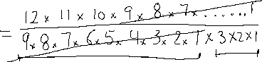

**Example 3 – Simplifying algebraic expressions involving factorial notation**

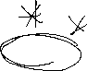

Simplify, where .

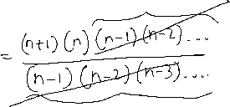

1. b)

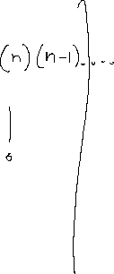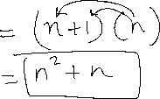

**Example 4 – Solving equations that involve factorial notation**



Solve $\frac{\left(n+4\right)!}{\left(n+2\right)!}=6$, where

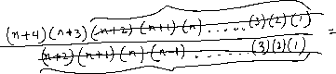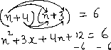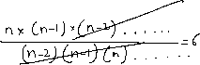

**Practice**: P. 243 #3, 5-11

