**Ch 1: LCM and GCF (Day 2)**



**Prime Number**



**Composite Number**



**List the Prime Numbers less than 100:**



**Zero and One:**



**Divisibility Rules:**



* **Divisibility by 2:**



* **Divisibility by 3:**



* **Divisibility by 4:**
* **Divisibility by 5:**



* **Divisibility by 6:**
* **Divisibility by 9:**



* **Divisibility by 10:**



**Example 1: Determine the Prime Factors of a Whole Number**

Method: Factor Tree – Write the Prime Factorization for 3300



**Greatest Common Factor:** The largest number that divides each of the given numbers exactly

**Example 2: Greatest Common Factor of 138 and 198**



**Use Prime Factorization**

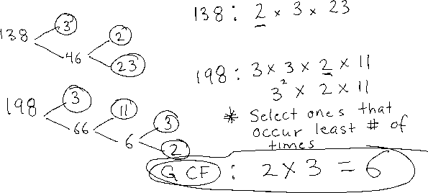

**Example 3: Greatest Common Factor of 36, 48, 60**

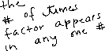

**Use Prime Factorization**



**Least Common Multiple:** The smallest number that is divisible by all the numbers



**Example 4: Least Common Multiple of 18, 20 and 30**



**Use Prime Factorization**



**Example 5: Least Common Multiple of 36, 60, 75**

**Use Prime Factorization**



**Ex. 6 Problem solving That Use LCM**

1. Tom, Dick and Harry get overtime pay. Tom gets overtime every 10 days, Dick gets overtime every 15 days and Harry gets overtime pay every 24 days. If all three get overtime pay on March 1, when will the three get overtime on the same day?

