**Ch 2 section 2.2: Multiplying Polynomials (Day 2)**

**Multiplying polynomials with more than one term require repeated used of distributive property.**

**Multiplying two binomials (review)**

**We do this using FOIL. F_________, O_________, I _________, L_________**



(x+6)(2x-3) (x-2)(x+9) (2x-7)(3x +7)

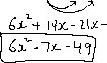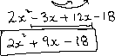

**Multiplying larger polynomials**

**Expand and simplify.**





a) (3k + 4)(k2 – 2k – 7) b) (–2t2 + 4t – 3)(5t2 – 2t + 1)











c) (2x-3)(x+5)(3x+4)

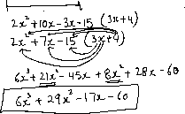

**Multiplying polynomials with more than one variable**

**Expand and simplify**.



a) (4k – 3m)2 b) (2v – 5w)(3v + 2w – 7)



**Polynomials involving multiplication as well as adding or subtracting**

**Expand and simplify.**

a) (4m + 1)(3m – 2) + 2(2m – 1)(–3m + 4)



b) (6h + k – 2)(2h – 3) – (4h – 3k)2



**Find the area and perimeter of the rectangle**

2x +3



x + 7

