4.4 Permutations When Objects Are Identical

By the end of the lesson you will be able to:
- Solve for the number of permutations when some objects are identical
- Solve a permutation problem involving routes

When objects are identical, we can still solve for the number of permutations possible.

The number of permutations for n objects, where a are identical, another b are identical, another c are identical, and so on, is:
$$P= \frac{n!}{a!b!c!…}$$
For example, in a set of four objects: a, a, b and b, the number of different permutations, P, is
$$P= \frac{4!}{2!2!}= \frac{24}{2×2}=6$$

Example 1 – Solving a permutation problem where objects are alike
How many different arrangements can be made using 9 flags: 1 green, 1 yellow, 2 white, 3 blue and 2 red?

Example 2 – Solving permutation problems with identical objects involving cases
How many ways can the letters of the word CANADA be arranged, if the first letter much be N and the last letter must be C?

Example 3 – Permutation problems involving routes
Julie’s home is three blocks north and five blocks east of her school. How many routes can Julie take home from school if she always travels either south or east.

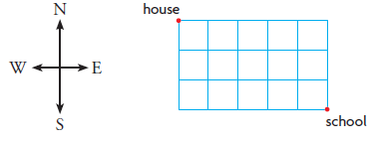
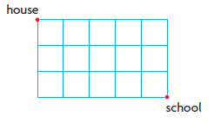

Practice: P. 266 #2, 3, 5-7, 9-10, 11b, 16, 18

