**5.2 Probability and Odds**

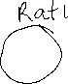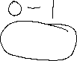

**By the end of the lesson you will be able to:**

1. Understand and interpret odds
2. Relate odds to probability

**Odds** express a level of _____________________ about the occurrence of an event.



**Odds in Favor** 🡪 A ratio of the probability that an event ___________ occur to the probability that the event _______________ occur.



Given by the ratio: ---------------- or $____________:______________$



$P(A^{'})$ is the _______________________ of A, where 1 – $P\left(A\right)$ = $P(A^{'})$

**Odds in Against** 🡪 A ratio of the probability that an event ___________ occur to the probability that the event _______________ occur.



Given by the ratio: ---------------- or $____________:______________$



If the odds in favor of an event occurring are **m:n** then the odds against are ____:____.



**Example 1 – Determining odds from probability**

Research shows that the probability of an expectant mother, selected at random, having twins is $\frac{1}{32}$.



1. What are the odds in favor of the expectant mother having twins?

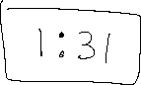

1. What are the odds against the expectant mother having twins?



**Example 2 – Determining probability from odds**

A computer randomly selects university student’s names from the database to award a $100 gift certificate for the bookstore. The odds against the selected student being male are 57:43. Determine the probability that the randomly selected university student will be male.



**Probability** 🡪 **Odds**

If the odds are a:b, then

P(A) = ___________



**Example 3 – Interpreting odds to make a decision**

At a carnival there are two games to play, Bim and Zap. The odds against winning Bim are 5:2 and the odds against winning Zap are 7:3. Which game should you play (better chance to win)?

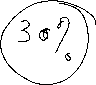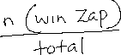

**Assignment**:

