Digital Literacy 10 Mr. Aitken & Mr. Castonguay

Digital Literacy Bootcamp Basics
Posts Vs. Pages

You will be using your blog in your English, Science and Social Studies classes in addition to other classes and elective areas to create a showcase portfolio. This is portfolio of your best work. Teachers will ask you to post certain assignments though you are welcome to also add work of your own anytime you wish. By the end of the year you will need to have completed two assignments in English, Socials and Science in addition to the assignments in Digital Literacy in order to pass the course and receive credit.
All of the content that you add to your blog portfolio from your various classes needs to be added to your blog under the specific PAGES. DO NOT showcase your work as a POST.
Think about it this way. A PAGE is like a statue. It doesn’t move. It is always in the same location, can easily be found, and can be viewed at any time.
This is the easiest way for you to see the work and assignments that you have completed throughout your time at Heritage Woods. You can simply select the various classes from the menu and find the assignments that you were looking for. This can prove useful when you are putting together your grad transitions presentations in a few years and need to find assignments to demonstrate your growth. It also allows your teachers to view your work and comment (if they so wish) on it.
Work that is not submitted on a PAGE will not receive credit for Digital Literacy until it has been copied to the relevant PAGE.
POSTS are for showcasing activities, teams, clubs and your own interests if you so wish. If you play on the Tennis team and win another Provincial Championship it is a good accomplishment to highlight on your blog. If you participate in KWAP and help out in the school, local or regional community, a POST is a way for you to showcase your accomplishments and demonstrate that you are a well-rounded student.
Think of a POST like a wall filled with music concert posters. When one concert is finished they put up a poster of the next concert directly on top of the first one. This makes it difficult to find the information.
When posting you can categorize your posts to make them easier to locate, however, the difficulty with organizing large numbers of assignments from various classes as posts is why you need to add all of your class content to your blog as PAGES.
If you would like to use your posts to write content on topics that interest you such as movie reviews, or your thoughts on something in the news you are free to do so. It is your space but keep in mind that you need to be a responsible digital citizen in regards to the content you post.

Adding Pages To Your Blog
As you complete each of the assignment you will be adding them to your various course pages (Science, Socials, English etc.). When you add a lot of content to your page it can get confusing. The instructions below will demonstrate a way to keep your content organized and neatly presented.
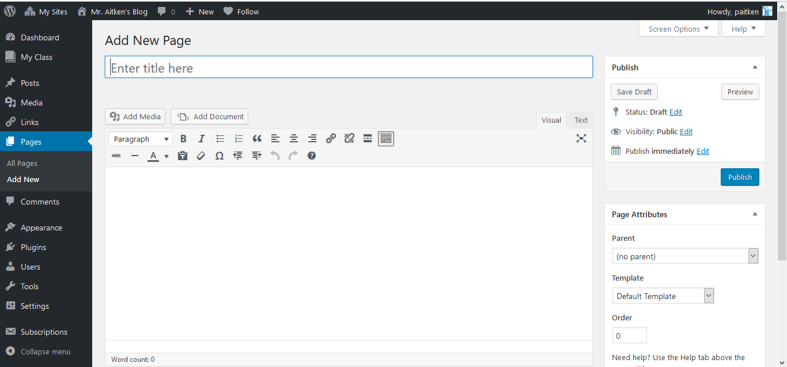
Whenever you start a new assignment you will need to create a NEW PAGE. Give your page a title and ensure that you hit the publish button to publish your page. You can come back and add your content later.
Select the New button at the top of the page and choose the New Page option.
You can then give your page a title – try creating one for your ‘Digital Footprint Assignment’
Publish your page – you can add content later.
Once the page is published select the View Page option that appears.

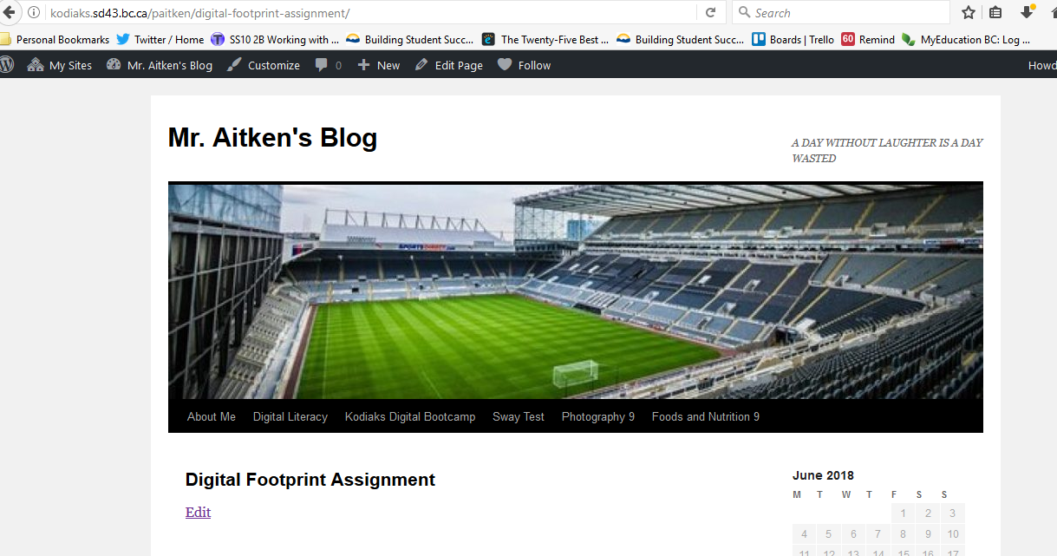
Once you have published your page you will need to select the View Page option. This will bring you to your newly created page. Ensure that you copy the URL of your newly created page. You will need it for the next step.
Copy the URL of your newly created Page.
You will then need to navigate to your Course page. If you are doing your Digital Footprint Assignment this will mean that you need to go to your Digital Literacy 10 page.

Navigate to the course page where you will be adding the assignment. If you are doing your Digital Footprint Assignment this will mean that you need to go to your Digital Literacy 10 page. You will need to select the Edit Page option. This will bring you to the editing page where you will paste your copied URL into your page. This will create a link within your blog – it will look like a small box. The title and the first lines of your content (if any) will be visible. Update that page and you will have successfully added/linked an assignment to your blog.
When you insert the URL from the assignment page, into the course page, it will create a link – in the form of a box. This will be displayed on your course page and will ensure that your blog remains neat and uncluttered to those who wish to view it.
Once you have entered the link be sure to update your page.
