Possible search tools:
- Use * to fill in missing words.
- Use -word to remove any search results that are related to that word.
- Use “word” to look for an exact quote.
Search conducted: Dahl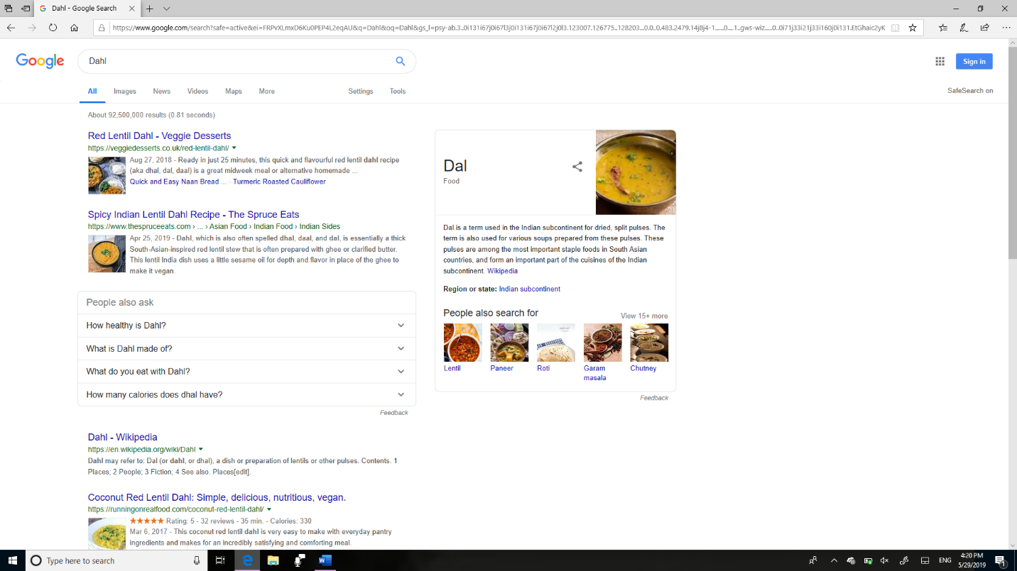 Proper way: * Dahl -soup -recipes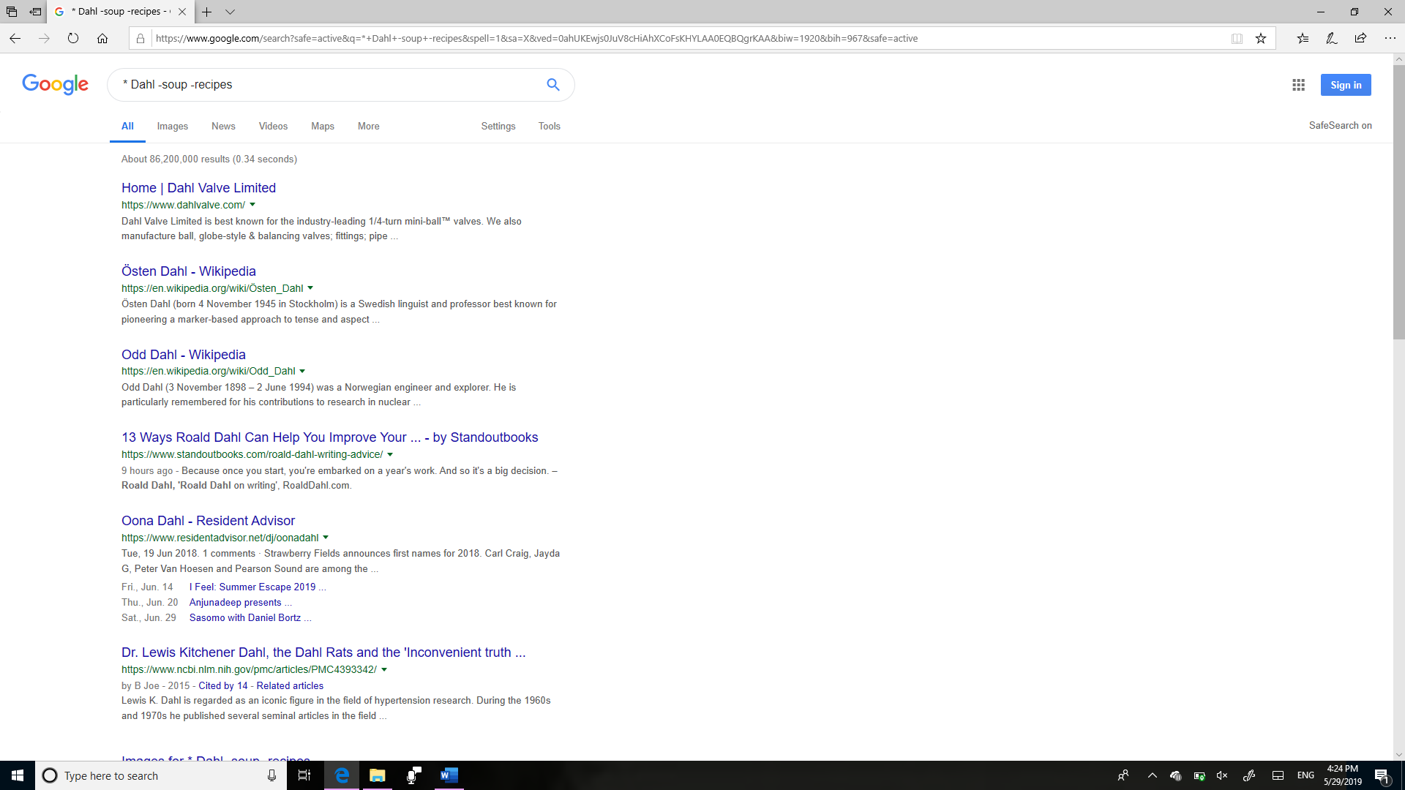
Citation site: Rohald Dahl, Google books result.
https://books.google.ca/books?id=JcG9CgAAQBAJ&pg=PT24&lpg=PT24&dq=*+Dahl+-soup+-recipes&source=bl&ots=ttGyOySjtM&sig=ACfU3U2PrxSO_gXRfhP0AEaUHKcC18w9UQ&hl=en&sa=X&ved=2ahUKEwj1k_CW8cHiAhWnIjQIHftJA-wQ6AEwFHoECAcQAQ

Looking for reliable info; Things to check for= the date that the article was published, if it’s a naturally trusted website, who published the article, if the article is relevant to the topic that you searched and if the website was made by a student, then what sites did they use to gather their information.

What is a PLN (personal learning network): A PLN is a network that you can go to for gathering information and collaborating with others about that same topic. It’s always on but we don’t need to be always on it. It consists of Twitter and YouTube as well as a few others.
Reflection: I do not have a personal learning network, so the things I would need is a group that I can chat with about a specific topic, and a trusted source where I can get my information. I can get this by going to my family and friends and seeing if they know anyone or if they know more about the topic than I do.

