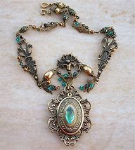
It’s Halloween in 2020, and Mona was all ready for late-night trick-or-treating with her two best friends, Kassie and Gwen. Just before she was all done putting on her Victorian dress and brushing her raven black hair, her dad called out, “Mona! There is a package for you!“ She opened it hurriedly to reveal an emerald and gold amulet. The font on the back read, “Your next.” Huh, weird. Whatever. Mona saw that the amulet went perfectly with her dress, so she put it on. The doorbell rang, and Mona went to answer. It was Kassie and Gwen, both dressed as little Victorian girls, holding pillowcases. “Nice necklace. Ready to go?” Kassie asked, staring at the large jewel in the middle. Gwen‘s eyes were also glued to amulet. Mona smiled, her friends were goofballs. “Ya, come on.“ “Let‘s hit the big homes first, they always have the best stuff.“ “Okay cool.“
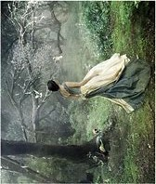
They walked to the edge of the foggy forest, where there was a path that led to a bridge into the other neighborhood. “They say this forest is haunted, and every Halloween, one person goes missing.” Kassie teased. Gwen shrieked as Mona popped out from behind a tree in front of them. Everyone burst out laughing as they continued down the path, but Mona had a strange feeling that they were being followed. Every few minutes she would see something like a black cloud out of the corner of her eye but when she looked, there was nothing but thin white fog.
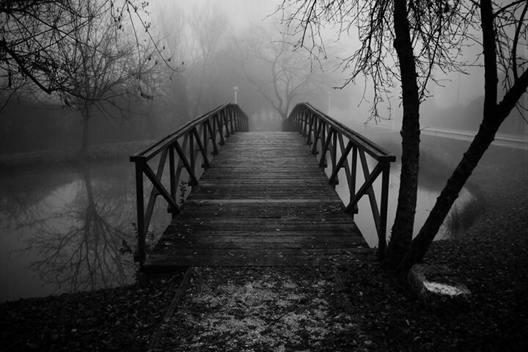
The Victorian girls were almost to the bridge that crossed the river, and Mona had just said the worst Halloween joke ever. Kassie and Gwen laughed but soon died down as they came to a stop. On the bridge was a figure. A dark figure that seemed to have steam coming off it. What is that?? Mona just backed up slowly, staring as the thing made its way off the bridge. She didn’t notice that her friends didn’t move.
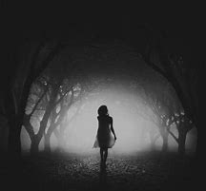
Mona could see the figure now. It was a lady made of black smoke and mist. She looked like a storm, white eyes as piercing as lightning. She kept gliding towards Mona, Kassie and Gwen. When backing up, Mona noticed, both of her friends were frozen, eyes still bright with the conversation, mid-stride. She tried to shake them, but they are cold. The terrified girl looks back at The Lady and sees that the storm has come to a halt no more than twenty meters from her.
“Do not look to them for help.” Mona hears the mist whisper, “They will not notice that you have gone.”
Gone? Whe- Mona hadn’t finished that thought before The Lady bounded towards her. Adrenaline kicked in and Mona ran as fast as she could. But even as her legs flew over branches, Mona could hear The Lady’s breathing close behind her. “Go away!” Mona screamed as she darted through the woods. Almost immediately, the breathing stopped, but Mona was not taking chances and kept running.
Darting behind a tree to catch her breath, Mona ripped of the amulet like it was made of string. The words on the back had changed again. Shivering and shacking, she whispered the words. “For better or for worse your luck will change.” This stupid amulet is just a cheap piece of crap. Anger boiled inside her, and the terrified, furious teen threw the green gem against the tree opposite of her.
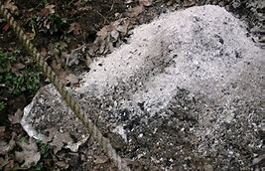
It splintered in half, then landed on the ground. As Mona watched, the entire amulet disintegrated into a pile of ash. Mona looked around in the fog and saw no one there. She didn’t hear Kassie or Gwen calling her name. Shaking her head, Mona decided that she was just tired, so she went back to the path to walk home. But as she walked in the fog, all Mona could think about was her amulet and The Lady. Was that just a hallucination? She shook her head again and just kept walking.
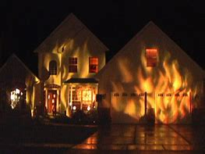
It was ten when Mona reached her street. She looked at her house fondly, glad to be back after what had happened that night. The lightshow of fake fire illuminated the home. Mona sighed and walked forward but stopped when she felt an ice-cold breeze on her shoulder. “You can’t get rid of me that easily.” Mona whirled around, stared into The Lady’s eyes, then collapsed on the sidewalk.
When she opened her eyes again, Mona was back in the woods. She was not surprised to be back here, in fact, she didn’t feel any emotions at all. There was only peace and quiet. At the bottom of her black dress was a paper package. She picked it up and whispered into the dark, “Who’s next?”

