“ABOUTME “
My name is Amirali Atarzadeh and I am from Iran, but I have lived in Canada more then one year. I am grade 11 international students in Heritage Woods Secondary. Last year, I was at the Pinetree high school. My favorite sport is basketball but in my spare time I also enjoy watching tv or listening to music. In my family, my father is an engineer, he is 46-years old and my mother is a housewife, she is 46- years old, I have a 20-year-old sister who is currently studying at BCIT. I have many friends here and in Iran.
I hope I have wonderful year

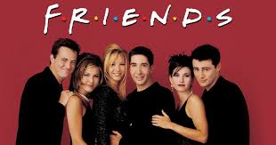

My favorite sentences

Life is like riding a bicycle. To keep your balance, you must keep moving.”
—Albert Einstein

My favorite video

https://www.youtube.com/watch?v=cnokM2fzYPY&t=61s

