“ABOUTME “
My name is Amirali Atarzadeh and I am from Iran, but I have lived in Canada more then one year. I am grade 11 international students in Heritage Woods Secondary. Last year, I was at the Pinetree high school. My favorite sport is basketball but in my spare time I also enjoy watching tv or listening to music. In my family, my father is an engineer, he is 46-years old and my mother is a housewife, she is 46- years old, I have a 20-year-old sister who is currently studying at BCIT. I have many friends here and in Iran.
I hope I have wonderful year

I would like to lessen to music every day and I would like to play guitar last September I started to learn how to play guitar also my family support me to learn guitar. I think everyone should learn a musical instrument. Music is one of my best hobbies

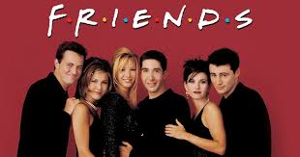

I watch a move or tv show every week. I watched many moves and my favorite move I have ever watched name is “FRIENDS” not only I like this tv show but also this is very popular and many people like it this tv show. I recommend to everyone watch this tv show I would like watch again this tv show.

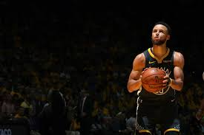

I am big fan of sport also my favorite sport is basketball and I have played basketball more then four year and I really like to watch NBA games. I play basketball every weekend and I have many friends they love basketball same as me.
Over all exercise is very good thing for your body health, no one like to have bad body health.

My favorite website

https://www.independent.co.uk/sport
As I said I like sport, this my favorite website because there is some news about sport, and I check sport news on this website.

My favorite sentences

Life is like riding a bicycle. To keep your balance, you must keep moving.”
—Albert Einstein

This one of my favorite sentences I have ever hard because it has simple mining also with deep concept, for this reason I put this sentence here.
It want to say if we want to continue our life we should balancing every things.

My favorite video

https://www.youtube.com/watch?v=cnokM2fzYPY&t=61s

I have watched large number of this kind of videos so this one is really good one because this video want to tell you in your life you can effect on it, do what ever you want in your life, this your life you can make it and only thing you need try hard to reach your dream, finally there is no reason if you say I cannot do it.
I really like positive video because it makes me strange.

I hope you know some information about my personally

