Digital Footprint
The goal of this assignment is for you to reflect on your digital footprint. For this assignment you will share how your digital footprint can impact your future education, grad school application, or job and career prospects. With this assignment, we want you to describe the key messages around digital footprints and learn to share with your peers how you will be able to manage your digital footprint responsibly.
Instructions
- Watch the following video about managing your digital footprint. This video is 3 minutes in length. Video: “Your Digital Footprint May Be Unflattering” found at http://www.youtube.com/watch?v=o8C1a2z_cuQ
- Reflect on your own digital footprint. Google yourself. Try to picture how your footprint comes across to others.
- Answer the questions below, share your answers on your Edublogs account in the form of a video, poster/infographic, or article (combining pictures and words) and add it to your Digital Literacy 10 Page (be sure to upload the document using the ‘Add Document’ button if you complete this using Word or PowerPoint. Other methods of completing this assignment may require you to embed your work.
“Your Digital Footprint May
Be Unflattering” Video

Questions
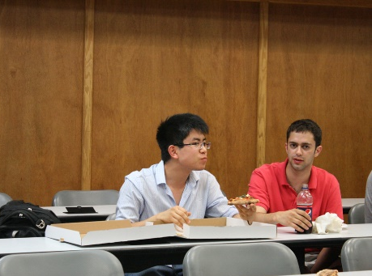
What information did you learn that you would pass on to other students? How would you go about telling them?
Describe at least three strategies that you can use to keep your digital footprint appropriate and safe.
How might your digital footprint affect your future opportunities? Give at least two examples.

Deliverables
Ensure that your response effectively addresses the goals provided above and answers all of the questions listed in the instructions. You have the option of doing the response in one of the formats listed below:

• Video Response (1 - 1½ minutes in length)
• Poster/Infographic/Website (including both text and graphics)
• Article (minimum six pictures, including both text and graphics)
Your response is due by September 30th and must be uploaded to your Edublogs account. We expect that the tone of this assignment will be considerate and respectful, and use language that is inclusive, appropriate, and appealing to the Heritage Woods community. Your response will be reviewed and if there are concerns or questions with your response you may be contacted by Mr. Aitken or Mr. Castonguay who are the COL teachers. If there is any evidence of plagiarism your response will be considered incomplete and you will have to redo your assignment.

Possible digital tools to use might be: Windows Movie Maker, iMovie, Easel.ly, Prezi, Sway, Microsoft Word, Piktochart, Canva, etc.

See an example video: https://www.youtube.com/watch?v=n9DDzRZaagQ

Feedback will come in the form of a comment on your blog. We will use the rubric below:

 | Missing - 0 | Not Meeting – 1-2 | Minimal - 3 | Meeting – 4 | Exceeding - 5
Overall Message and Media  (What is your conclusion and how did you show it?) | Missing. | Message shows no or little understanding of your digital footprint. The media is not apparent as well. | Message shows an understanding of your digital footprint but a lot of information was minimal or irrelevant. The media and the message are disjointed and did not complement each other. | Message shows a good understanding of your digital footprint. Media works well with your message but the two could complement each other better. | Message clearly demonstrates fully your understanding of your digital footprint; media and message blend together seamlessly; pictures/sources are referenced.
Analyze (Did you find key information to support your message?) | Missing. | Information given does not support the message that you are trying to present. | Information present but a lot of the information is irrelevant and does not support your message. | Good information present; answers are typical and accurate | Excellent information. All your information is insightful and supports your message. Examples of positive and negative impacts regarding a digital footprint have been included.
Audience  (What do other people think about your presentation?) | Missing. | The final product risks offending the audience and will not be shared to the outside world. | The final product is not well received by the audience and will not be shared to the outside world. | The final product is received by the audience but does not illicit a further response to be shared with the outside world. | The final product is well received by the audience in the outside world and inspires further discussion.
[photos: Footprints (modified) by Peter Nijenhuis via flickr, “Uni Interview“, by Alex France, “Footprint“, by Nadar, “Ann Miura-Ko“, by HackNY.org licensed under CC BY-SA 2.0.]

