**SAFETY FIRST!**

Clean Up, Clean Up, Everybody Everywhere!

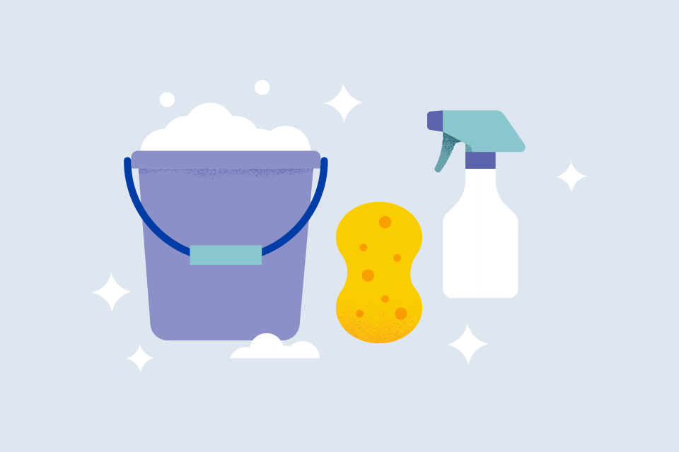

Don’t Be Lame, Put Out your Flame!

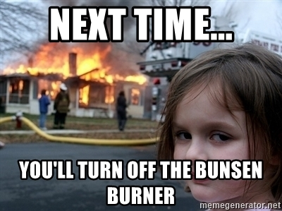

**Don’t Be Daft, Don’t Forget to Waft!**

