Science Lab:
WOOD BUGS: Can they become carnivores?
By Anna, Leah and Abby

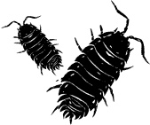

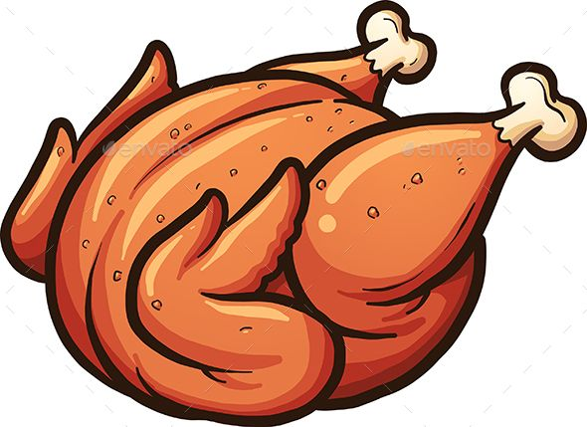

https://www.pinterest.ca/pin/405464772693940827/?lp=true

https://workbasedlearning.pnnl.gov/pals/resource/cards/pillbugs.stm

Habitat:

Wood bugs generally live under rocks, leaves, logs or planters. They are found in damp environments, or in gardens.

I found wood bugs in my garden under my basil plant. It is kept on my front porch and is watered almost every day.

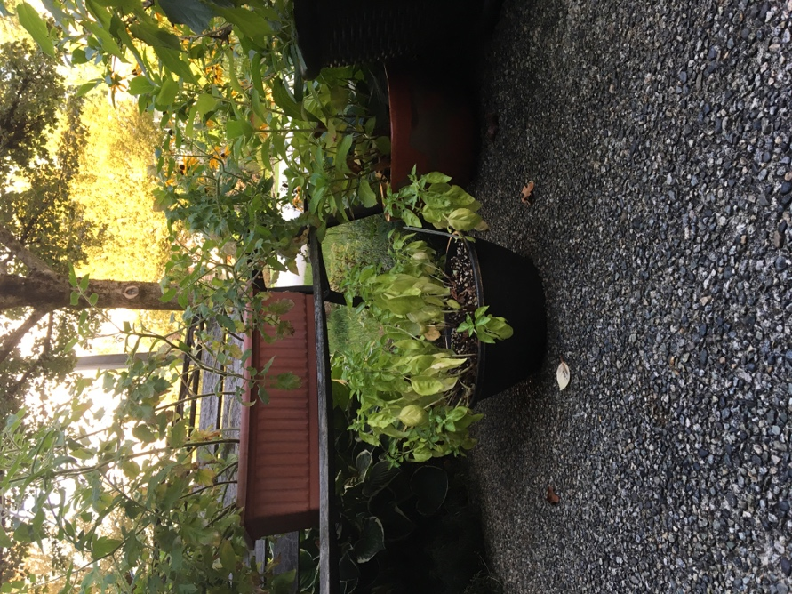

Hypothesis:

IF a wood bug does not eat for over a day, THEN it will resort to eating whatever it can, including meat.

Materials:

- 2 Wood bugs (We named them Jeff and Stewert so we could differentiate them easier)
- A glass jar
- A small piece of turkey/chicken
- A small piece of apple
- Notebook to record data

Procedure:
- Put the bugs in the pan
- Waited about 20 minutes for completed action in the wood bugs behaviour to make them feel in more in a desperate state
- Put in the meat
- Timed how long it took for them to get to the meat
- Put in apple
- Timed how long it would take for them to get to the apple

Our Data
- At first, we only put in one piece of apple and two pieces of turkey, eventually we had 5 pieces of turkey, one being about 3x bigger than the other one, and being about the same size as the apples

Wood Bugs | Offering Turkey | Offering Apple  Pieces
Stewart | Ate it within 12.61 seconds of starting of starting the experiment | Ate it within 6.08  Seconds of starting the experiment
Jeff | Ate it within 12.30 seconds of starting of starting the experiment | Ate it within 3.58  Seconds of starting the experiment

Qualitative Observations:

- The wood bugs were climbing on each other
- They were circling the tin on the edges for a while (clockwise)
- They walked on the turkey a lot
- It took them a bit to identify the food that was in the tray before they ate it

Graph:

A Graph To Show How Long It Takes Wood bugs To Eat

Conclusion:
The wood bugs would still prefer what they were expected to eat. We assume this was because they weren’t in a desperate stage to survive. If we had nearly starved the wood bugs, we think they would have adapted better to the meat because they knew it was their only option. They got to the turkey in an average of 12.46 seconds, however, after offering the apple, they were more interested in getting to it because they are more familiar with that food group. The wood bugs got to it in an average of 4.83 seconds, still leaving their preference as fruits, vegetables, plants, mulch, etc.
Both of our wood bugs did resort to the turkey at one point in our experiment. They were just less enticed to do so because they have been adapted to a whole other diet their entire life. Jeff, the one who was starved longer and witnessed his friends die the day prior, got to the turkey sooner. We believe this to be a result of him being more desperate. Stewart, our other wood bug, we fed. He still ended up going to the turkey. But we believe this to be out of curiosity, versus actual desperation.
We believe our experiment could be more successful if we had raised wood bugs from birth. So, we can be their source of authority in a way, and raise them to adapt to certain foods, in our case, turkey.

