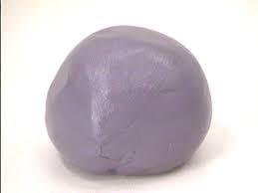
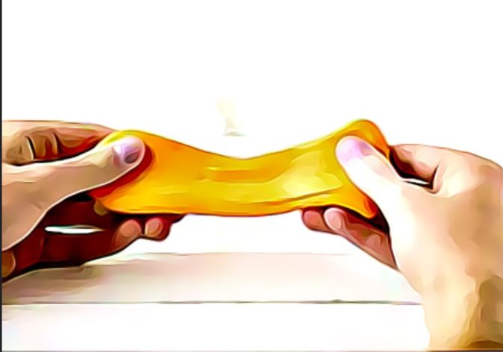
How Can the Silly Putty Recipe be Improved to Increase its Bounce Height?
By Aarav and Anson

Will adding Borax increase the bounce height of the Silly Putty?

Variables
Manipulated Variable: Quantity of Borax
Responding Variable: Height of Bounce
Controlled Variables(s): Amount of Glue, Amount of Water, Drop Height, Force when Dropped, Landing Surface, Temperature of Room (°C), Measuring Unit (cm)

Hypothesis
If the amount of borax used is increased, then the bounce height of the silly putty will increase as the putty will stick less to the table and be more solid.

Materials
- 40 mL of water
- 10 grams of borax (formerly 2 grams)
- 20 mL of white glue
- 2 beakers
  - One 50 mL beaker
  - One 100 mL beaker
- Stir rod
- Flat Surface (floor in this case)

Procedure
- Fill the 50 ml beaker with 20 mL of water.
- Add 2g Borax into 50 mL beaker.
- Stir gently until mixed and set aside.
- Fill the 100 ml beaker with 20 ml of white glue.
- Add 20 ml of water to the 100 ml beaker.
- Stir gently.
- Pour contents of 50 ml beaker into 100 ml beaker slowly, all while stirring.
- Add 8 more grams of borax into solution.
- Stir gently for approximately 4 minutes.
- Take out borax and glue solution and roll it between your hands in a ball until it is in a solid sphere form.
- Take your original silly putty ball.
- Hold it over the floor at a height of 100 cm.
- Have your partner hold a meter stick perpendicular to the floor.
- Drop the ball.
- When the ball bounces, look at the highest point of its bounce on the meter stick.
- Record the height in the data graph.
- Repeat from step 11, but instead use your new and (hopefully) improved silly putty ball.
- Repeat steps 11 to 17 with the new ball 5 times, recording your height each time in the data graph.
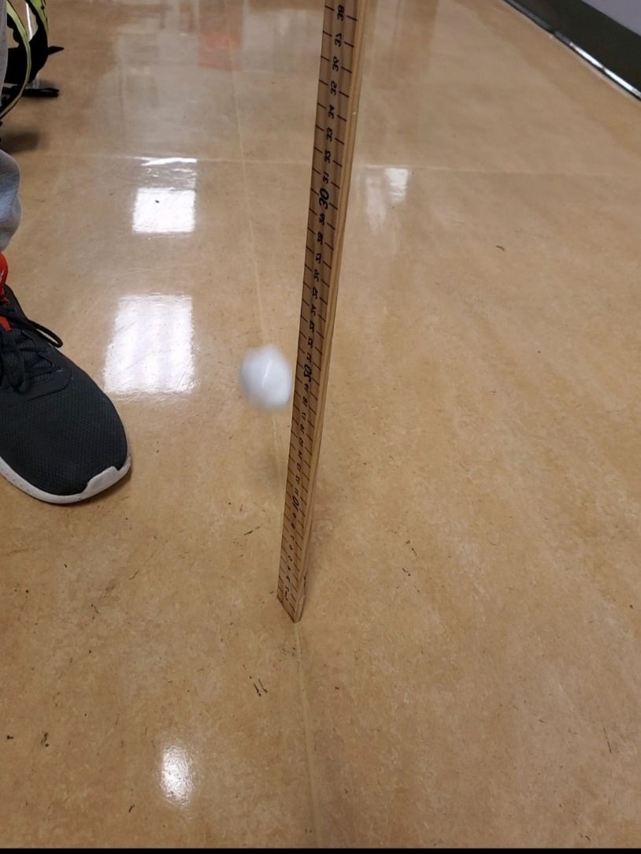

Data (Qualitative)
- The ball without more borax was a bit more thick and solid than the one with extra borax.
- The ball with more borax was a little bit flimsier when it hit the floor, possibly affecting bounce height.
- The ball with more borax somehow looked bigger even though we used the same amount of glue for both balls.
- The ball with more borax acted with elastic force as it absorbed into the ground and sprung back up.

Data Table (Quantitative)
Bounce Height (Original) | Bounce Height (New)
1. 20 cm | 1. 20 cm
2. 22 cm | 2. 23 cm
3. 21 cm | 3. 20 cm
4. 19 cm | 4. 25 cm
5. 23 cm | 5. 22 cm

Data Analysis (Graph)

Average of Original: (20 + 23 + 20 + 25 + 22) / 5 = 22
Average of Extra Borax: (20 + 22 + 21 + 19 + 23) / 5 = 21

Conclusion
In conclusion, our hypothesis was correct. Adding an extra eight grams of borax to the solution helped increase the height. In our data table shown above, the average of the bounce height with the extra borax was 1 cm higher than the original. However, error could have occurred while measuring, as the human eye is not perfect, as well we may have accidentally added more drop forced than we intended to without even knowing. Some thoughts we can put in is how does glue affect the bounce height, as well as temperature of the ball because the old putty was much colder than the new putty. One way to improve this investigation is to keep both putty balls at the same temperature and have them be the same age. Our original putty was 4 days older than the new putty, and that could have contributed to differences in height as our old putty was more rigid and less malleable than the new putty.

