Sneakit
1300 David Ave
Port moody, bc
V3h 5k6

Submitted to:
Mr. Sather
Heritage Woods Secondary School

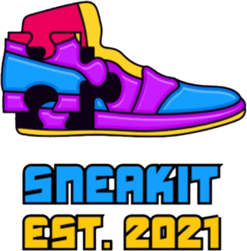
“Get More from Shoes”

Ashlyn, Flavia, Ava, Julia and Felora

Table of Contents
- Executive summary .............................................................................. 3
  - SneaKit Promotional Goals
  - Promotional Budget
- Description of Industry .................................................................. 3 - 6
  - Industry Outlook
  - Market
  - Competitors
  - Growth Potential
- Description of Venture .................................................................... 6 - 8
  - SWOT
  - Customers
  - Product
- Promotional Campaign .................................................................. 8 - 9
  - Money Spent
  - Promotional and/or Institutional Advertising
  - Type of Advertisements
  - Strategy to Promote Brand
  - Overall Promotional Strategy
- Proof of Concept .............................................................................9 - 14
  - Newspaper/Magazine
  - Internet Website
  - TV Ad
  - Social Media Platform
- Advertising Speciality .................................................................15 - 17
  - Forms of Advertising Speciality (N/A)
  - Special Promotional Sales
  - Extras

Executive Summary
This booklet will outline SneaKit’s promotional plans and details for their promotional campaign launch. Throughout this document, there are sections that include details of the type of industry SneaKit belongs to, what SneaKit entails (the product, business, and brand), and the aspects of SneaKit’s first promotional campaign. This business plan will also have a “Proof of Concept” section that will show the types of ads there will be in the campaign and the platforms that they will be launched into. Instagram, for example, will be a major part of SneaKit’s social media platform to endorse the brand image (institutional advertising). Whereas SneaKit’s website will be used solely to sell the product and promote its features and functions (promotional advertising). Any promotional campaign regardless of the business has a financial cost which would be the money used and will impact the expected return on investment. Nevertheless, since SneaKit is a small brand-new business that has just gotten started, they still need to take full advantage of their first promotional campaign. Therefore, the company’s main goal is to get the brand into the market and minds of consumers. However, as a small business, SneaKit will work around its limitation and use advertising methods that will allow them to save money as they launch their promotional campaign. In accordance with the SneaKit’s promotional budget ($1,500) they will direct the money for maintaining the website, Instagram promotion, and YouTube ad for long term purposes.
Description of Industry
Industry Outlook:
Footwear production has increased by 21.2% since 2010, that’s an average of 2.2% per year. In the future, the shoe market is expected to grow by 16.2% in 2022. The value of footwear exports continued to increase in 2019 with a record of 146 billion dollars, which was mostly driven by Asia as they increased their exports by 2.8%.
The first pair of modern lace shoes were invented in 1790 and without a doubt, has grown remarkably over the years. These days, people want excellent quality, high fashion shoes and will pay the money and a significant premium to get them. The shoe market is always progressing towards keeping up with the demand and satisfying customers. Currently, there are numerous cleaning solutions that are specifically made for certain types of fabric your shoes are made of, which is in contrast with the past, where there was no technology to do this. Many people want to keep their shoes looking brand new and want to keep them in nice condition as shoes today can reach over $1,000 per pair. Many people like to spend their money on shoes and wear a different pair every day of the week, that’s why SneaKit was created, to help people keep their shoes looking brand new.

Market:
In 2020, 20.5 billion pairs of shoes were produced all around the world. The total number of consumers globally buy 14.5 billion to 19 billion pairs of shoes a year. Which is equal to 2 pairs of shoes per person a year. However, the average person has 12 pairs of shoes, and the average women owns 20 pairs of shoes.
These numbers show how big the shoe market is globally and as such, provides Sneakit with a fantastic opportunity for the shoe care market. In 2020, the shoe care market size reached USD$4.92 billion in revenue, with a forecast for 2025 of USD$6.0 billion in revenue. That is a annual growth rate of 3.9%. Down below is a graph showing the forecast annual revenue growth over the next 4 years to 2025.

Competitors:
Jason Markk - Headquarters in Los Angeles
- Pop up stores around the world & have their products in many stores such as footlocker and Sport Check
- Known as “Most trusted”
- First shoe cleaning company
- All their products are biodegradable
- Has bad reviews on YouTube of people doing a before and after of their shoes
Shoe MGK – Headquarters in Southern California
- Known for decent quality
- Not only do they have a website, but they are also in shoe stores such as the shoe company, SoftMoc etc.
- Many different product lines
- Generally, not good for the environment
Vans – Headquarters in Costa Mesa, California
- Many stores all around the world, as well as online
- They not only make their own cleaners but sell trendy shoes
- They have established loyal customers
- Innovative designs
- Their main focus is selling shoes, and as much on cleaning kits
Clean kicks – Headquarters in Bartlesville, Oklahoma
- Great promotion strategies, but not very well known
- Many items in their kits – such as a textured cloth
- 5-star rating and great reviews
- Not well known – not a loyal brand
Amazon – Headquarters in Seattle, Washington
- Biggest online seller
- They sell many products from many different companies
- Known for fast shipping
- Can have shipping delays due to natural disasters or low staff

Below is a map showing where SneaKit is located, compared to the locations of our competitors.

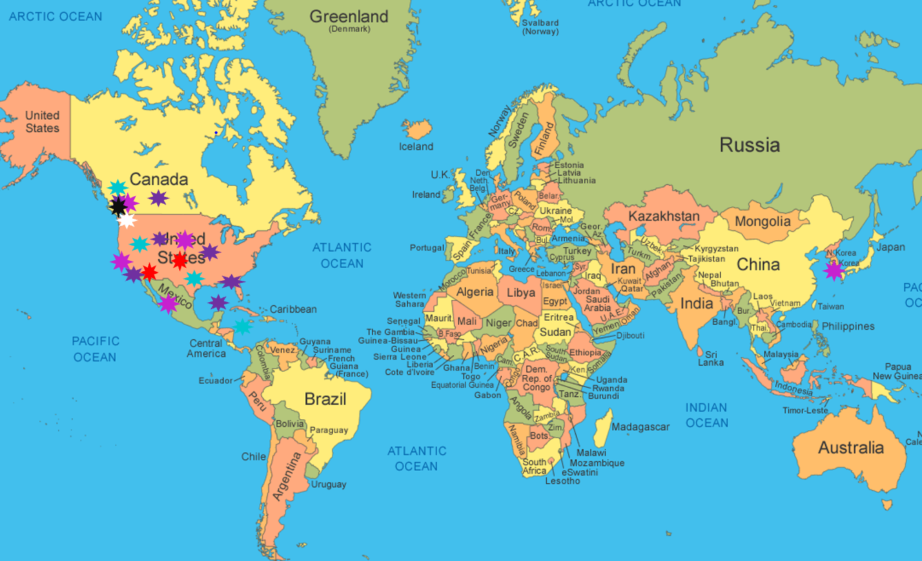
- Sneakit - Vans - Jason Markk - Shoe MGK - Clean kicks - Amazon

Growth Potential:
Many people around the world strive to keep their shoes clean, and we predict our brand will resonate with the consumer leading to rapid growth this year, even though we are a new company, just starting up. With the global shoe care market growing, there is more demand for cleaning products in the shoe industry which will ensure Sneakit will be positioned for strong revenue growth as we build and create strong brand loyalty. Even though we have many competitors, we can make our company stand out with innovative marketing campaigns and a strong product. We will reach above our competitors with fair prices and sustainable materials, as well as ensuring we deliver on what our customers need. With the Shoe care industry expected to grow by 3.6% annually by 2025, this gives SneaKit a wonderful opportunity to be a part of this journey and growing industry.

Description of the Venture
SWOT:
Strengths:
- 60% eco-friendly
- Many options of kits for distinct types of shoes
- With every 20 kits sold we donate one new pair of runners
- We have a large target market
Weaknesses:
- Not 100% eco-friendly
- We are a new company therefore we are not very well known
Opportunities:
- Expand our stores across the globe
- Growing industry
- Create online stores
- Promote online using social media – more customers
Threats:
- Our competitors
- Covid-19

Customers:
SneaKit’s focused target market is teenagers ranging from 13-19 who have a considerable amount of money and have a strong social media presence. Teenagers nowadays enjoy high fashion and wearing trendy clothing. Shoes are a big part of any outfit therefore teens can use our product as a straightforward way of keeping their shoes clean. Moreover, our second target market is 35- to 50-year-old adults who wear nice shoes to work. Typically, our customers need to be middle to high class as well as be living in regions where the weather can make their shoes dirty. For instance, Vancouver is rainy, and people’s shoes get muddy. However, in San Diego for example, they do not need a shoe cleaner as it is sunny, and their shoes will remain clean. Also, not everyone will have the determination to keep their shoes clean, therefore SneaKit’s target market includes customers who want to have nice, clean shoes and will take the time to clean them every day. Since teenagers are young, there are not as many products as possible out there that they can buy and use themselves, SneaKit gives them a terrific opportunity to be independent and take care of their expensive shoes.

Product:
SneaKit is a shoe cleaning kit, which has everything you need to clean your shoes. Inside the kit is a cleaner, a horsehair scrub brush and protectant spray. Not only do we have one kit, but we have many different options for the various kinds of shoes, including canvas, leather, and suede. However, down below are pictures of our go-to kit that can be used on every type of shoe. Our customers can buy pre-packaged kits, or they can customize their own kits into their likings or needs.

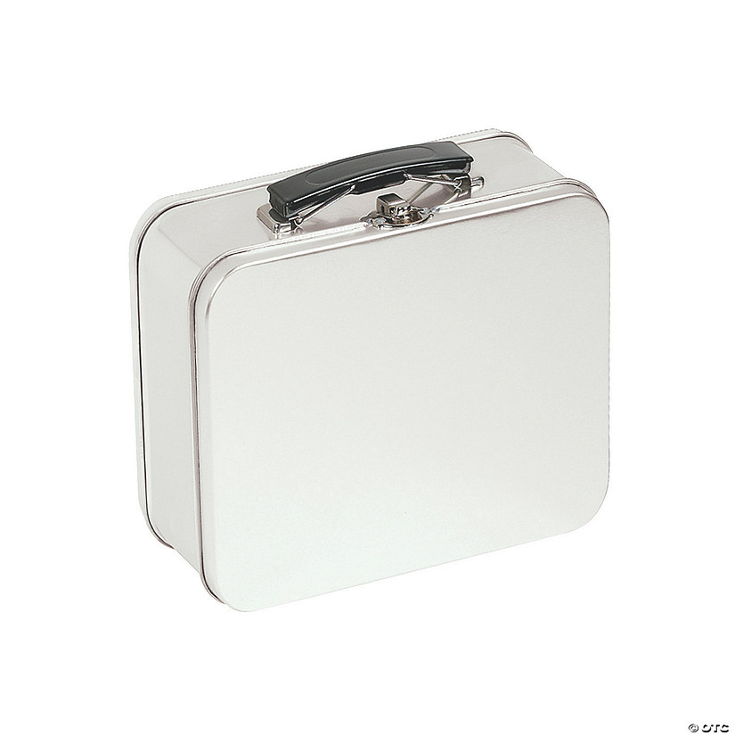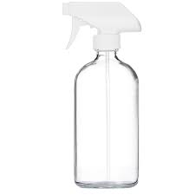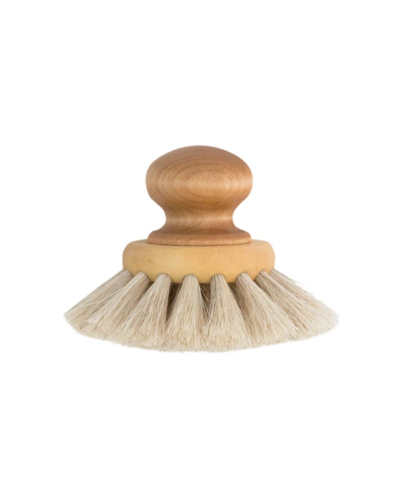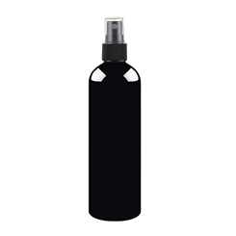

SneaKit is not just easy to use, our product is made with 60% sustainable materials, so we can do our part to help the environment. Not only that, SneaKit plans to donate one pair of new runners with every 20 kits we sell. On our website, our customers can sign up for rewards with every purchase, this makes a great way for them to get deals and keep investing in our products. Further details about our website on page 7.

Promotion mix:
Our 4 p’s are closely tied together. We provide high-quality products that cost us around 10-15 dollars to produce, which is higher than our competitors, but this allows us to price our product higher than other companies'. This higher price can be sustained given our high quality and exclusive cleaning products. We decided to avoid physical stores to save a trip for the customers and to avoid the high infrastructure costs. Online shopping is more efficient, and people are leaning towards it more and more every day. Our seasonal promotions and customer' loyalty points will help us attract more customers for our peak season in fall and winter, which is the season that shoes get dirty more often. Also, with our loyalty program we can keep our customers and make sure they will come back to our company for future purchases. To wrap this all up, with our premium pricing and high-quality products, we will position our company as an exclusive brand that attracts middle to higher class customers and our brand will be known for that brand image. Furthermore, with online shopping and our return policies that will help the customers trust us, this will show them that we value their time and their overall experience.

Promotional Campaign

Money Spent on Advertising:
Small Billboard – Junior Poster | $800 a month (11’W x 5’H)
Website | $100 up front - $50 to maintain monthly
Instagram Promotion | $150 - $600 a month (ads charged for clicks, likes & views)
YouTube Ad | $100 - $300
Flier | 1,000 for $122
Newspaper | $395 a month
Total: | $1,000 – 1,350/per month

The promotional mix changes based of the needs and budget of the company each month; this table represents an estimate of how much it will cost.

Promotional and or Institutional Advertising:
Our company decided to use a combination of both types of advertising. Our main goal is to increase sales but also set a strong premium brand image. Our focus and budget will be towards our promotional campaigns and advertisements like billboards, YouTube ads and newspaper ads. For Institutional Advertising we will use our home page on Instagram, our website and Tiktok which are cost friendly or free. Since we are a new company, we want to save as much as we can so we can conserve cash for grow further in the future.

Advertisements:
- Website
- Instagram
- Tiktok (free)
- Facebook
- Newspaper
- Billboards
- Fliers

This choice was made by considering our budget for advertising and how cost-friendly each of these ways are. Tiktok for example, if we can reach many followers, we can eventually get verified and sponsor influencers. Even though a billboard can be up to $800 we believe they are useful as thousands of cars can drive past them every day.

Strategy to Promote Brand:
Our strategy that SneaKit will be using to imprint the brand into the minds of consumers that we do right in this world. Our product is 60% sustainable and with more growth of our company we hope this will become 100%. Not only this, but we also donate one new pair of runners to people in need with every 20 kits sold. If we hit our goal and sell 3,000 kits this year, this means we will donate 150 pairs of shoes. We hope that our customers will see what we are doing, and this will make them want to help us help.

Overall Promotional Strategy:
SneaKit’s overall promotional strategy is using social media. Social media is a big part of today’s society, and we believe the best way to get to our target market is using social media to promote our company. Whether it’s Instagram, or our YouTube ad, this is the best way to reach and connect with our customers. We want to show our customers how we care for them and the environment. Our ads and promotions will hopefully show this, making us more customer brand loyalty.

Proof of Concept
Newspapers/Magazine:

SneaKit’s goal is to be put in the Vancouver Sun, The Province & The Vancouver courier. We wish to be put in the newspapers during the wintertime. This is the time where it’s wet and rainy and the perfect time for people to clean their shoes, as this is the time of year when shoes are dirty. We will try and get as many ads as possible in the newspaper as possible as this targets our older target market, so 7 days a week. As stated in the table above, it will cost us approximately $395 per month.

Internet Website:
One of our main ways of promotion is Instagram and our YouTube ad. With our website, this is a place for people to search for and buy our products. Our Web presence we will be using Wix. We will also be using Tiktok and Instagram. We will find micro influencers, send them our products to sponsor them, therefore they can create a video talking about how well our products work. This will make people want to buy our products as popular influencers like them. Each day, we will post about our product, such as discounts or before and after images after the use of our products. Our target market is 13–19-year-olds, therefore, to reach them with our product, we plan to hop on popular trends and spike their interests. For example, we could promote using sports, fashion, and food. This will keep them intruded and give us a follow. Below are pictures of our website.

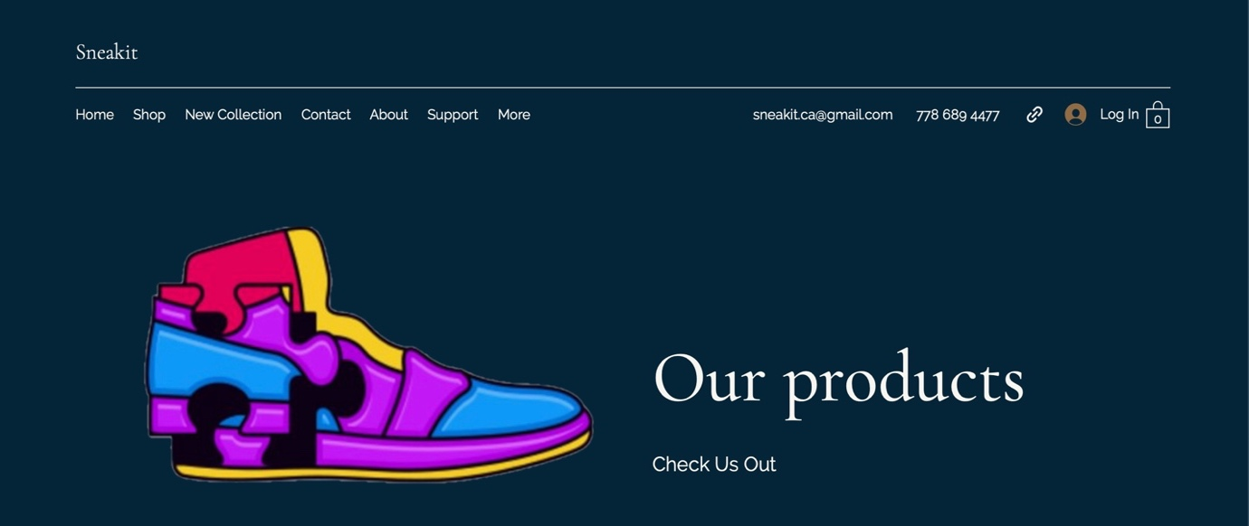

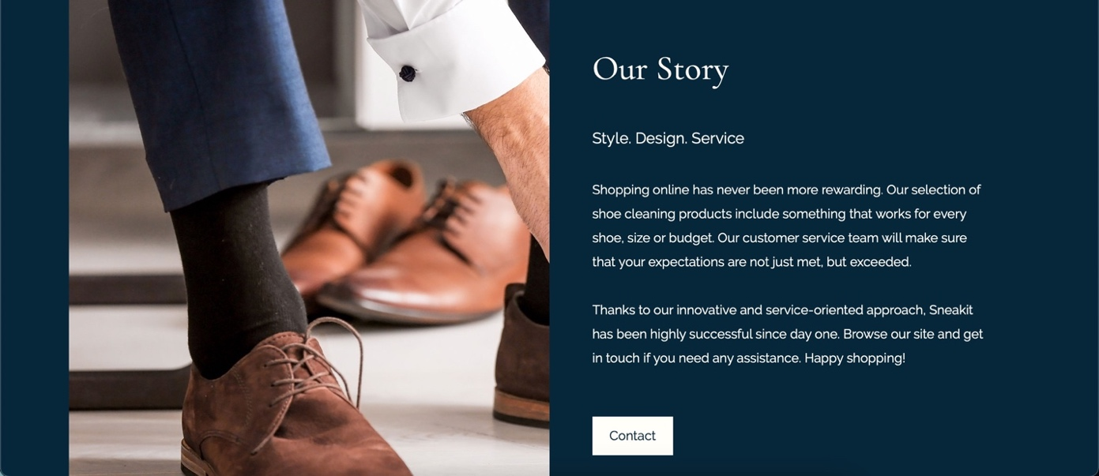
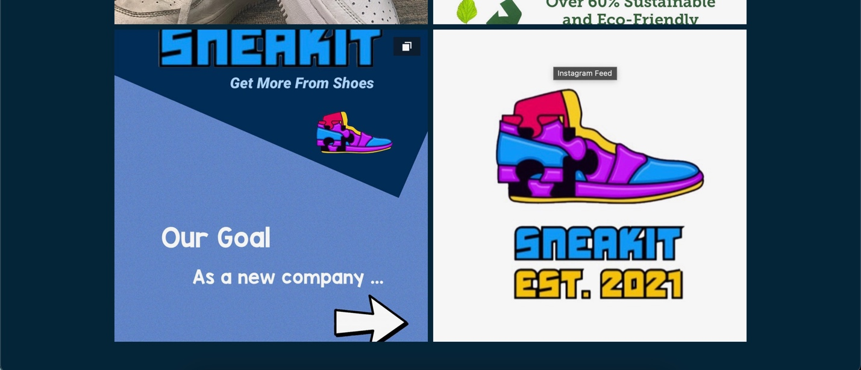
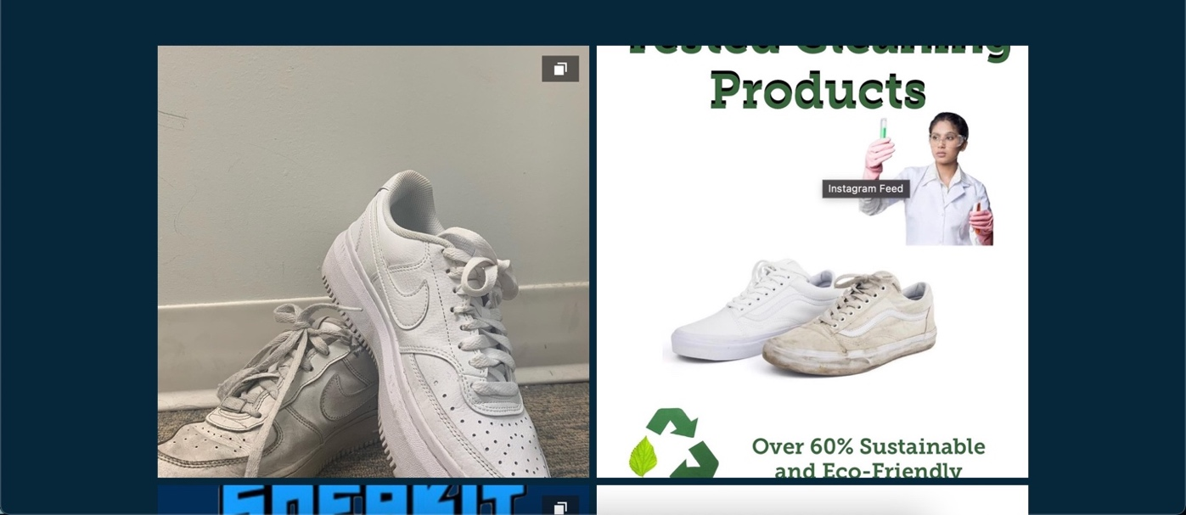

TV - YouTube Ad: Down below is a script of our YouTube Advertisement.
Julia:
“I’m so tired of my shoes getting dirty due to the weather! There is no way to your shoes clean in this rainy condition.”
*Ava steps in dirt*
Ava:
“Oh no! My shoes! They’re so dirty!”
Julia:
“It’s alright. We can’t keep them clean, but we can clean them. Let’s check out some shoe cleaning products to see which one is the best.
*Julia starts searching up shoe cleaning products*
Ava:
“Hold up! Go back, what is SneaKit? It seems that they have pretty good products and good reviews!”
Julia:
“Perfect, they have variety of kits designed for different kinds of fabrics. Let's order their basic kit and clean our shoes!”
*5 days later ava’s clean shoes getting showed off*
Ashlyn:
“Your shoes are so clean; how did you do that?”
Ava:
“I use SneaKit!”
Ashlyn:
“Shop now at www.SneaKit.ca/.com! Get more from shoes!”

We plan to have this ad on YouTube, Tiktok and Instagram. We plan to have this ad seen around 3-6 pm since this is when our target market (13–19-year-old’s) are done school for the day. Around this time, they are relaxing after school and taking a break before they start their homework, so they are on their phones. On YouTube, we can have this ad played before any shoe related videos, so we reach our target market. With this ad, we don’t want to go over $400 so we can stay in budget and save money. Since we are a small business, we aren’t very well-known, we are doing our best to stick to lower cost advertising so we can save money in the long run.

Social Media Platform– Instagram:

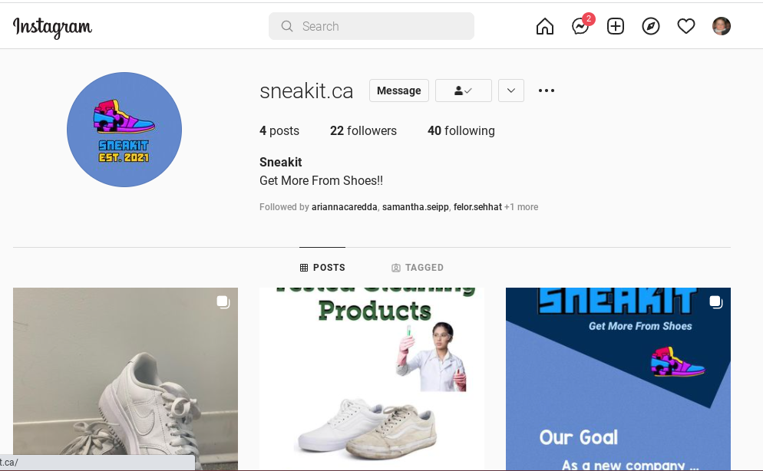

We plan to get more and more followers on Instagram, as well as Tiktok. Our goal is to get verified and create brand loyalty. This way, we can send our products to influencers, to create videos of our products to show to all their followers.

Advertising Specialties

Forms of advertising Specialties:
Advertising specialties such as calendars, pens, fridge magnets, etc. will not be used as a form to help advertising as it will not help reach SneaKit’s target market and does not relate to the product.

Special Promotional Sales:
SneaKit intends to hold unique promotional sales with four sales times and an exclusive special discount for members. The sale will take place on Boxing Day, Black Friday, and three days in March and September, with discounts varying from 10% up to 30% off selected products. Members are entitled for a year-round discount of 50% off one kit after purchasing two kits.

Extras – Billboard & Facebook ad
