Invention proposal: Measure maker Kazuki, Adyen
Are product is called: Measure Maker

Scroll down to see the triple bottom line
The Measure Maker is a mechanical pencil, that has a ruler, and a detachable stick that works like a compass. The ruler is in centimeters, inches and, millimeters. The Measure Maker is a pencil for many situations but mostly for making accurate measurements for length/height/width or situations where you need perfect circles. The Measure Maker also comes in handy when you forget a ruler, or don’t have a compass with you. The measure Maker is also convenient as you can measure things on the go and write things with only one pencil which comes in handy at home, work or even the public.
Estimated Materials:
- Mechanical pencil:
BIC Extra Precision Mechanical Pencil, 0.5 mm, 12/Pack
Retail price: $4.49 per
Wholesale price: $2.25

Staples
- Lead:
Pentel Ain Stein 0.5 mm Lead Refills, HB, 4/Pack
Retail price: $9.69
Wholesale price: $4.85

Staples
- Plastic stick for compass:
uxcell Acrylic Round Rod 2mm 5/64 inch Dia 10 inch Length Transparent Clear Solid Acrylic Rod PMMA Bars 5pcs
Retail price: $7.79
Wholesale price: $3.90
Uxcell Amazon

Estimations:
Our estimated cost in order to make our product would be about $5 dollars.
Our estimated size of out product would be around the same size of a pencil, but a bit larger overall.
The estimated amount of time for us to build our project would be 1 hour and 45 minutes to 2 hours in total.

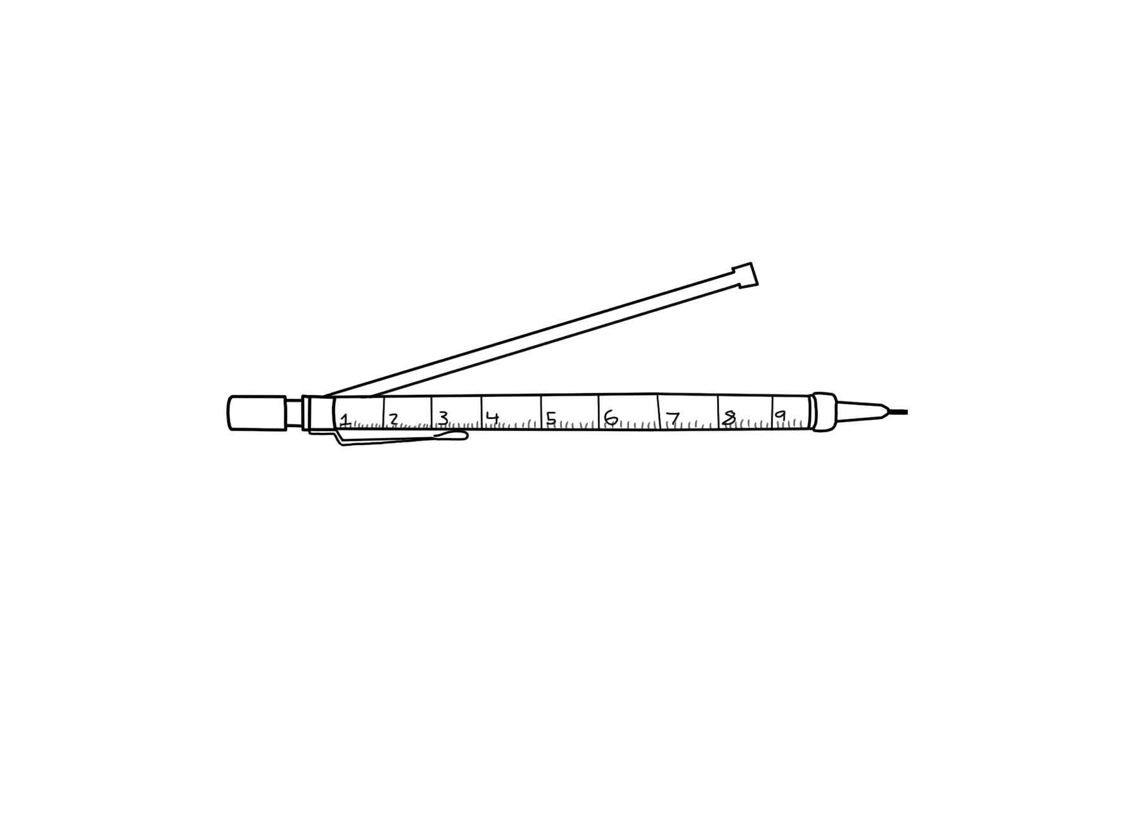

How does the Measure Maker meet the Triple Bottom Line?
The Measure maker meets the Triple Bottom Line because of its great sustainability in relation to the three sections which are People, Planet and Profit. To start, The measure maker is good for the environment as it will be made out of recyclable plastic. The Measure Maker is good for profit because its made out of good materials and sold at a fair price in relation of the cost of making the Measure Maker. Lastly, the Measure Maker is good for people because the Measure Maker is a tool that helps people do things like make measurements or make circles with ease. This makes the Measure Maker sustainable because its bearable, equitable and viable proven by the sections mentioned before.

Other sections:
Profit + Planet:
Reduce the amount of packaging which creates less waste and, less money spent on packaging.
Since its plastic, we don’t need to cut many trees in order to mass produce it, and leave trees alone. There will be more nature living than cities running on land.

People + profit:
We can make things easier for people, to do their work or job. So people would buy this tool to make their life easier, and less work to finish something.
Since there is refills needed we could also sell lead, so people would buy to refill their measure pencil

Planet+ people:
People want things that are easy so, since there is a measuring tool on the pencil. They don’t need to remember the ruler and create trash when the ruler breaks. It better to have 1 object that has everything than multiple things, so there is less waste being produced in the end.
And since there its refillable people don’t need go to the store and buy packets of pencils, and only the lead, which is easier to carry around. One pencil and a case of lead compared to a packet pencils you have to carry. The One pencil and a case of lead would be easier.

The center:
Reducing waste is a good thing so, reducing the amount of packaging we put helps us, spend less money on packaging. Also, helps people not take a while opening them, and getting mad they can’t open it.

