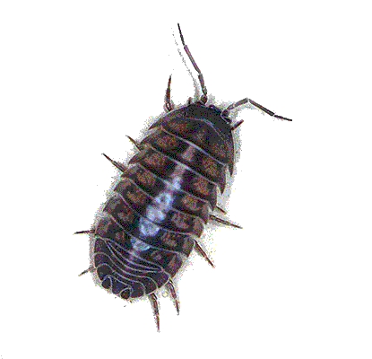
What Environment do Wood Bugs Prefer?

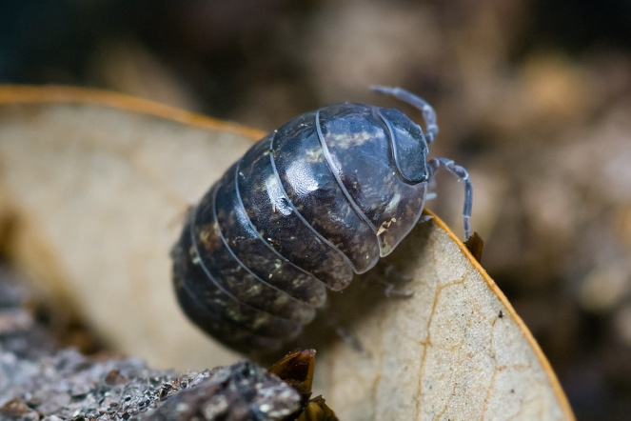
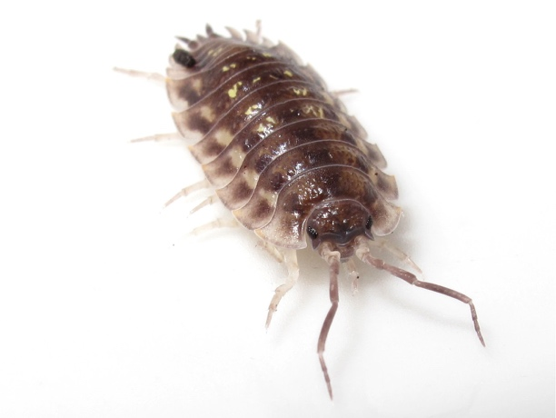
By Hannah, Danielle and Bridget
Wood bugs, or Woodlice, are the terrestrial crustacean that’s sweeping the nation, more commonly know as the pill bug, or roly poly.

“Oniscide”

Block. 2
“Armadillidiidae Vulgare”

Pill Bug (Can roll into a ball)

Sow Bug (Cannot roll into a ball)

Habitat of a Wood Bug

Wood bugs like to live in damp, dark places, preferably under decaying leaves, or logs. They also live in the soil or under rocks. The average life span of a wood bug is 2-5 years.
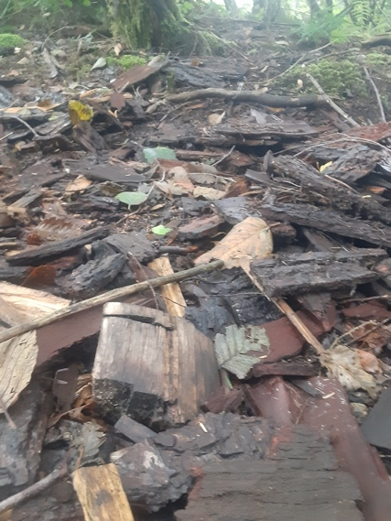
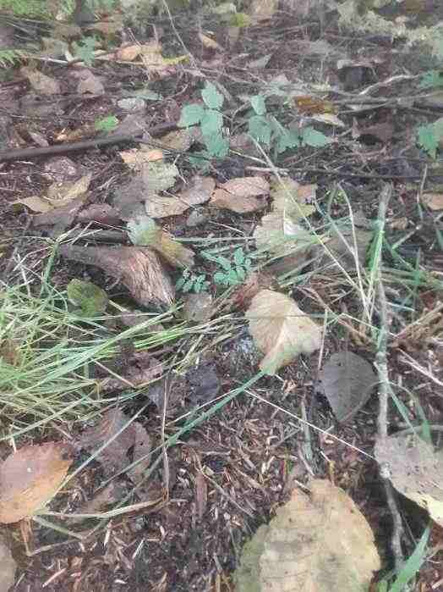
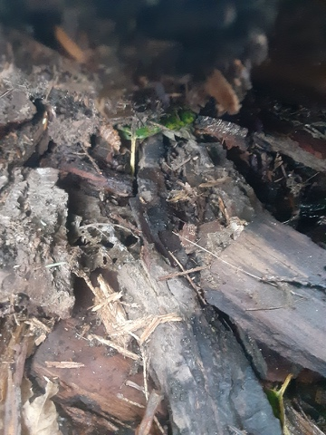
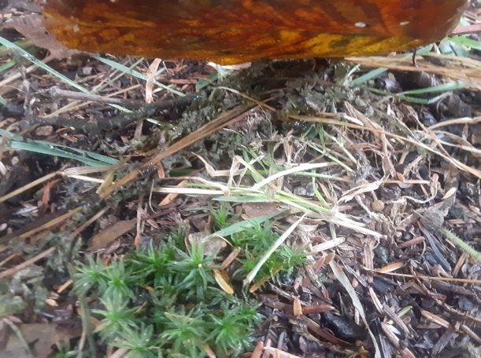
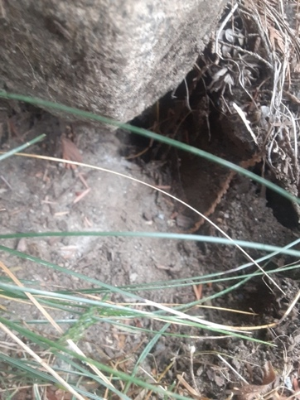

vv

What You Need and What You Need to do
Materials
- Glass milk jug
- Small plastic semitransparent orange pill bottle
- Metal garden pot
- Dirt (mixed with roots and dead cedar needles)
- Gravel
- Moss
- Sticks
- Potatoes
- Dead leaves
- A metal dissection tray
- 11 Wood Bugs
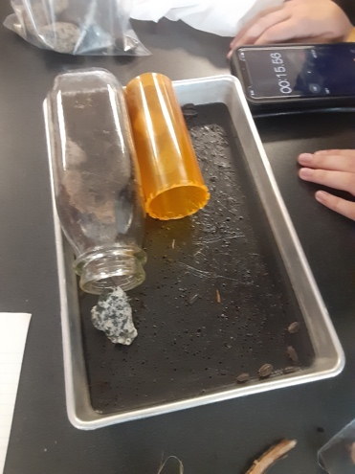
- One container with holes poked in lid
- A Timer
Environment #1 Contained
- Soil
- Whole Mini Potato
- 3 Sticks
- Tin Plant Pot
Environment #2 Contained
- Moss
- Leaves
- Dirt
- Glass Bottle
Environment #3 Contained
- Half a Mini Potato
- A Rock (Piece of Gravel)
- Dirt
- Moss
- A Pill Container

Procedures
- Collect 11 wood bugs
- Put them in container with holes in the lid
- Set up the 3 wood bug environments
- Put the wood bugs in the tray
- Put environments #2 and #3 into the tray
- Start a timer for 5 minutes
- Watch the bugs
- Make observations
- Keep track of how many bugs crawled into each environment
- Once the timer goes off, take out all bugs that have crawled into the environments and put them back on the tray
- Switch environment #3 out with #1
- Start another timer for 5 minutes and repeat steps from #7-#10
- Then take all the environments out of the tray
- Take wood bugs out of the tray and go release them into the wild
- Take all the materials out of the jar and dispose of them accordingly
- Clean tray and put it away

Hypothesis
If you set different environments in front of wood bugs, then not all eleven bugs will go in the habitats.
Data
Data table
 | Environment#1 | Environment #2 | Environment #3
Number of Bugs That Went in | 0 | 1 | 0
Number of Bugs That Didn't Go in | 11 | 10 | 11

Qualitative Observations
- They scuttled around the habitats
- They hid underneath the habitats
- They crawled over each other
- Many of them went under the glass bottle
- Not interested in the rock ramp
- Not interested in the stick ramp
- They stayed close to the edge of the tray
- They tended to bunch up
- The big one tried to get under the glass bottle
- They don’t care about the potato

Quantitative Observations
- 1 out of 11 went into Environment #2
- 4 hid under the glass bottle
- 4 always to be in front of the habitats
- 1 checked out environment #3
- 1 escaped in the beginning (we put it back)
- It took 2 minutes for a wood bug to crawl into Environment #2
- 1 escaped at the end (we put it back, we believe it was the same bug that had escaped before)
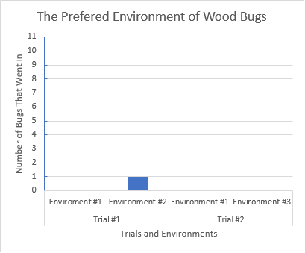

Conclusion
The data collected from the experiment shows that on average 1 of the wood bugs went into environment #2, and 0 went into environments #1 and #3. The data supports our original hypothesis, but it could still be wrong because our data is incomplete. Sources of error we had was that we had a different container for each environment and one of these containers was not wood bug friendly, so they couldn’t climb into it. We did multiple environments, but each had more than one variable in it and we didn’t have a control group. Another source of error would be that if an environment had a potato in it, it was put in different places. This should have counted as its own variable, but it wasn’t. We also didn’t test all the environments against each other, thus causing our data to be incomplete. If we were to do this again we would only do variations of one environment, use the same type of container for each environment, and test all the environments against each other.

