Reading for pleasure: inspiring children to read

Why reading for pleasure is important | Explore Learning
November 30, 2021

Reading is not just something that children should do in school, it needs to be an everyday part of our lives and something we choose to do at all ages! Here’s why reading for pleasure is so important…
Dr Seuss once said, “You can find magic wherever you look. Sit back and relax, all you need is a book.”
We know from talking to many of our parents that often the biggest challenge is not simply getting their child to read at home, but to enjoy reading too! Often children will read a book set at Primary school, but are reluctant to pick up a book to read at home for pleasure. But the question “does your child read for pleasure?” is a phrase that can be surprisingly hard to define.
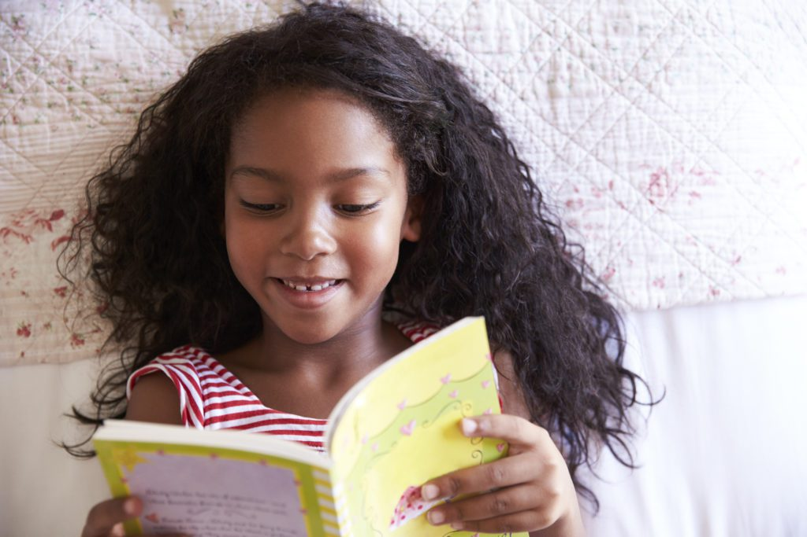
What does reading for pleasure mean?
Reading for pleasure is something that we do of our own free will and get satisfaction from. Sometimes, someone might have originally asked us to read something but we continue because we’re interested in it! According to Nell (1988), reading for pleasure is a form of play that allows us to experience other worlds and roles in our imagination.
For children, reading for pleasure is reading that goes beyond their teacher’s reading expectations and is done to fuel their own curiosity and enjoyment.
Why is it important to read for pleasure?
There are plenty of benefits for those who enjoy curling up with a book. A report carried out for The Reading Agency revealed convincing evidence that reading for pleasure can increase empathy, improve relationships with others, reduce the symptoms of depression and improve wellbeing throughout life.

Reading for pleasure research
Research has also shown that students who choose what and where they read tend to be more motivated, read more and show greater language and literacy development. The study by academics at the Institute of Education, part of the University of London, found that reading had the strongest effect on vocabulary development but the impact on maths and spelling was also significant.
Some key research findings…
- Evidence suggests that there is a positive relationship between reading frequency, reading enjoyment and attainment (Clark 2011; Clark and Douglas 2011).
- Pupils who read more are also better readers (Clark and DeZoya 2011)

Reading for pleasure benefits
Reading for pleasure has also been positively linked with an increase in the following literacy-related benefits for children:
- Reading attainment, phonics and writing ability
- Text comprehension and grammar
- Improved spelling
- Breadth of vocabulary
- Positive reading attitudes
- Greater self-confidence as a reader
- Pleasure reading in later life
- Greater all-round academic success
Despite so many positive links, over recent years there has been a definite decline in children picking up a book outside of school. Some parents fear that the increased access to technology, like tablets and games consoles, has got in the way of children’s traditional love of reading.
However, we can actually use technology to help capture children’s interest in books! Most children see using a tablet as a fun activity and therefore accessing literature in this way can increase their enjoyment and confidence, resulting in a positive impact on their reading.
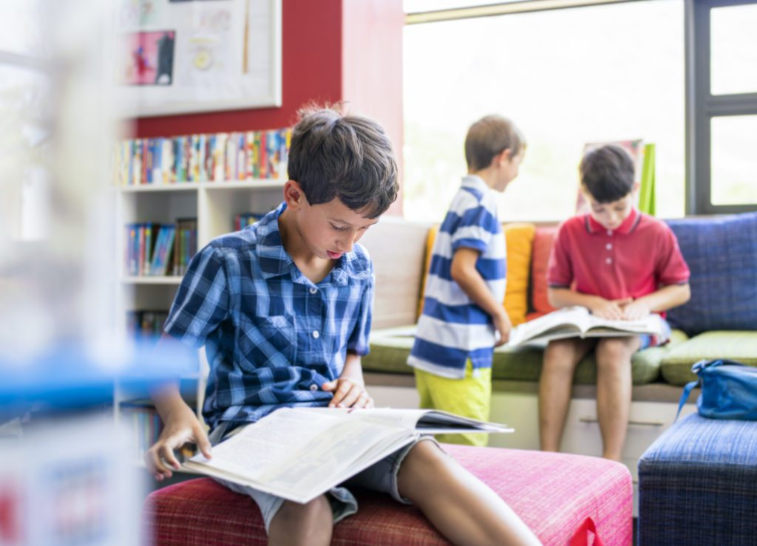

What is the best way to promote reading for pleasure?
The UK literacy school curriculum includes a focus on reading a wide range of texts to encourage reading and discussion. We know that certain elements promote a love of reading, such as freedom to choose reading materials, access to a variety of texts and quiet, comfortable places to read. Reading is not just something that children should do in school – it needs to be an everyday part of our lives and something we choose to do at all ages!

