The Assignment:

Name:
Deaglan Sheriff
(First Name and Last Initial)
Advisory #:___13_______

You will be observing your host throughout the day. There are 3 parts to this assignment:

Part 1- The Interview: Observe your host at work, at some point interview your host and record/make notes of the results
Part 2 - Reflection: After the day is finished, reflect upon your experience and answer the reflection questions Part 3 – Post Your Assignment to Your Blog: Once your have completed Part 1 and Part 2 post it on your blog. Make sure you take pictures and/or videos to document your day, you can place them in your blog.

Name of your host: Erin Derbyshire-Sheriff

Relationship to you: Mom

The Interview: (ask your host these questions)

- What is your job title? ___

Regional Manager, Community Business & Real Estate, Vancity

2. What is your job description?_
Manage a team of 12 account managers/analysts and cash management account managers who support business members.

- What are the duties and/or tasks you perform at your job?

Manage & support team in order to provide loans, mortgages, investments for business members. Loans range from $1,000 to $75,000,000 and investments of various sizes. Also involved with strategic work to decide direction and policies of organization. At Vancity, we are also very involved in supporting the community and thinking about the environment. When we are looking at completing a financing transaction, we think about how the loan will impact the community and how it will impact the environment.

- What qualifications do you have for this job in the following areas:
- training?
Initially completed the relationship account management training program at RBC when started out in commercial lending. Since have done a number of courses over the years on communication, leadership, financial statement analysis and various other things. Always obtaining training every year in different areas.
- education?
Undergraduate degree with a major in economics and minor in business administration . CPA – CGA
- experience?
Prior to completion of university, worked in a number of roles at RBC including teller, cash cage, receptionist, various background duty jobs. Upon completion of university, worked for McDonald’s restaurants in the accounting department for 9 months. After this completed the training program at RBC and then worked in commercial lending for 19 years at both RBC and Vancity. Approx. 4 years ago, became a leader.
_____________________________________________________________________ d) skills and attributes (personal qualities)?_
Communication, understanding of financial statements/math skills, understanding people/personalities, organization skills, time management skills
______________________________________ _ __________________________
- What are some of the things you like about the job?
Learning about different businesses all around the city every day. So many different businesses that I would never know about if I wasn’t in this job. Meeting different people all of the time. Ability to be able to help people meet their financial goals and business goals. Ability to be able to help my staff grow as people and learn every day.

- What are some of the things you dislike about this job? _
Meetings, some days I feel like I am babysitting not working with adults, competing priorities of the job sometimes are hard to balance ______________________________

- How do you anticipate this job changing in the next 5 years or so?

Banking is becoming more and more online. Would expect that the types of transactions that the staff I support are working on will become more complicated with less complicated transactions being completed electronically and little to no staff involvement. Currently Vancity is only in the Lower Mainland and on the Island, could see it covering more of the province.

Other question (s):
______________________________________________________________________________

Student Reflections:
- Give three reasons why you would like this job (be specific):
a) To work with money
b) They are focused on the environment side and the community
c) You can do lots of different things at the company (ie. Marketing, financial literacy, social media, finance, branch positions)
- Give three reasons why you would not like this job (be specific):
a) Too many meetings to sit in all day and listen to other people talk about work. When I was at my mom’s what they were saying made no sense.
b) A lot of things that I would have to learn that I don’t currently know now. (It was like they were talking another language)
c) There are a lot of people that you have to talk to and work with. (Lots of different departments involved and everyone has to be kept informed.)

- Is this job for you? Why or why not?
No, I don’t think that this job is for me because I don’t believe that I can work with all of the stuff that happens at once. I also don’t see myself sitting at a desk all day long or sitting in that many meetings. Another big reason why I wouldn’t like this job is that I would have to talk all day to everyone. Especially to my team. Like phone calls. Almost all the time my parents are on calls with other. Not even just that I will only have such a small room to work and talk in.

- Explain the value of the TYKTW experience in relation to your ideas about your post secondary (after high school) plans (education?, training?, travel?, work?).
I don’t believe that I have any more plans than I did before going to my mom’s work (Vancity) about college/university and my career. Other than I don’t think I want to be in a job that I have to sit at a desk for a lot of the day. So after going to her work and listening and doing everything they did changed my mind about working. I also know that I don’t want to talk as much as my mom has to throughout the day.

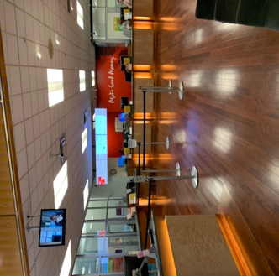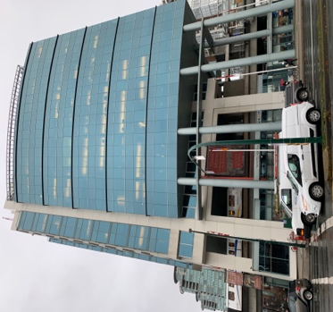

Blog Post:
Step 1: Go to your Blog Step 2: Create a new POST
- Title: Take Your Kid To Work Day 2018
- Category: Extracurricular
- Tag: This varies by teacher:
    - Aitken - TYKTW2019A
    - Castonguay – TYKTW2019C
    - Raghoobarsingh – TYKTW2019R
    - Hewitt – TYKTW2019H
- Add Media: Add a picture or video of your work place Step 3: Add your assignment to the post by doing one of the following
- Copy and paste the assignment from a word document
- Type in all of the questions and answers
- Upload a PDF or a completed Word Document
Step 4: Click Publish

