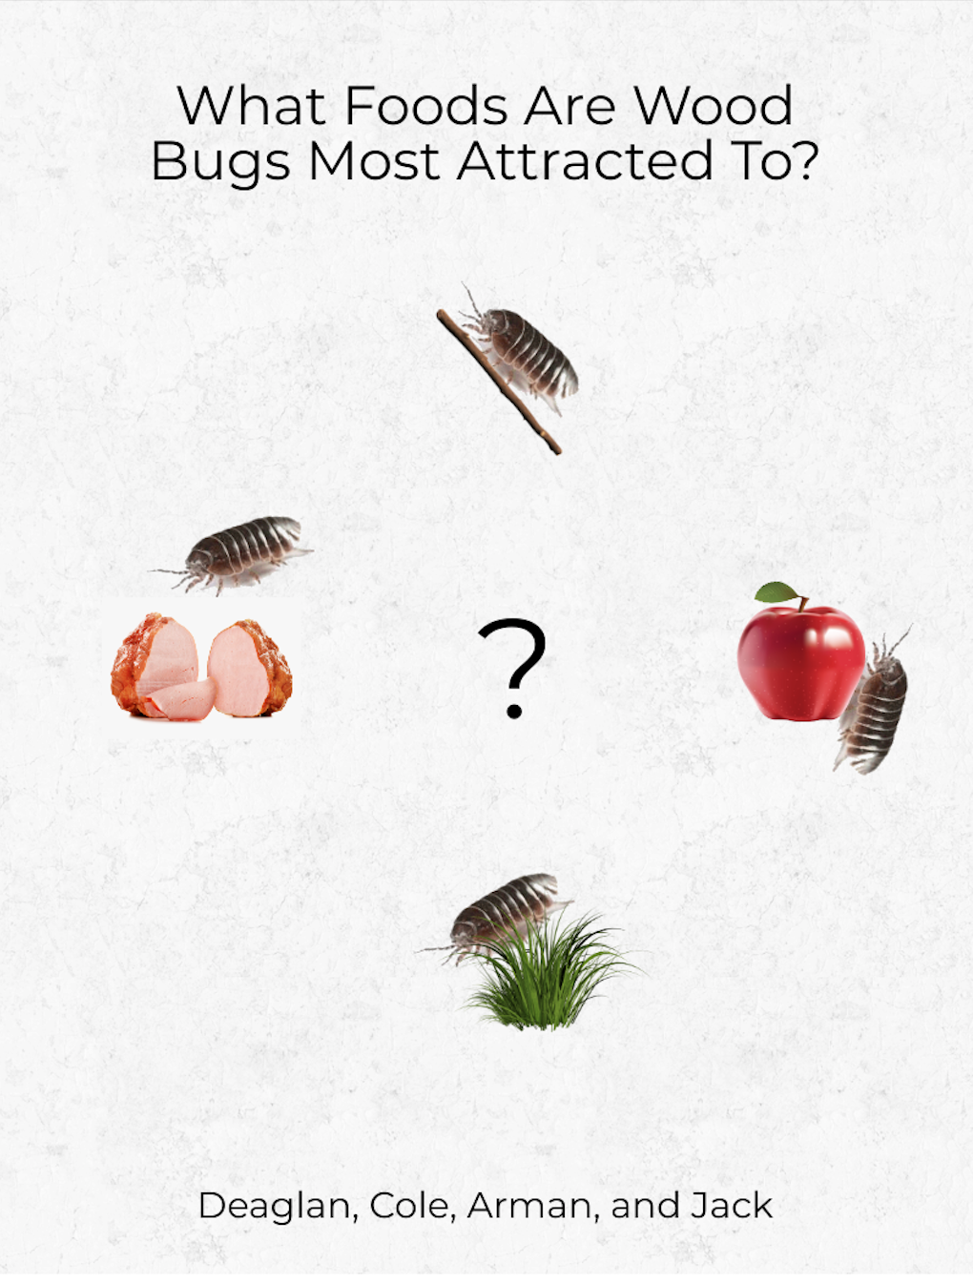

Habitat

If you have any questions regarding the wood bugs, let us explain. Scientifically known as the Armadillidium Vulgare, the wood bug is an isopod, meaning that it is a crustacean. During the day, you will typically find wood bugs in or buried under soil or debris. Their preferred soil habitat is composed of organic matter. Wood bugs prefer to live in dark and humid areas such as under fallen leaves, log or rock. Wood bugs mainly feed on decaying plant leaves, and other decomposing materials. A study in 2008 showed that the foraging of wood bugs (searching for food) had a positive impact on the environment. Shown by increased mineral layer nutrients and higher amounts of carbon removed from fallen leaves.

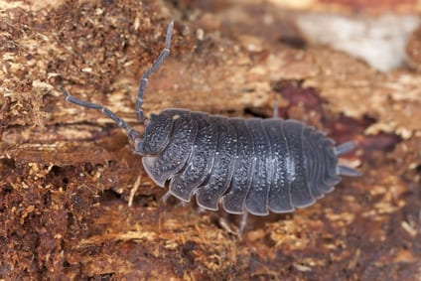

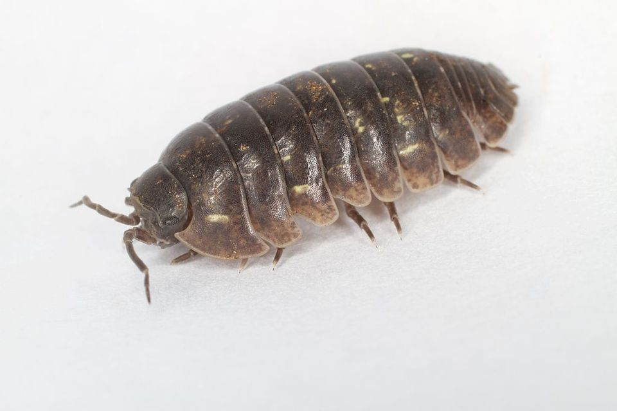

Hypothesis

If we place a wood bug within a tray, then they will be able to differentiate what they are more attracted to and will go towards it at a quicker speed.

Procedure

Step 1 – Formed a question
Step 2 – Created a hypothesis
Step 3 – Thought of an experiment
Step 4 – Gathered the materials that needed in order to complete experiment
Step 5 – Undergo the experiment
Step 6 – Record times
Step 7 – Identified the quantitative and qualitative aspects
Step 8 – Created a graph / data table
Step 9 – Wrote a conclusion

Materials Needed For The Experiment

- Meat
- Grass
- Fruit
- Stick
- Tray
- Wood bugs

Quantitative Data

  - The times decreased each attempt *except for the sticks*
  - The average time across all first attempts was 14.39 *quite high compared to the average time*

Qualitative Data

  - The wood bugs progressively went to the item faster
  - Sticks were their favourite item
  - They disliked grass the least
  - Sticks were consistent low times

Data Table

Materials | Round 1 | Round 2 | Round 3
Grass | 17.80 | 16.76 | 14.01
Sticks | 11.05 | 13.22 | 12.52
Apple | 17.26 | 13.25 | 11.48
Ham | 16.07 | 12.09 | 11.45

Graph:

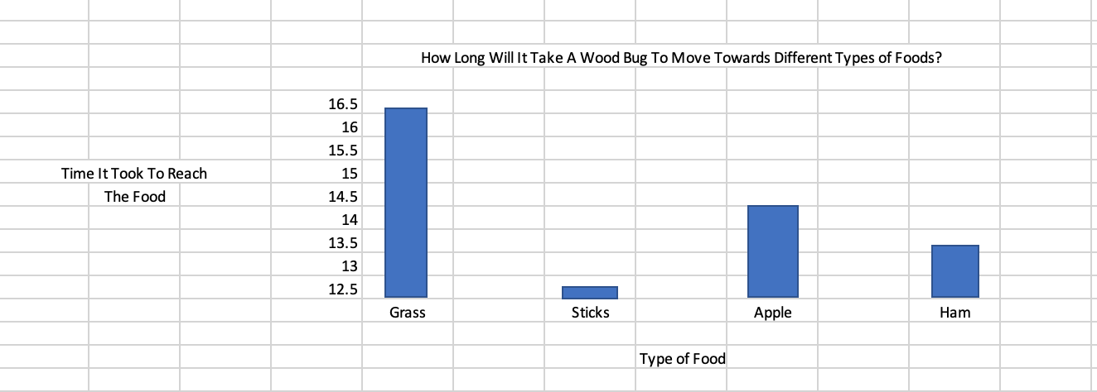

Conclusion

In conclusion, we believe that our hypothesis supported our results. Through having wood bugs repeat four different tasks, three times each taught them not only to better understand their goals, but to familiarize and adapt themselves to new surroundings. This was not the only skill they used however, the wood bugs were able to differentiate which foods they were more attracted to, causing them to progress towards their favourite foods, and to eat them as well.

Citations

- Beck ML, Price JO. 1985. Genetic variation and differentiation in Armadillidium vulgare (Isopoda: Oniscoidea). Genetica 66: 169-171.
- Capinera JL. 2001. Handbook of vegetable pests. Academic Press, San Diego.
- Frouz J, Lobinske R, Kalcik J, Ali A. 2008. Effects of the exotic crustacean, Armadillidium vulgare (Isopoda), and other macrofauna on organic matter dynamics in soil microcosms in a hardwood forest in central Florida. Florida Entomological Society 91: 328-331.
- Howard HW. 1980. The distribution at breeding time of the sexes of the woodlouse, Armadillidium vulgare (Latreille, 1802) (Isopoda). Crustaceana 39: 52-58.
- Koehler PG, Pereira RM, Allen RA. 2012. Pillbugs, sowbugs, centipedes, millipedes and earwigs. UF/IFAS. ENY-221. (10 August 2015).
- McDaniel EI. 1931. Insect and allied pests of plants grown under glass. Michigan Agricultural Experiment Station Special Bulletin No. 214.
- McDaniel, E. I. 1924. Greenhouse insects. Michigan Agricultural Experiment Station Special Bulletin 134: 52.
- University of California Integrated Pest Management Online. 2013. Managing pests in gardens: Fruit: Invertebrates: Sowbugs and pillbugs UC IPM. (10 August 2015).
- Ziegler A, Suzuki S. 2011. Sperm storage, sperm translocation and genitalia formation in females of the terrestrial isopod Armadillidium vulgare (Crustacea, Peracarida, Isopoda). Arthropod Structure and Development 40: 64-76.
- Pest Control, Westside. “Westsidepestcontrol.com” Westsidepestcontrol.com,
westsidepestcontrol.com/sow-bug-removal/.

