I Am Number Four
Synopsis:  I am number 4 brief summary:  I am number four was just like any other teenager. He went to his local high school which was called “Paradise High School”. But there is a twist from him to me. He was being chased by enemies that were sent to try and kill him and 8 others. After numbers One, Two and Three had all died number four was next. All he must do is hide and not be seen or he will die. When getting chased secretly Number Four and Henri would travel town to town. When in Paradise, Ohio which is what he calls home Many different life changing events happen. | Setting/Author:  Where:  The book I am number four was taken place in a town called Paradise, Ohio. During this book the location changed throughout. In the beginning and middle it was in the house in Paradise and in the end the setting was the school.  Who:  The book I am number four was written by Pittacus Lore. Pittacus Lore was born on July 9th, 1980. He is now 34 years old. This great author as written many other books like, The Power of Six, The Rise of Nine and many more. I am number four in 2010 spent 5 weeks on The New York Times best seller in the children's category.  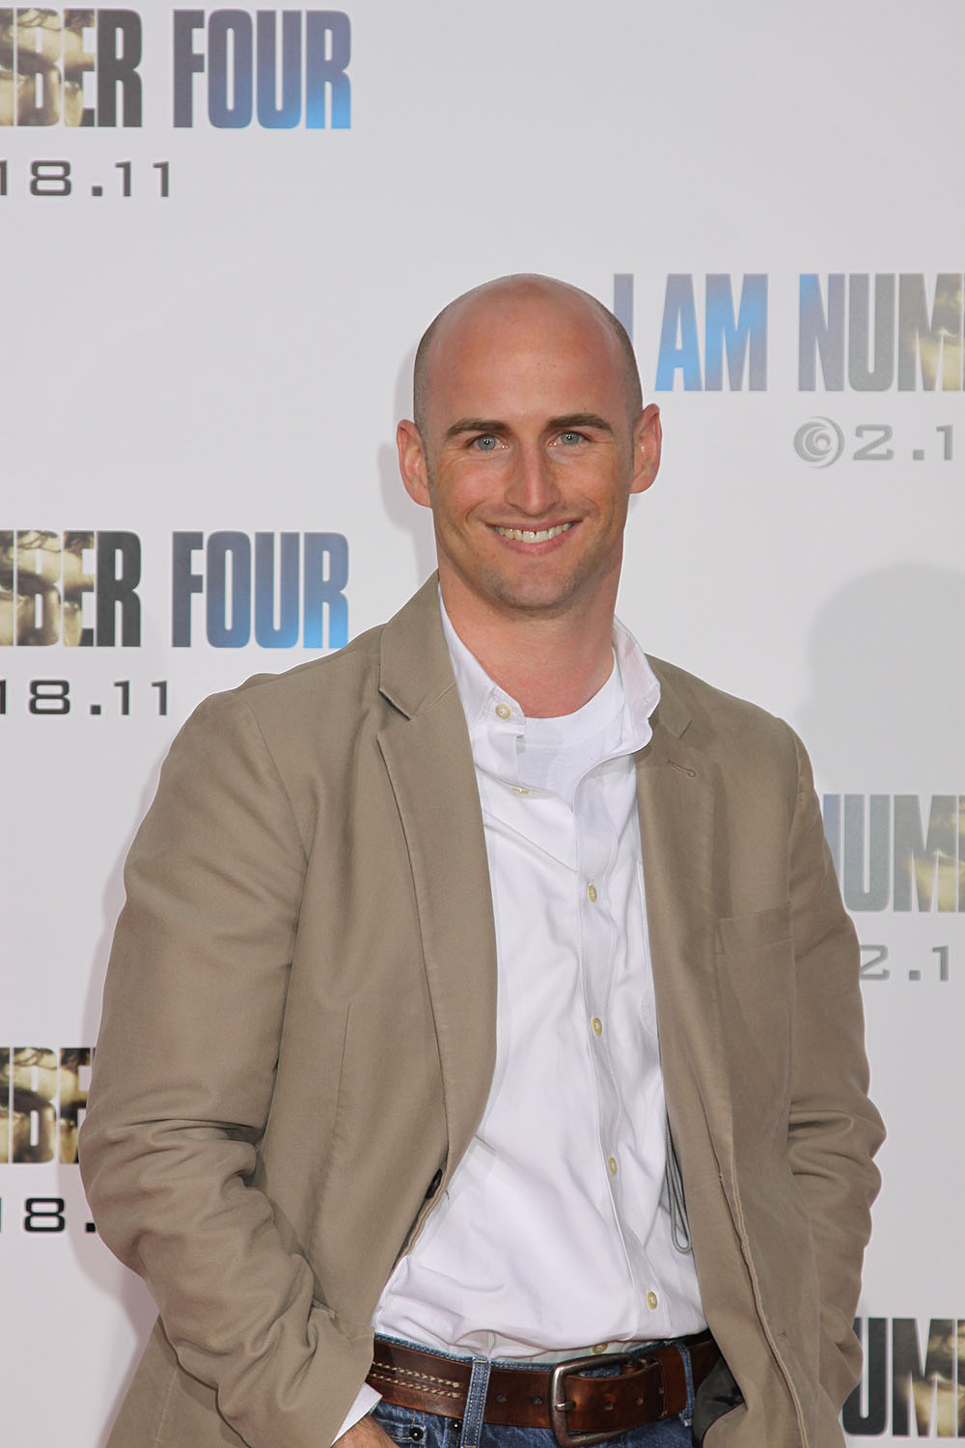 | Characters:  Antagonist:  In the story the Antagonist was Setrakus Ra. He was the antagonist because he was the “bad guy” of the story by trying to kill everyone.  Protagonist:  Number four (John Smith) because he is the lead character in the story. His name is mentioned all the time because he was the next to die after number 3.  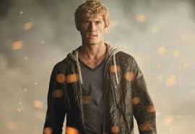  Other Important:  Henri: Was like a father to number four.  Sarah Hart: Sarah was in the same school as number four in Ohio.

Significant Events:  - When Number Three died because number four would be next. This put pressure on him and changed his life.  - When john meets Sarah and become boyfriend and girlfriend. At this point Sarah didn’t know all about Johns background but John shared all of it with her.  - When fighting the Mogadorians Henri died. While Number Four and Sarah killed the rest of them. Unfortunately, they wasted all their powers while killing them. | Things I liked:  In this book I really like a few things about it. One of the big things that I enjoyed most about this book was how there was so much action throughout the whole book. I am not a big reader, but this book kept me wanting to read more and more.  Another big thing I like about this book is that there is a movie. I know that this doesn't have much to do with the book but when I read a book, I like to watch the movie as well. I like this because sometimes the book and the movie are not the same so it's nice to see two different perspectives. | Create A Cover Page: