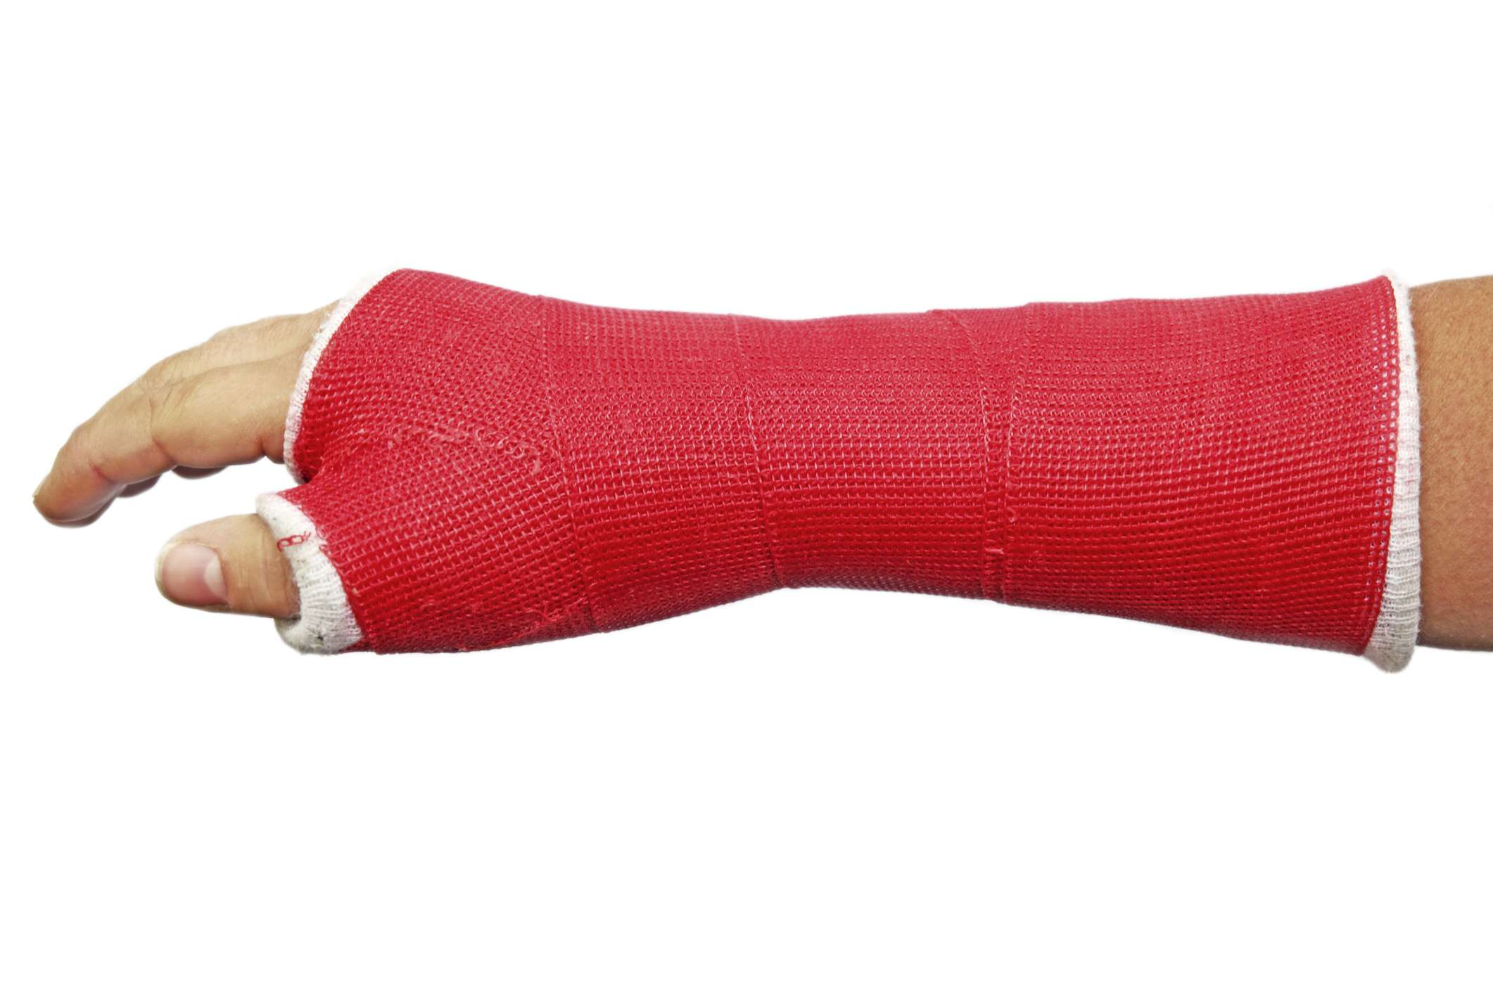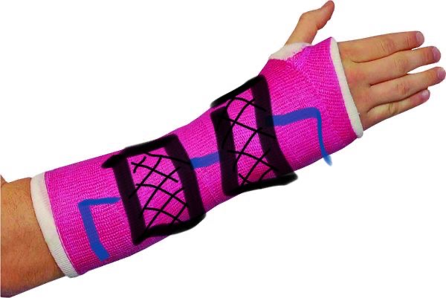

🙞 🙜

The new and improved cast with so many features!

Our cast feels just like a regular cast, but with many more features to make our consumers comfortable!

* Therapeutic
* Cooling and heating system built inside (thermometer)
* Feels just like a regular cast
* No discomfort (adjustable)
* Medical practitioners will soon use this product instead of regular casts to give more comfort to clients
* We expect clients to have much more comfort with this product and begin to use these more than regular casts

# Who would use it?

Temperature Therapeutic Cast

### By:

### Deborah, Mina, and Ava

## Features:

We wanted to make a product that would help people and impact their lives greatly. We thought making a product like this would help people be more comfortable and that this would give them a little more flexibility when injured.

* Therapeutic (includes cold and hot materials which are scientifically proven to be healing to the affected hear.)
* Temperature adjusting (built in thermometer and buttons to regulate the temperature to the desired liking. It uses flexible solar panels for generating heat, and cooling pads to produce colder temperature.)
* Provides comfort with the temperature and therapeutic materials (you are able to change the settings to your liking.)
* Eco-friendly (uses flexible solar panels and other eco-friendly materials.)
* Reusable

# Why is our product the way to go?

## Why we chose this?