Dominic and Kyle
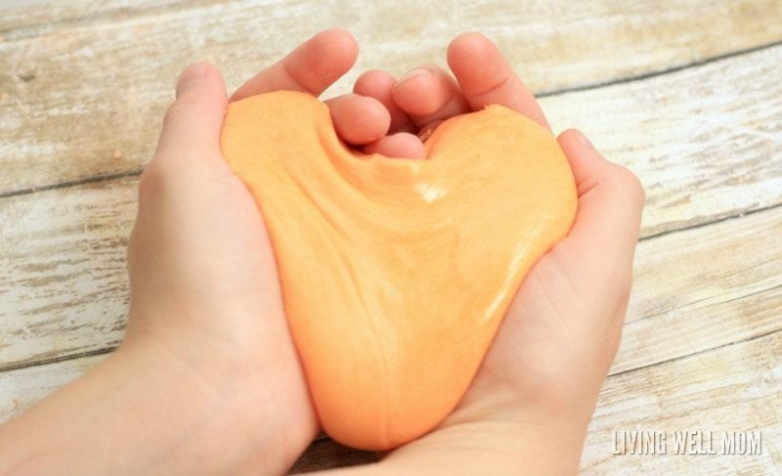
Trying to find out if silly putty will bounce higher if there is less water added
1. Variables, the manipulated variable in the experiment is going to be the water. We will add half the amount of water we used last time. The responding variable will be the bounces of the putty. Lastly the controlled variable will be all the of the other ingredients like the glue and borax.
2. Hypothesis, if less water is put into the putty then the bounciness of the putty will increase.
3. Materials
- Water
- White liquid glue
- Borax
- Stirring rod
- Small measure mixing cup
- Large measure mixing cup
- Ruler
4. Procedure, step 1: first you must add 10ml water to 20ml glue inside the large mixing cup. Step 2: then you stir, set aside. Step 3: add 20ml water to 2g Borax in the small mixing cup, step 4, sir set aside. Step 5 add the Borax with water to the glue and water. Step six: stir well, step 7. roll into puddy shape.
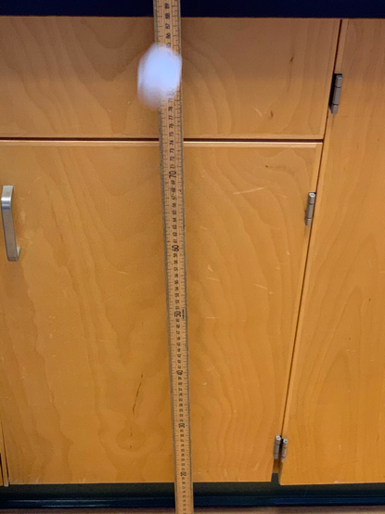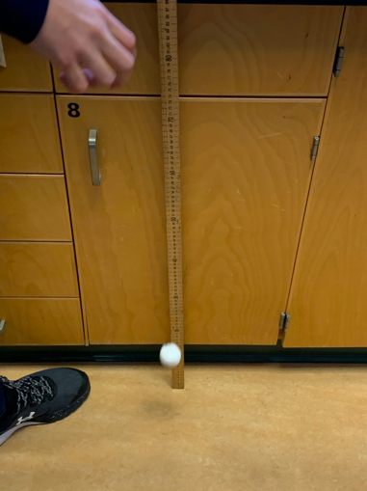
5. Quantitative data
How high it bounces cm | Original putty | Putty with less water
 | 20 cm | 29cm
 | 22 cm | 31cm
 | 21 cm | 32cm
 | 23 cm | 34cm
 | 24 cm | 37cm
 | 19 cm | 33 cm

6. Qualitative data, the silly putty with less water was a lot harder and bouncier then the original silly puddy. The one with less water felt more like a rubber ball then silly puddy. The one with less water did look like it bounced a lot higher than the original putty.
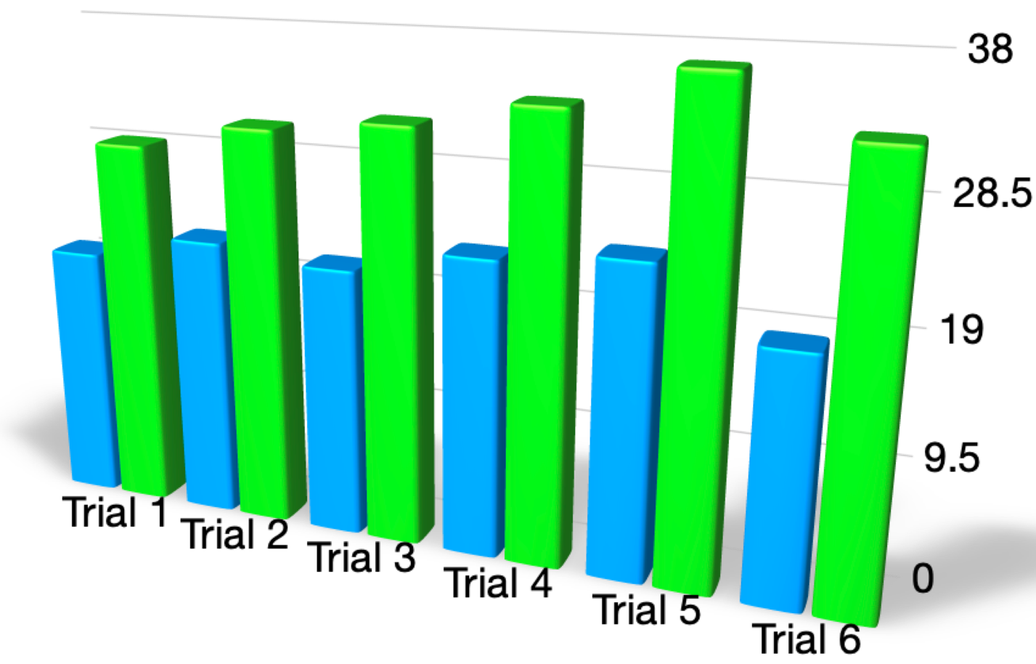
A bar graph to show how the bounce of silly putty will change depending on how much water is added
Hight it bounced in cm
green is the silly putty with less water and blue is the original.

* All the silly putty was dropped from a height of 1 meter.
7. Conclusion, the data that we received supported our hypotheses. The Data shows that with the changes we made, the bounciness increased greatly, while the original was lacking bounciness. Something that could have made it bouncier was if we used no water with the glue soliton at all however that might have made it feel more like a bounce ball.

