Ellie September 19, 2019

Goose Bay:

Climate-
Goose Bay is a maritime climate. This means that the winters are snowy and cool and the summers are a pleasant temperature but wet. It has cool summers with the maximum temperature being about 21 degrees. The lowest temperature is about -22 degrees though. In Goose bay it tends to rain the most in July, with an average of 111.8 millimetres of rain. Even though it rains more in July it is still part of the warmer seasons which include June to September. The cooler seasons are December to March.
Regions-
Goose Bay is in Newfoundland and Labrador, one of the provinces that have a maritime climate and are off the coast of the Atlantic Ocean.
Population:
Goose Bay’s population is 8, 109 people. This means that it is in the top ten list of biggest cities in Newfoundland and Labrador.
Transportation:
Goose Bay was an Airforce base in the second world war, because of this Goose Bay is now the transportation hub of Labrador. During the war Goose bay had one of the busiest airports in the world. Now Goose Bay is capable of servicing one of the worlds biggest aircrafts.
Economic activities:
Goose Bay’s main Economic activitie is Forestry. Goose bay also has fishing and farming profit. In the summer and fall Goose Bay is great for hiking, fishing and canoeing.
Cultural Life-
Goose Bay has many events to show off their art and culture.
Other/interest:
Goose Bay got it’s name because the first setters came to Goose Bay to build the “Goose Bay Airforce base” and it got it’s name because of that base.
Landscape/cityscape:
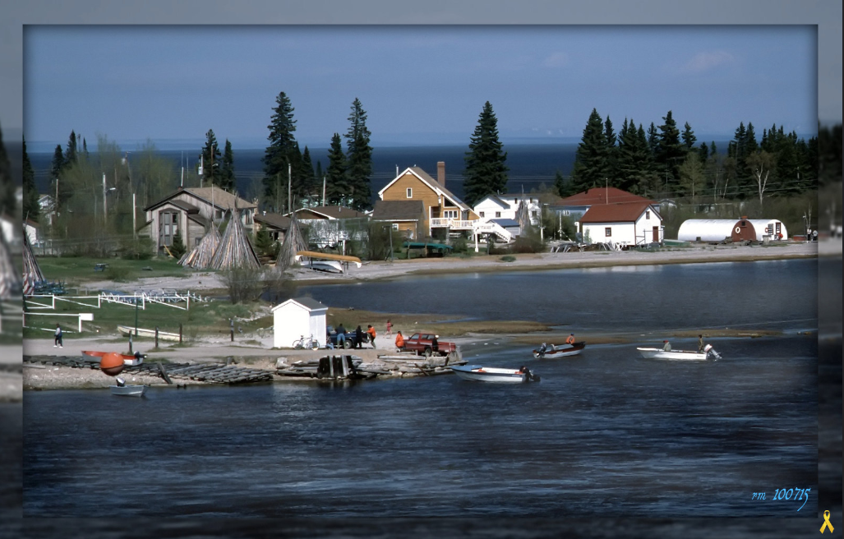

Province:
Goose bay is in Newfoundland and Labrador but mostly Labrador. These are the exact Coordinates 53.3017° N, 60.3261° W.
Housing costs-
Goose Bay’s official website states that:
- 1 bedroom $750 – $800/month
- 2 bedroom $1,000 – $1,100/month
- 3 bedroom $1,200 – $1,500/month
- Full house rental – $1,800 – $2,000/month
That these are the expected average costs of houses in Goose Bay.

Crime rate-
Goose Bay has the 6th highest Crime rate against women in Canada. Journalists have found that small cities crime rate has gotten so much worse. So Goose Bay has lots of crime.

