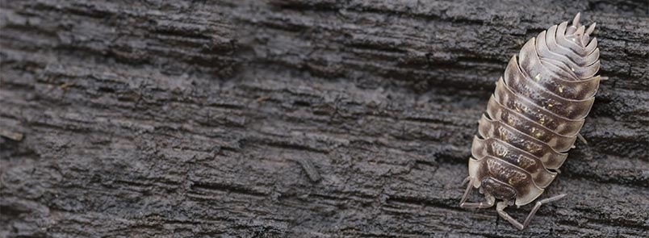

Wood Bug Experiment
By Sara, Bella, Emily and Emma

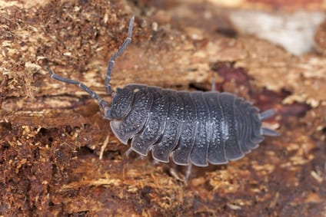

Habitat

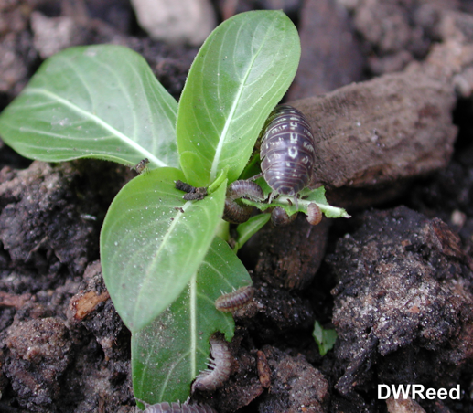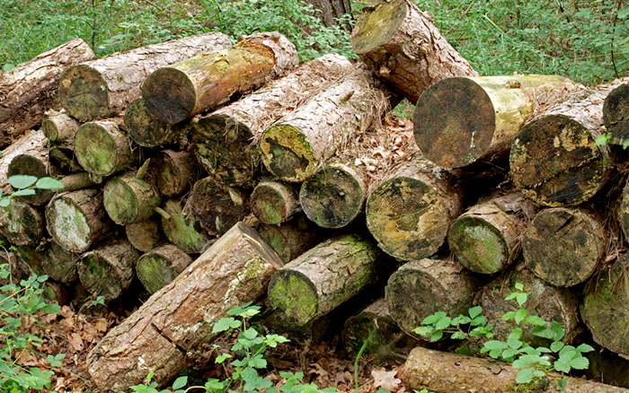

Wood bugs, also called pill bugs. They live in dark and moist places, such as under rocks, logs, outdoor potted plants or leaves. They like living in damp environments, where they feed on decaying vegetables. Wood bugs generally eat leaves, decaying wood and other vegetations. Since they require a moist environment for them to live, they don’t survive indoors for more than a few days unless it is under moist or humid conditions.

Hypothesis: If the wood bugs are motivated, then they will cross the line faster than the wood bugs
who aren’t.

Materials:
- Food (potato)
- Wood Bugs
- Tape
- Dish with high rim
- Tweezers

Procedure:
- Find a dish with a high rim
- Tape the finish line on the end of the dish
- Tape the finish line of the other dish and add food behind it
- Set a timer
- Add wood bugs to the other end of both dishes
- Time the two groups of wood bugs until they cross the line
- Repeat experiment multiple times
- Compare the data
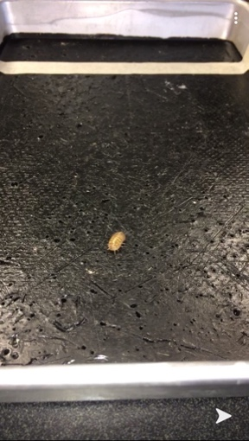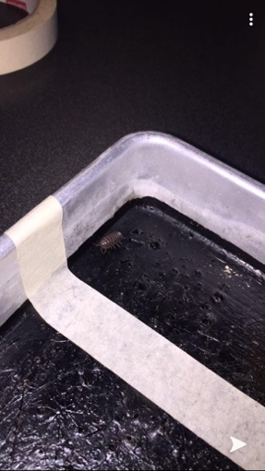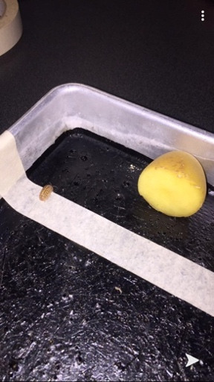

Data Table:
Trials | Potato | No-Potato
1st Run | 1:03 minutes | 54.6 seconds
2nd Run | 50.8 seconds | 1:62 minutes
3rd Run | 53 seconds | 1:38 minutes
Overall Average | 55.6 seconds | 1:32 minutes

Qualitive Observations: The bugs are faster when they have food at the finish line. They also often
followed the “leader” to the other side.

Graph:

A bar graph to show how potato affects the speed of the wood bugs
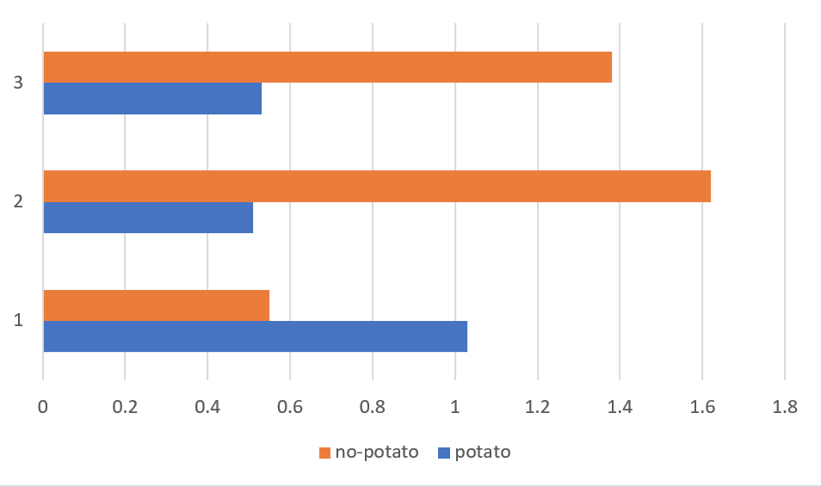

Conclusion: The data collected from the experiment shows the hypothesis was correct. We ran the test
three times without food and three times with half a potato. The runs with the potato were
on average 37 seconds faster than the runs without the potato.

