Creative Thinking

When my mind is closed
And thoughts are not coming
I take a breath
And will that fog away
In that moment
I calm and concentrate

Sometimes just writing it down
Helps me focus my thoughts
Or even just speaking aloud
When that doesn’t work
I get creative

Sometimes a run
Or a game of soccer
Maybe a book
To make me distracted
But in the end
The outcomes the same
I get a fresh new idea

It doesn’t end there,
Maybe a poem
Or a new fun dance
Anything to get my brain
Ready and in the game

Whatever the idea
Whether small or large
Are always fun to come by
In the end
I just want to push myself
That’s all there is to it

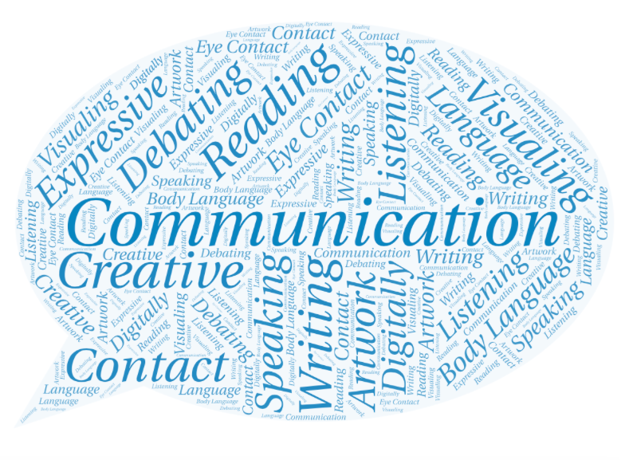Critical and Reflective
Thinking
Check with Multiple Sources
Watch Body Language and Facial Expressions
What advice would you give a younger student about figuring out what is true?

- Check with multiple people and/or websites to see if info is accurate
- Make sure all info is up to date
- Check whether the sources are reliable
- Watch their eyes; including blinking and whether they’ll make eye contact with you
- A change in their voice
- How they are standing
- Pay attention to any unusual movement

Pay Attention to Details
- Watch what they are saying
- Consider their body language
- Check the sources they use (citations)
- Check the author and design of websites

- Make sure the source is reliable
- See who the article was published by
- Watch out for the wording of what they are saying and/or writing
Look for Bias

