Digital Literacy 10 Mr. Aitken and Mr. Castonguay
Completing the About Me and Digital Footprint Assignment

Now that you have selected your theme, customized your blog, and added the relevant plugins you are now ready to begin to start adding content to your blog. Your first two assignments are intended to further familiarize you with posting and adding content to your blog in addition to making you aware of what it means to be a positive digital citizen and the impact that this can have on your future opportunities.

The About Me Assignment:
This is the assignment that will introduce you to the world. You are going to be writing about yourself (something that is never easy) and some of your favorite interests. All of the content that will be included below needs to be put on to your ‘ABOUT ME’ PAGE. Posts will not be accepted as completed assignments.
Start by going to your dashboard and clicking on the pages button. This will bring up all of the pages on your blog.
Click on the Pages button on your Dashboard – this will bring up all of your Pages.
You can now select the ‘About Me’ Page and begin editing it and adding the content that you need to in order to complete your first assignment.
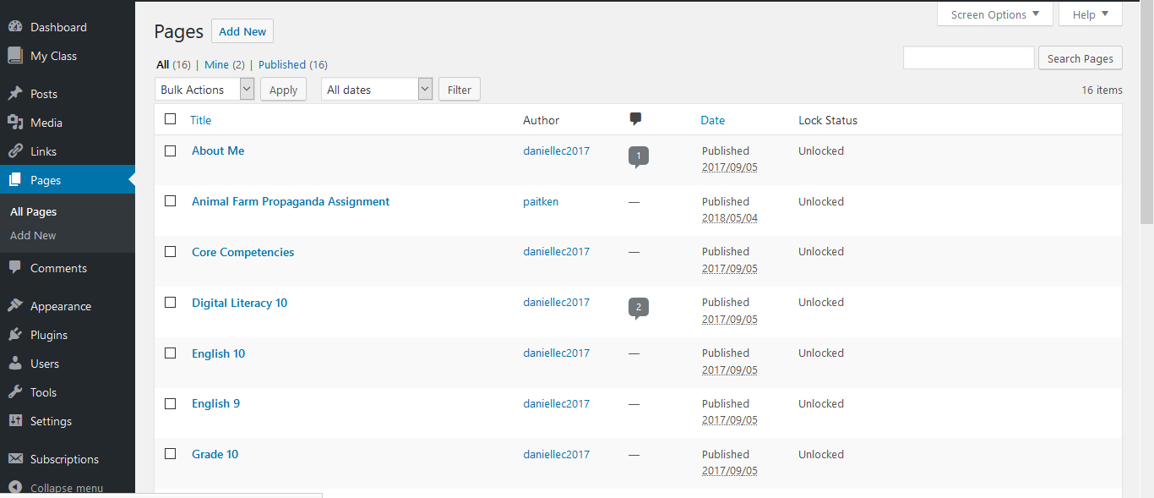
In order to complete the about me assignment you will need to start by writing a brief paragraph about yourself, your interests etc. It is important to remember that you should not use your full name or any specific details about yourself. This is just a brief, introductory paragraph for anyone who reads your blog.
Following your introductory paragraph you need to include the following items along with explanations about why you selected that particular item.
Favorite Video: Adding this video to your blog (from YouTube) will demonstrate the way in which you are able to embed content from the internet into your blog. You will need to start by selecting the ‘Add Media’ button in your editing panel.
This will bring up a dialogue box similar to the one below. You will then need to select the ‘Insert Embed Code’ option from the menu on the left hand side and paste your embed code from YouTube into the text box.
Select the Insert Embed Code option from the list on the far left.

Paste your Embed Code (From YouTube or any other source on the Web) into the text box.

Select Insert Into Post in order to embed the content into your blog.
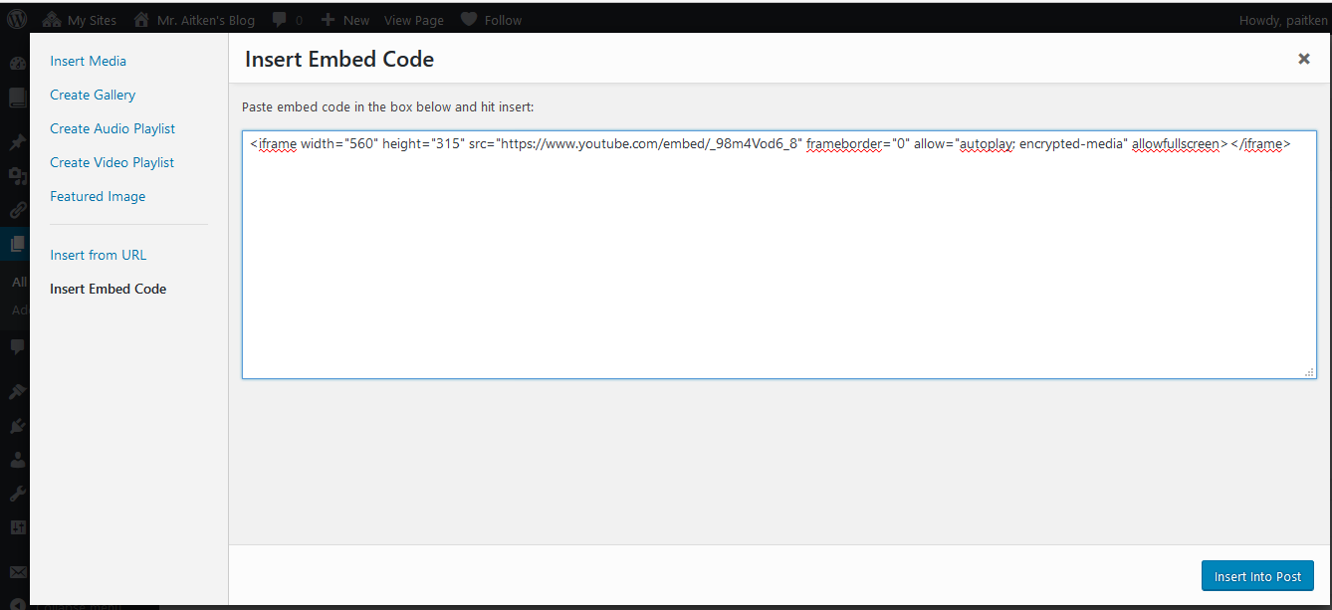
Now that the video is embeded into your blog don’t forget to explain why you like this video in a short (at least four sentences) paragraph.
Favorite Website: Adding a link to your favorite website will show you how to link to other pages on your blog. This is useful when you are doing research or writing about a particular topic – you can then direct people to the source of your information or to allow them to do further reading/research on the topic.

To insert a link you need to ensure that you have copied the URL from the address bar of the site that you would like to link to.
Once you have copied the URL from your favourite website you can paste it into your blog.
To make that text into a link you need to click on the button that is a looks like a chain-link in your toolbar.

This will open a dialogue box – ensure that the URL is again pasted into the link – you can link to any text – your text does not necessarily have to be the URL itself.
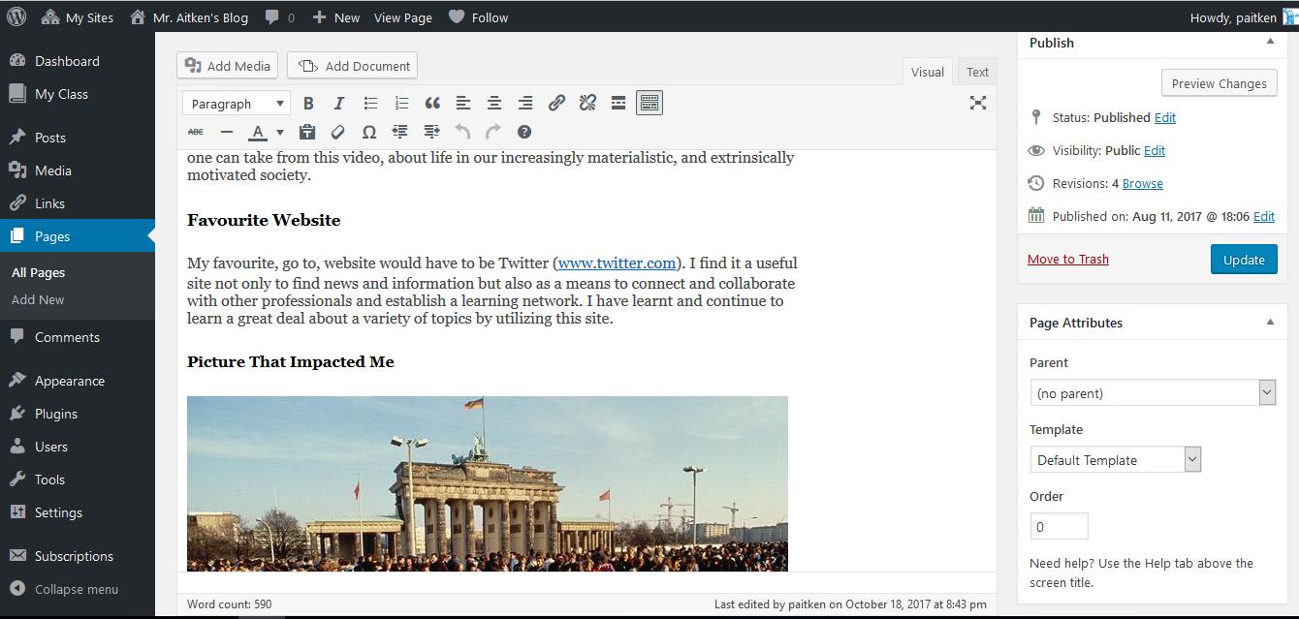

Once you have linked the URL in your blog it should be displayed in blue. You are now ready to write a brief reflection on why this is your favorite website. Once that is done you can move on to adding your favorite image.

Favorite Image: By learning how to insert an image you will learn how to both upload files to your blog as well as be able to properly cite a source. To upload an image you will need to start by selecting the ‘Add Media’ button in the editing screen. In the menu on the left side of the page you will need to click on the Insert Media button. Which will bring you to your Media Library as in the image below.
You will need to upload the media that you would like to insert into your page. Click on the ‘Upload Files’ button and then follow the steps to select the file on your computer that you would like to upload. You will need to have the file on your computer (this may mean that you download the image from the internet). Once your file is uploaded to your media library you can select the insert into page option to finish adding the picture to your ‘About Me’ page
Select the Insert Media Button from the menu on the left hand side of the screen.

Upload your files from your computer to your Media Library. Once they are in your media library you are free to use them as many times as you like.
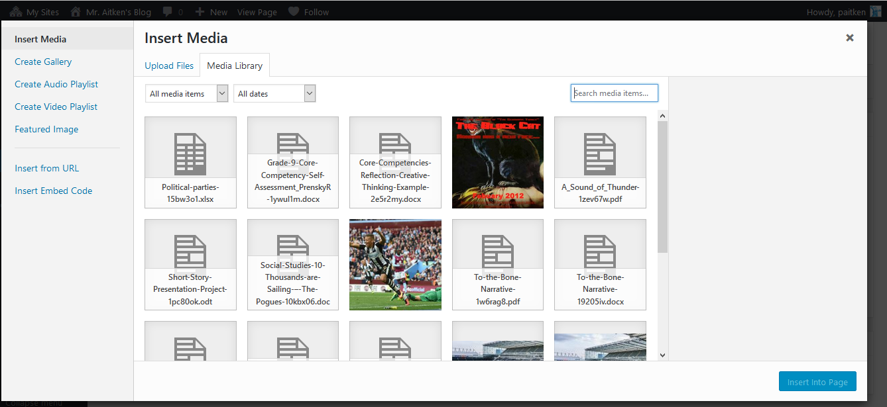
You will then need to add a short reflection about why this picture is important to you or why it shows an event that is meaningful to you. You are strongly discouraged from posting personal pictures with images of yourself, friends or family. You should look to add content of events, places etc. that are meaningful to you.
Citation: You need to ensure that you have an appropriate citation for the picture that you chose. The picture is someone else’s work (unless it is a picture that you, yourself took – although even then you should note that it is your personal image) and they need to be given credit for that. Below is the proper format for an image citation in MLA format. You should look to fill in as much information as possible related to the image that you used.
Creator’s Last name, First name. “Title of the digital image.” Title of the website, First name Last name of any contributors, Version (if applicable), Number (if applicable), Publisher, Publication date, URL

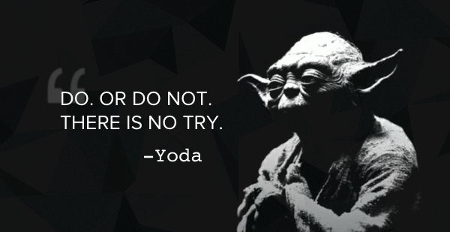
Favorite Quote: There is no motive for having you add your favorite quote except to have you think of something that is both memorable and meaningful to you. These should be words of wisdom that you live by and can encompass your values and even your personal identity as you move forward this year and throughout your time at Heritage Woods.
Your quote does not have to be an image.
After you have added all of this content you have now completed your About Me Assignment. Be sure to update your page (the blue button on the right side of the screen) to ensure that your work is saved and published to the web.
When you have completed your ‘About Me’ assignment you are ready to move on to complete your Digital Footprint Assignment.

