Digital Literacy 10 Mr. Aitken and Mr. Castonguay
Digital Literacy Bootcamp Basics
Adding Content to Your Blog

Office 365 Content
Adding Word, Excel and PowerPoint Documents

The majority of the content that you add to your blog is probably going to come from products in the Microsoft Office Suite (Office 365). Adding Word, PowerPoint and Excel Documents are one of the things that you will end up doing quite frequently in your classes. The steps below will guide you in adding the documents to your blog correctly so that they display properly on the screen.

- Make sure that your document is saved onto your computer. You will need to upload your document to the site when you have completed the steps below.
- Open the dashboard of your blog and look for the plugins tab on the left hand side. Click on the Plugins tab.
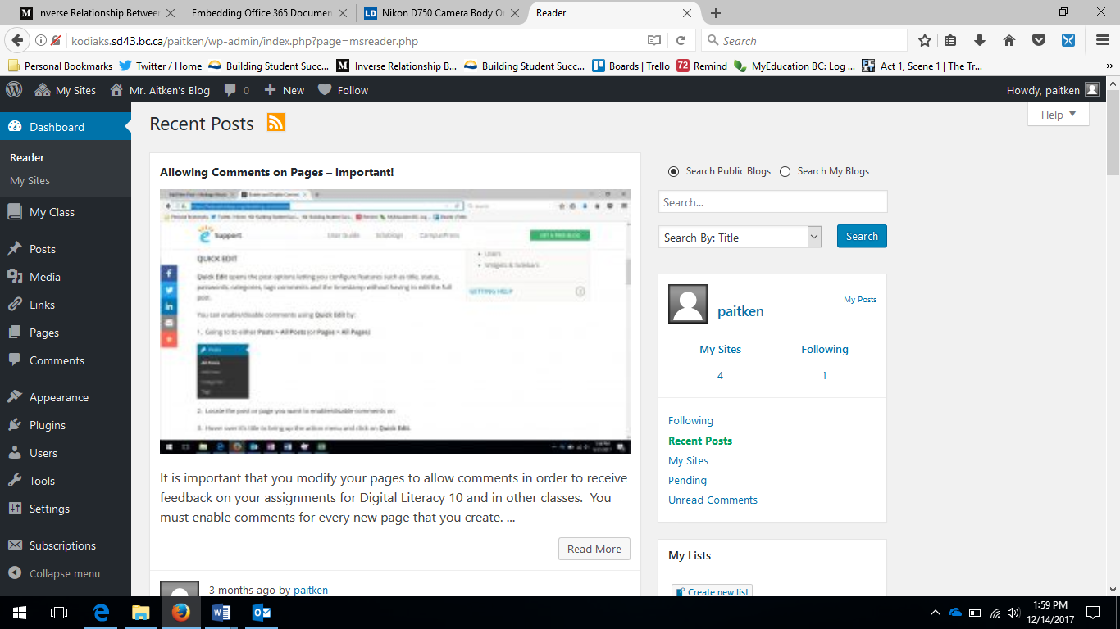
Click on the Plugins Tab on the left hand side of your page.

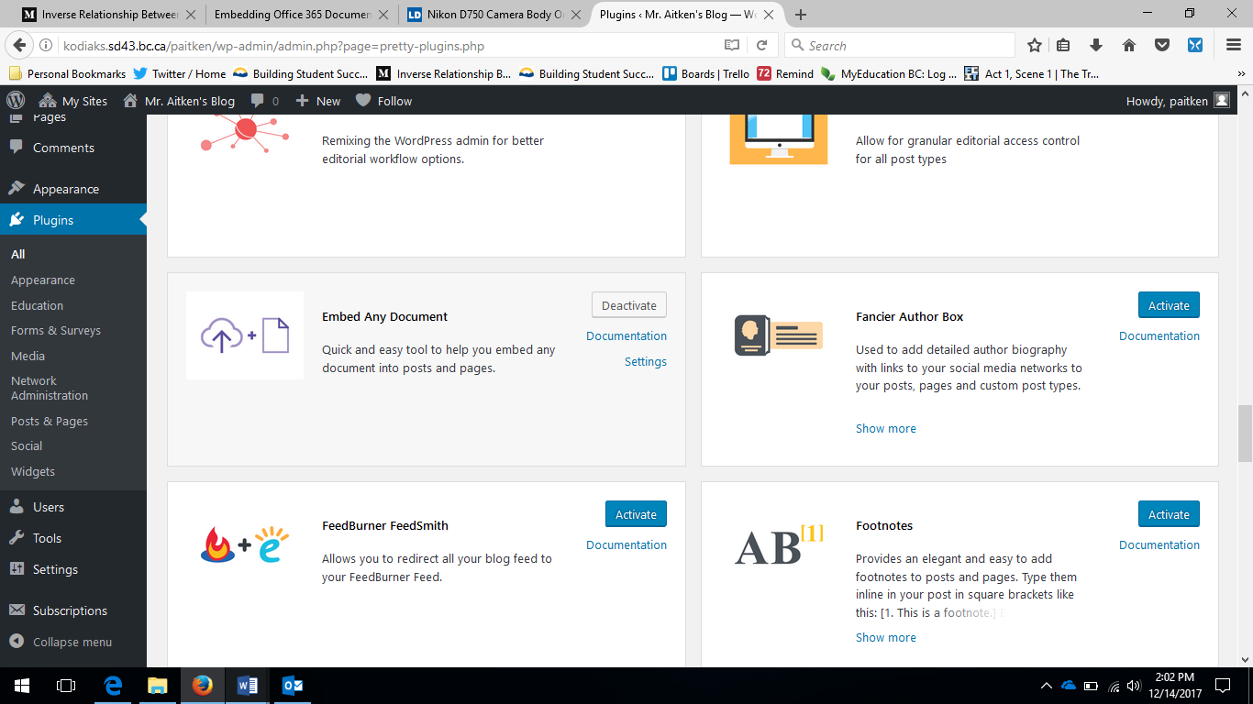
- Scroll down the optional plugins until you find “Embed Any Document” – Click on the Activate button to activate the plugin.
Be sure to activate the Embed Any Document plugin on your plugins page.

- Now that the plugin has been activated you are now ready to insert your Word Document or PowerPoint.
- Go to the page that you are editing – you will now see an additional option besides the Add Media button. Click on the option to Add Document.
Click on the Add Document option. This option was not there prior to you adding the plugin to your blog.
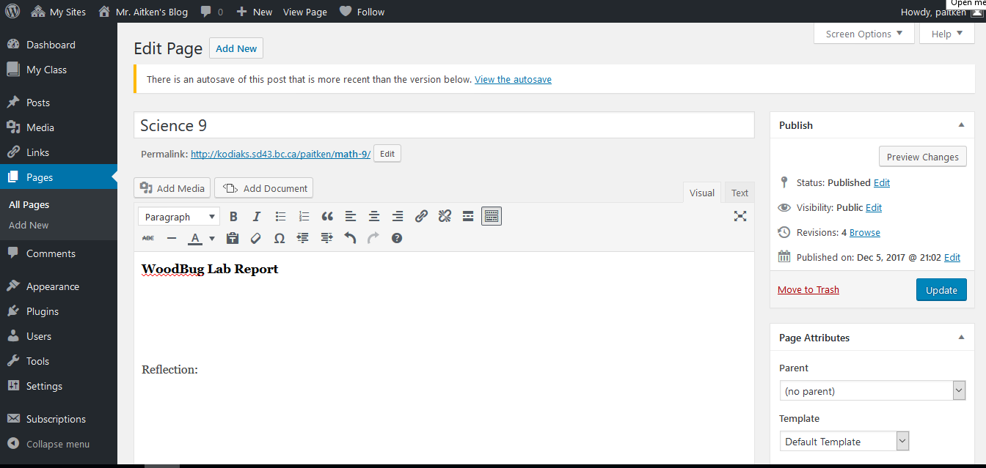

- After clicking on the add document page you will see the following pop-up menu.
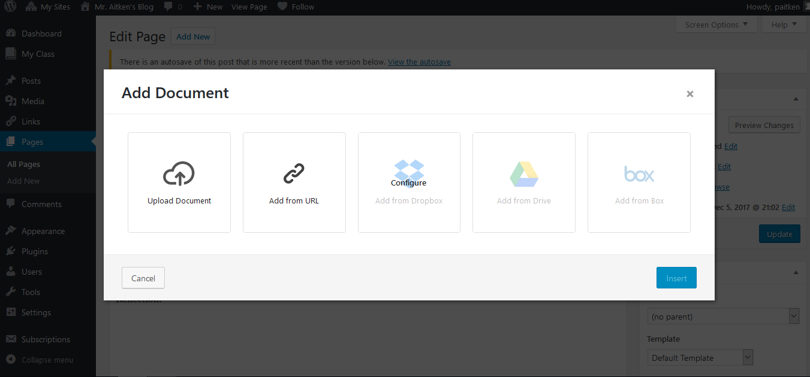
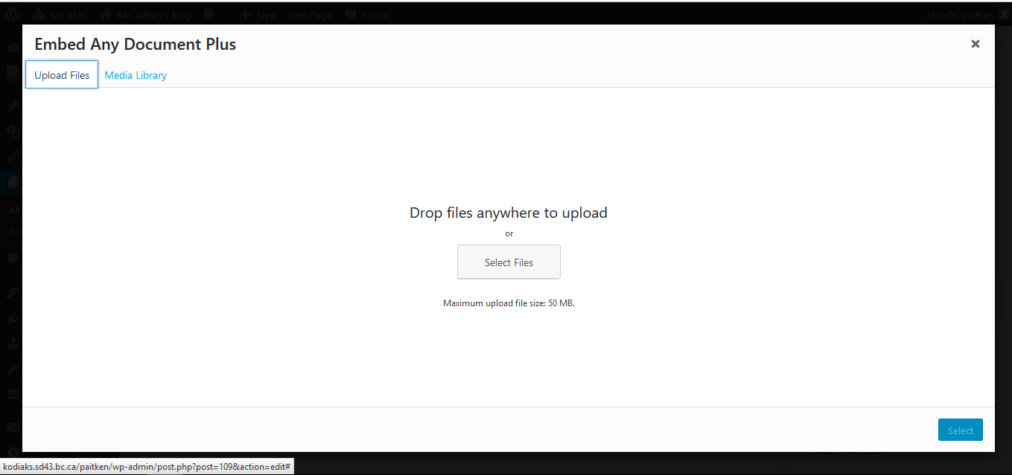
- Click on the upload document button. You will then be taken to the more traditional screen which will allow you to add media/document files etc. You will first be taken to your media library. If you have already added documents to your site for other classes or a previous version of the assignment you will find them here.
Click on the select file option to locate the project/file that you would like to upload and embed into your page.
Your media library is the place where you are able to see documents that have previously been uploaded to your blog.

- Find the document that you need to upload. If you are doing this from your OneDrive folder you will need to ensure that you have access to your OneDrive files on your computer. You can also download a copy of your file from OneDrive to the computer (normally you would do this if you have not installed OneDrive or if you are working on a computer that is not your own).

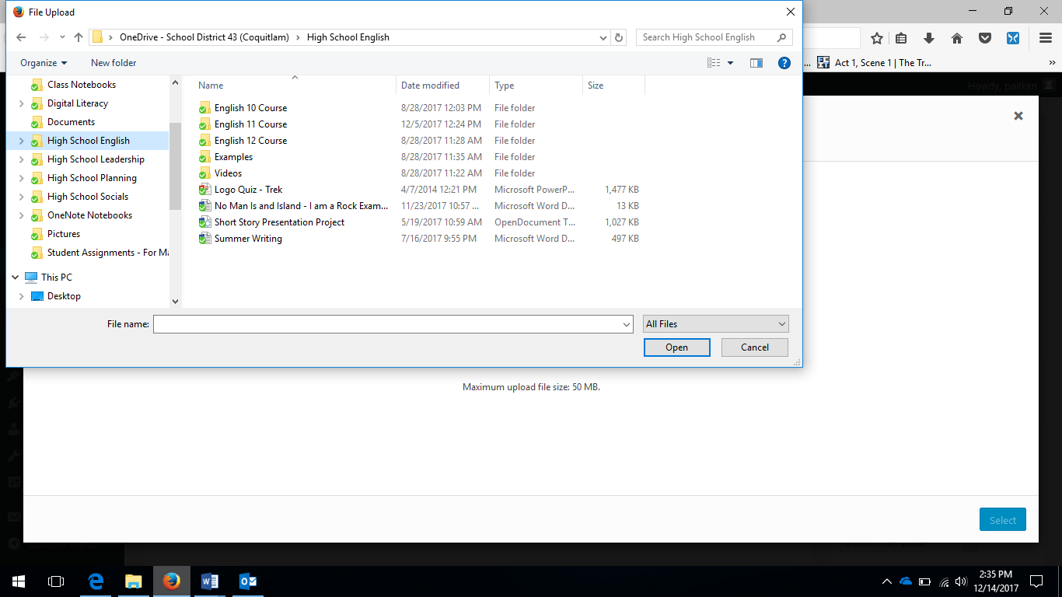

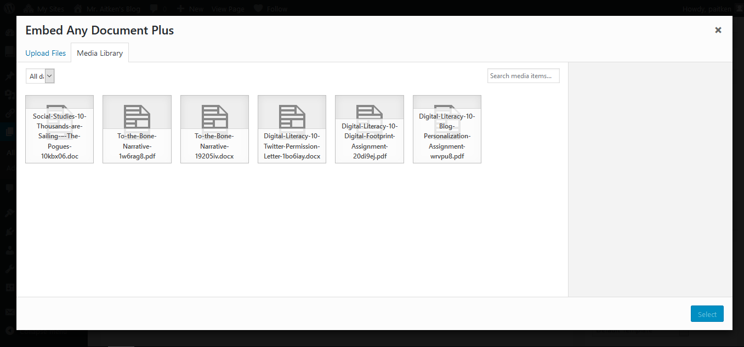
- Once you have uploaded your document you will be taken to the media library page. Select the document that you would like to embed and click ‘insert’.
- After clicking on insert you will see the following pop-up menu. If you are inserting a PowerPoint presentation you will need to ensure that you stick to the file size limits imposed by the Edublogs site. You may also need to play around with the viewer in order to get the desired presentation of your embedded document.

- After you click insert you will see the text of your embed code as opposed to seeing the file as you would have been able to do if you had used the Insert Embed Code under the Add Media button. Basically don’t worry about seeing the code. You can leave it as is and when you update and view your page your document will be there. You are now ready to write the reflection on your assignment.
For PowerPoint presentations you may need to toggle between the Microsoft Office Online Viewer and the Google Docs Viewer to improve the presentation on your page.
Don’t worry about seeing the embed code text in your assignment. When you update your page and visit your page you will see the embedded document in your page.
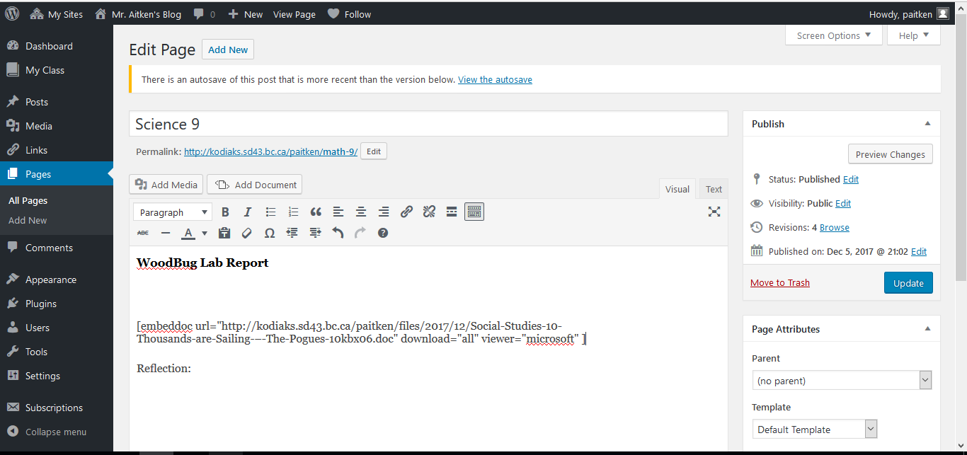
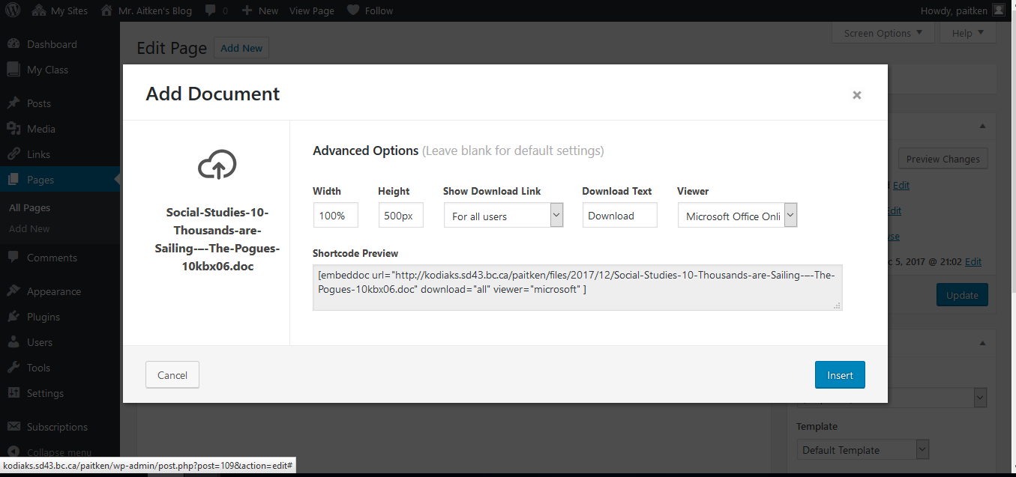

Adding Sway Presentations to Your Blog

MS Sway, which is part of the Office 365 suite that you have access to as a student within SD43 is a powerful presentation tool. You can add all sorts of content to your Sway presentation by embedding and adding the content into your cards. (You can see the guide on how to use Microsoft Sway on the Kodiaks homepage).
Embed codes can be found on many sites – YouTube, etc. and you can embed this content into your Sway presentation (at present you are not able to embed the content from some sites). You can also embed content from Microsoft Forms, Microsoft Word and Twitter and even another Sway Presentation.
Your completed Sway can also be embedded into other places, including your blog, allowing you to showcase your work.
To embed your completed Sway click the Share tab (1) and a drop down menu will pop up. Here you can share your work with others by providing them the link (2) (make sure you select view or edit and that you also select the option that indicates anyone with a link can view your Sway) or you can use the embed code (3) to embed your assignment into your blog.
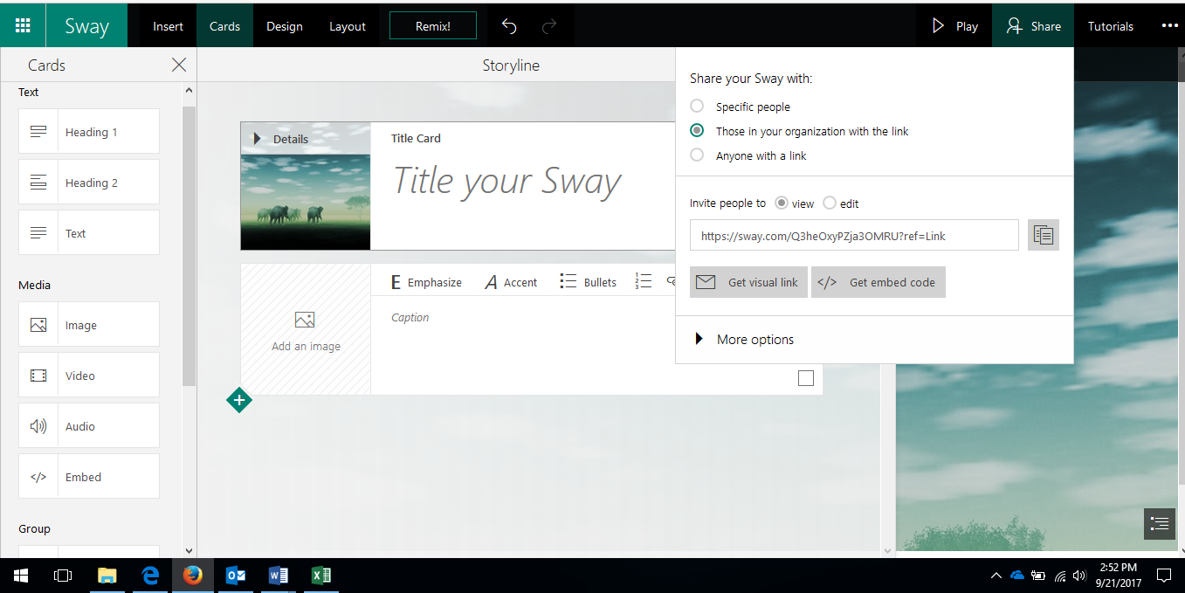
3
1
2
Once you have copied your embed code from the Sway site (or any site such as Piktochart or other online applications) you will need to put it into your blog.

To do this you will go to the page that you are editing and click the “Add Media” button. This will bring you to the pop up menu which allows you to add specific types of media.
On your Page make sure that your cursor is in a place that you would like to add your content.

Click on the “Add Media” button. This will bring you to the screen pictured below.

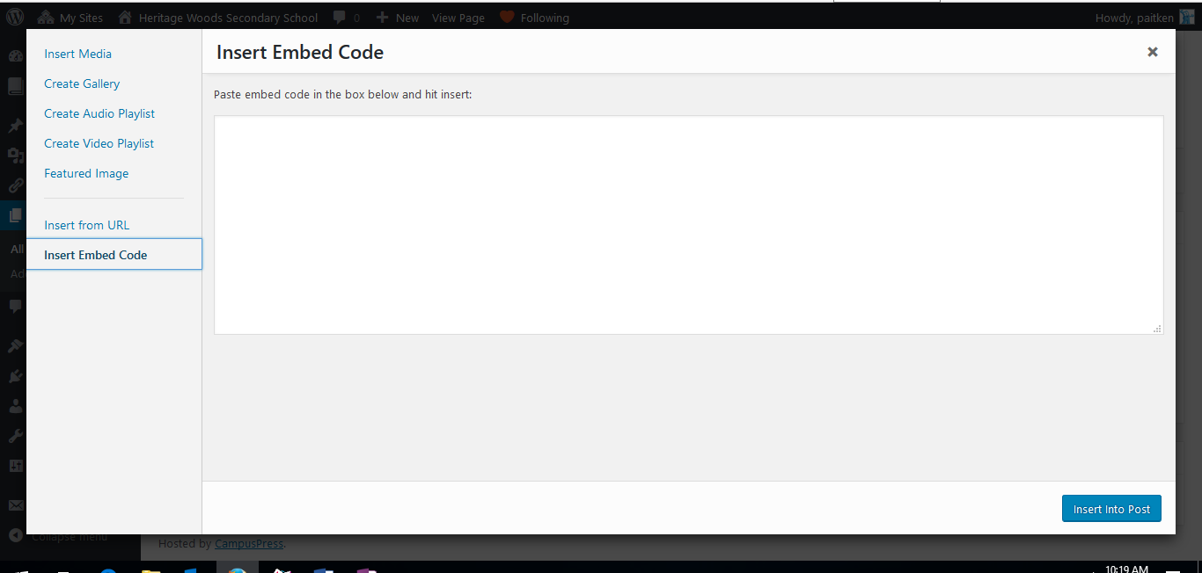
Once you see this screen you can click on “Insert Embed Code”
You then paste the embed code from your Sway or other online content into the dialog box.
Click “Insert Into Post” and your content will be added to your blog.
Be sure to Update or Publish the page once you have done this.

Sway’s will also let you embed video’s and can be a great way for you to put your video presentations onto your blogs while also avoiding the 50MB file size limit imposed by Edublogs. More about that below:

Adding Videos
Videos are a great way for you to share your ideas, communicate your learning with the outside world and have fun while doing it. Posting videos to the blog, however, is made more complicated due to the fact that many video projects will easily exceed the 50MB file limit for the Edublogs site.
There are a few ways to work around the issue of the 50MB file size for video’s
- Insert the video into a Sway
  - You can use the MS Sway program in Office 365. Insert your video into a MS Sway Presentation and then embed the Sway onto your blog. This also avoids you having to use a YouTube account and means that they can keep everything within Office365.
    - Inside Sway, when you are adding cards, you will need to add a media card. This will allow you to add your video. Depending on the size of your video it can take awhile to put it into the Sway Presentation.
- Upload Video to YouTube – Unlisted Video
  - If the you have a YouTube account you can upload the video to YouTube as an unlisted video –(private is not viewable and you don’t need to make your content fully public) this means that it is not searchable on YouTube and does not appear in their channel listings.
  - For an added layer of security surrounding your video you are also able to make their assignment pages password protected so that only people with a password can view the page and the video. See Mr. Castonguay or Mr. Aitken for more information on how to do this.
- Compress the video to meet the file size limits
  - There are programs available online and in our video lab that will allow you to compress the file size of yourr videos in order to have them meet the 50MB file size requirements. Alternatively you could elect to split the video up as well into various parts to meet the 50MB requirement.

