Digital Literacy 10 Mr. Aitken & Mr. Castonguay

Digital Literacy Bootcamp Basics
Setting Up Your Blog

Getting Started: Logging In
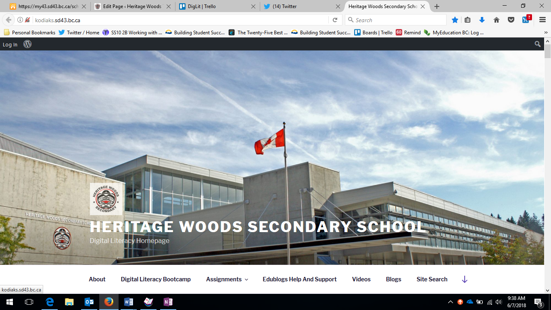
Before you can get started with your blog you will need to login. You will need to go to the site kodiaks.sd43.bc.ca. This is the Digital Literacy 10 Homepage. Along the bottom are links to your Digital Literacy Assignments, Media Guides, and Videos to assist you in developing your blog. You will see a login button on the top left hand corner of the screen.
Login Button – Click Here to Proceed to Login to your individual blogs.

All of your Digital Literacy 10 Assignments can be found here. The drop-down menu contains a link to the core competency reflections and an example of how your assignments should look when posted.

Video Tutorials as well as help and support for your Edublogs site can be found by clicking on these tabs.

Usernames and Passwords
Your username and password for your blog is different from your school username and password. To login to your blog you need to use your first name and last initial, followed by the year that you entered grade nine.
For example, the username for John Smith would be johns2018
All of the blogs have been initially set up with a generic username and password. The first thing that you will do after logging in for the first time is to change your password. Ensure that your password is something that you will remember and that you look to change it on a regular basis to keep your account safe. If you ever forget your password see Mr. Aitken or Mr. Castonguay to reset it.

Using Your Blog – The Dashboard
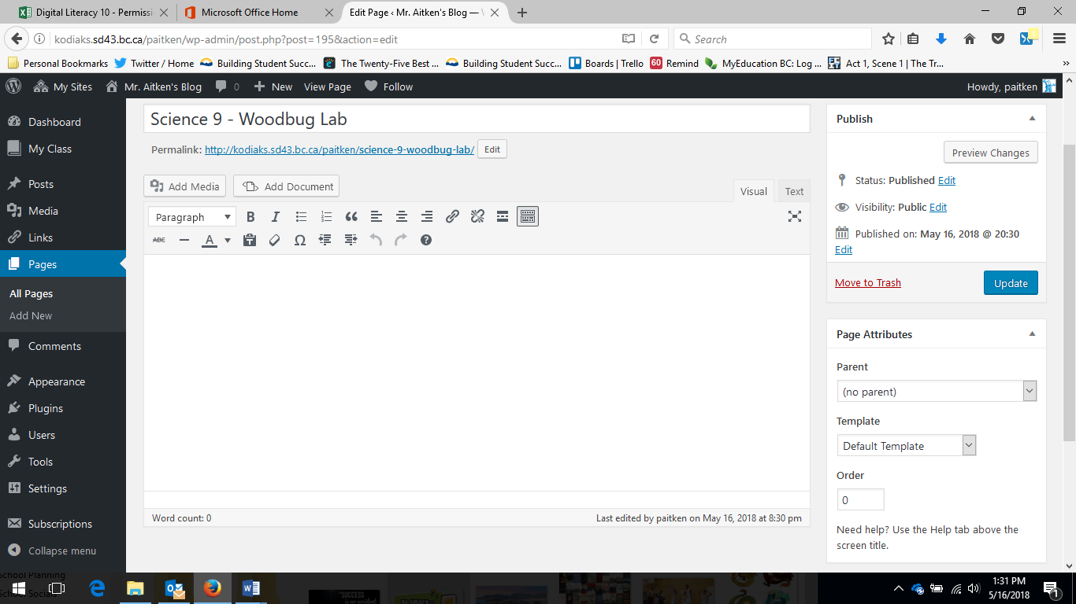
The Edublogs service that we use to host the student and staff blogs is based on a WordPress platform which is a commonly used platform for both personal and professional blog sites. Everything is based around the ‘Dashboard’ and allows you to customize the appearance of your page as well as the
Clicking on Posts/Pages allows you to view all of your published and unpublished pages.
Appearance – allows you to change the theme, colours, header image of your blog. Also a way to access and edit the menu’s
Plugins allow you to use additional modules compatible with the WordPress platform.
The Add Media and Add Document buttons allow you to add content to your pages – Add Document works for Word Documents and Add Media allows you to embed content from web-pages, office programs etc.
The Publish section allows you to adjust permissions (make the page private)
Hitting the update button saves your work. Be sure to do this frequently.
The editing platform works in a similar way to a Word Document with a number of features allowing you to change text colour and size, indents and margins, add links etc.
content that is displayed and added by you. While editing the blog, and adding content you will spend a majority of your time on this page – therefore it is advantageous to point out some key features. The page displayed is one that is ready to edit – your actual dashboard will show recent posts in place of the editing feature.

Additional Editing Features
You can add links to web pages or other content quickly and easily, add a read more tag or indent your content.
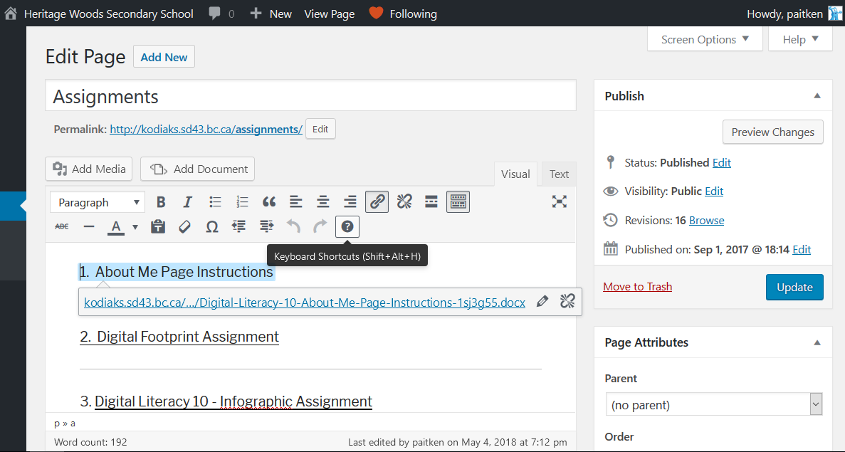
There are additional editing features within the editing page. These will allow you to change headings, bold underline and italicize text, add a read more tab (useful for inserting pictures when you have text below) among other things.
If you want to write your blog free of distractions (sidebars etc.) click this button and it will remove all of the content on both sides of the screen.
Text Colour, Bolding and Italicizing text, strikethrough etc. can all be done here.
Clicking on the drop-down next to ‘Paragraph’ will allow you to add headings, pre-formatted text etc.

Next Steps - Personalizing Your Blog
Now that you have your blog and are up and running you are ready to start making this your own space. You are unique and have varied interests. This can be reflected in your blog. You can change the theme, add images, and modify the overall look of your blog.
The first thing that you will need to do is to select a Theme for your blog. Your blog has been established with the default theme in place and in order to make this space yours you should look to change it.
Click on Appearance and then Themes when you are on your Dashboard.
You can then select your theme from the list that is present. You can look at the details of your theme before activating or sort themes by categories.
When you have selected your theme you can customize it by clicking on this button.
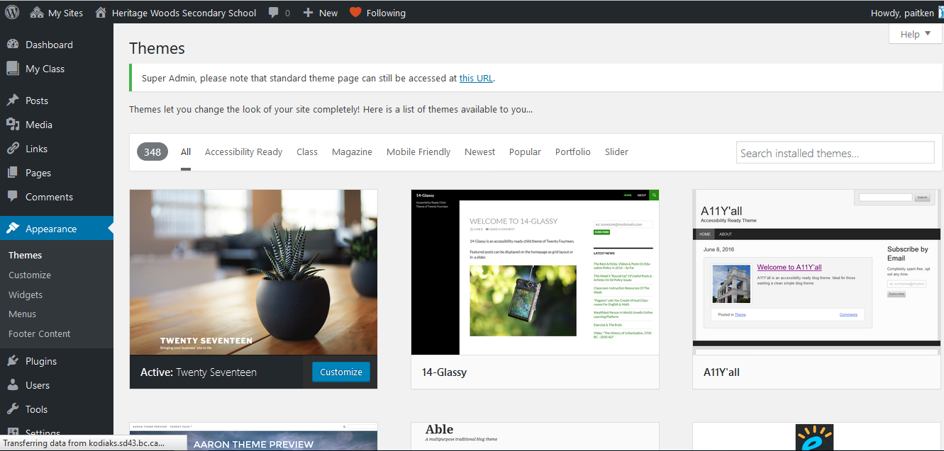

While there are 348 possible themes to choose from there are a number of them that do not work well with establishing a portfolio (Aaron is an example of a theme that does not work). You should make sure that your theme is mobile-friendly and that the menu of your various pages is clearly displayed.
You are free to change your theme at any time. If you do elect to change your theme at a later date you may have to alter the header image, menu’s and a few other small things under the Customize tab.

Installing Necessary Plugins

In order to post Word Documents and PowerPoints to your Blog you will need to install the appropriate plugin. This allows the programs to work around the user permissions in Office 365. To install the plugin, called Embed Any Document use the following steps.
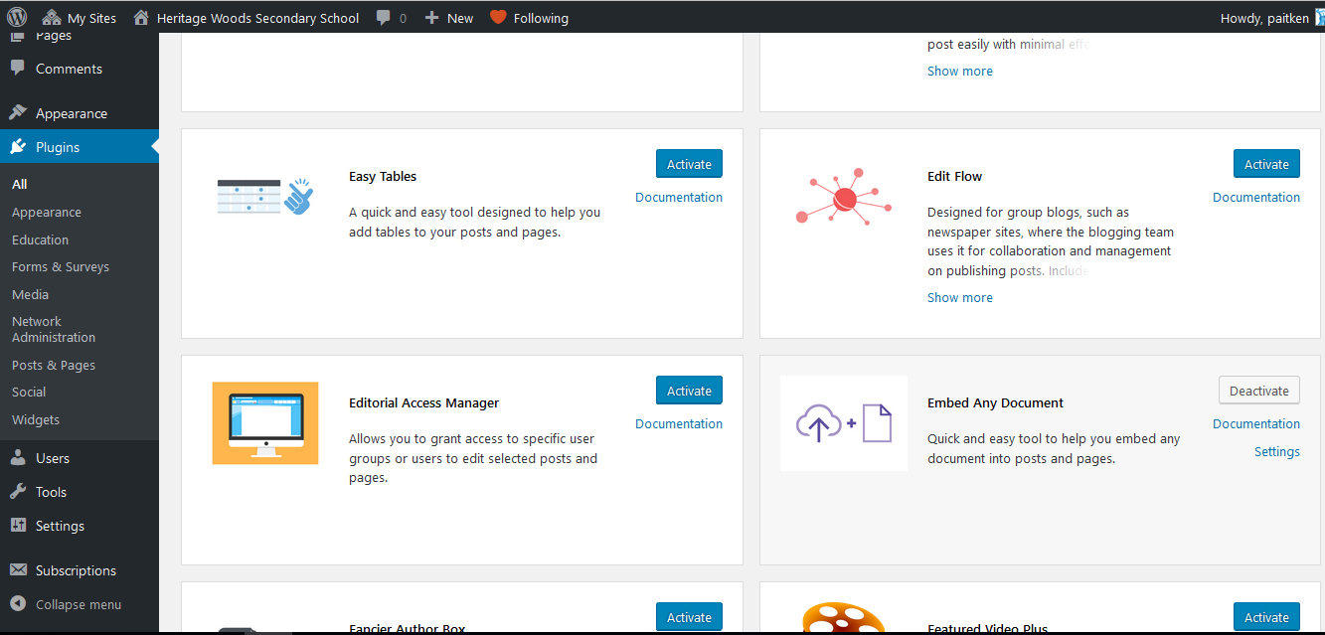
Select the plugins tab on your dashboard.
Scroll down the list that pops up until you see the ‘Embed Any Document” plugin.
Click ‘Activate’ to activate the plugin. You will now see a “Add Document” button when you are editing your pages and posts. Select this button to add Word, PowerPoint or Excel files to your blog.

FOR MAC USERS

This plugin only works with Microsoft documents. If you are using Pages, Keynote or Numbers files you will need to export them to the Microsoft equivalent (Word, PowerPoint, or Excel) and save the file to your computer before attempting to upload the document to your blog.

You are now ready to complete the first assignment. To see your first Digital Literacy Assignment go to www.kodiaks.sd43.bc.ca/assignments and select the first option – About Me

