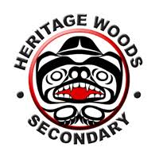

The Assignment:

Name: Ethan T
(First Name and Last Initial)
Advisory #:9_

You will be observing your host throughout the day. There are 3 parts to this assignment:

Part 1- The Interview: Observe your host at work, at some point interview your host and record/make notes of the results
Part 2 - Reflection: After the day is finished, reflect upon your experience and answer the reflection questions Part 3 – Post Your Assignment to Your Blog: Once your have completed Part 1 and Part 2 post it on your blog. Make sure you take pictures and/or videos to document your day, you can place them in your blog.

Name of your host: Beatrice_______________ Relationship to you: Mother________________________

The Interview: (ask your host these questions)

- What is your job title?

Food Regulatory Advisor

- What is your job description?

Provides food regulatory guidance to food inspectors.

- What are the duties and/or tasks you perform at your job?

Answers questions from food inspectors on compliance of food with the Food and Drugs Act and Regulations and the Safe Food Of Canadians Acts and Regulations. She also writes operational guidance for how inspectors conduct their inspections based on regulatory requirements.

- What qualifications do you have for this job in the following areas:
a) training?
- Was a food inspector for 3 years
- worked on developing, implementing, and training national food safety programs.
- Worked in Corporate development
  - Helps her understand how the organization is run.
- Was a food allergen specialist for 10 years prior to being a Food Regulatory Advisor.
- Supervised inspectors for 2 years
b) education?
- Bachelor’s degree in Food Science from UBC
c) experience?
- 27 years of experience working with food legislation

d) skills and attributes (personal qualities)?
- Investigative skills
- Analytical skills
- Interpersonal skills
- Decision/Judgement making
- What are some of the things you like about the job?
She enjoys always being able to work on new projects and meeting and working with people across the country.
- What are some of the things you dislike about this job?
Nothing, she chooses not to focus on dislikes.

- How do you anticipate this job changing in the next 5 years or so?

She thinks the job will become more complex because the food industry will start to evolve more technologically, and the future job will involve assessing the impact of the new technology on food safety.

Why I liked the job:

- The first thing I enjoyed about this job was the personalities of the people that worked there. Everybody I talked to was clearly passionate about their profession and it showed as they described their jobs and all the information that they have learned through them. Their interest on their various expertise’s was really infectious and made me excited to learn about their jobs.

- The next thing I liked about the job was it had a major role in enforcing the law. Other jobs that involved the law like police officers and lawyers had always interested me so, it was interesting to learn about a different side of law enforcement that I had never thought about before.

- The final part of the job that I’ll mention is the amount of interesting technology that was used around the labs. Intriguing machines like incubators and FTIRs were everywhere a

Why I disliked the job:

- The first thing that I disliked about the job was the workspace. Although many of the labs were filled with many interesting various machines and tools, a lot of them were also quite cramped and some also smelled pretty bad. These were minor problems that I would probably overcome over time, but at least for the start, it would be hard for me to get used to working in this type of environment.

- The next aspect of the job that I disliked was the lack of scenery change. This wasn’t true for all of the jobs I was introduced to but, for many of them, they were restricted to their offices or labs all day. This would be hard for me because I would rather work in a job with many different sceneries so that I wouldn’t get bored looking at the same place every day.

- The final thing that I disliked about the jobs I was introduced to was all of them were very health science forward, particularly, food and drug sciences. Although I did find this topic interesting, I don’t think it would be something that I would love to do for the rest of my life.

Is this job for me?
After touring around all the various labs in the building, I can say that this career path will not be one that I’m likely to follow. Even though everybody working there was super friendly and passionate about their jobs, I can’t say that food sciences are something that I would love to do for the rest of my life. For that reason, I don’t think this job is right for me.
Even though I wasn’t able to find my future job on Wednesday, it was still a super cool opportunity to learn about other’s job and see how a workplace like that flowed and functioned.

Values of the TYKTW Day:

The TYKTWD experience was very helpful for planning my future in many different ways. For starters, learning about people’s backgrounds and how much work they put into getting their jobs was very eye-opening to see how much effort was needed to be successful in whatever career I choose. I also learned what I value in a job and what I would rather not have. This is important because when I go to post-secondary school, I want to have as clear of an image as possible of what I want my future career to be so that I can spend the majority my time and effort focused on making it a reality instead of being undecided and potentially wasting my time. Overall, I enjoyed my day and thought it was a great experience to help plan my future.

(Photos below included below)

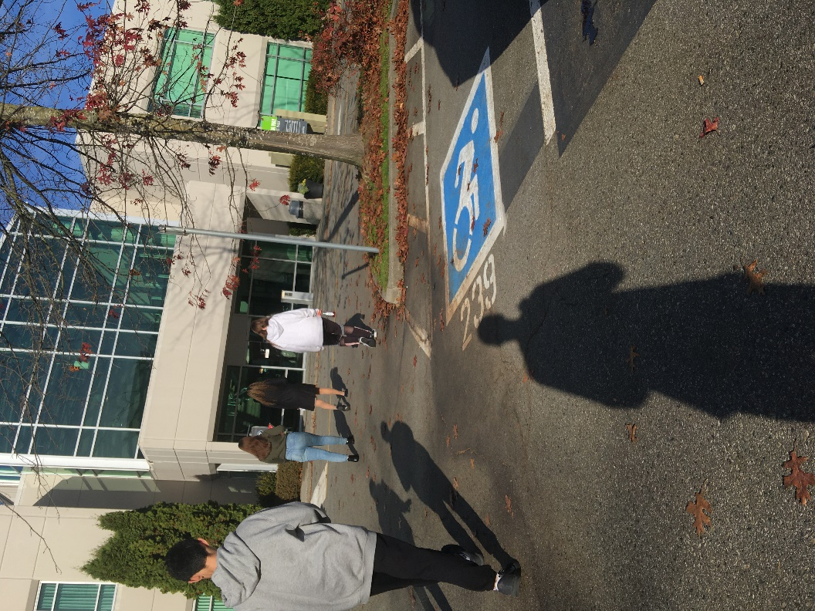

(Photos were not allowed to be taken inside labs)
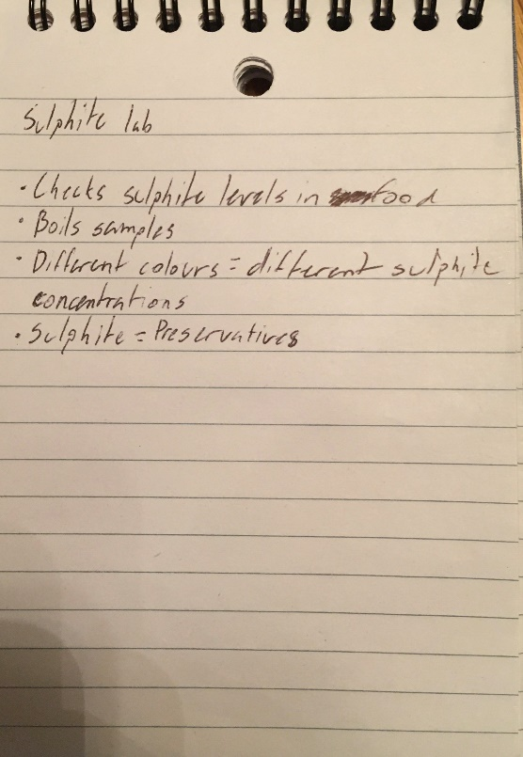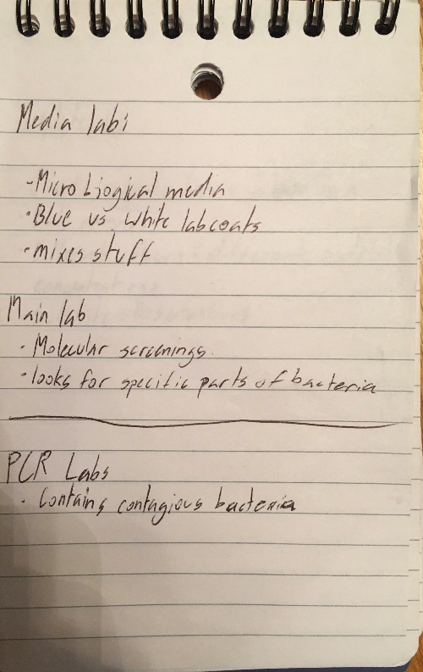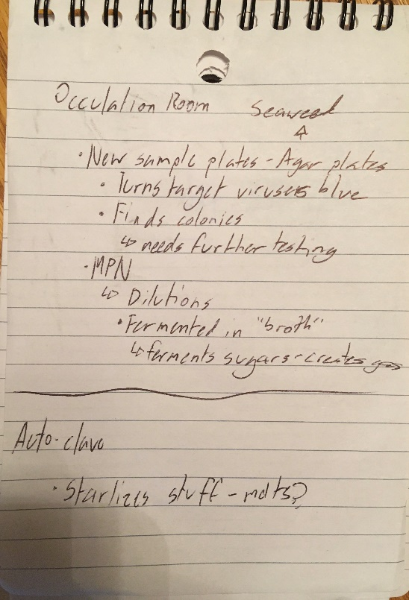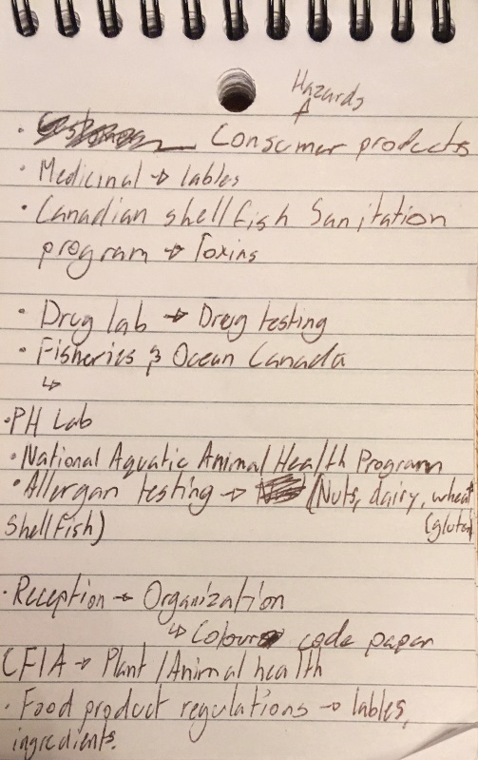

(General notes taken during the tour)

