THE WOODBUG EXPERIMENT
Plant EnvIOrnmnet
WOOD EnvIOrnmnet

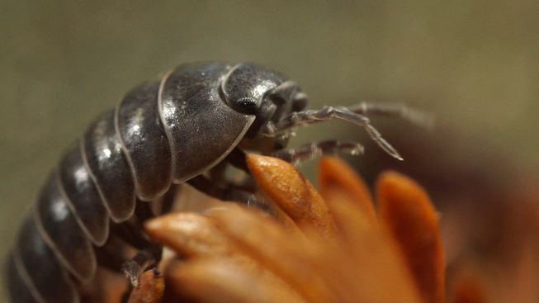
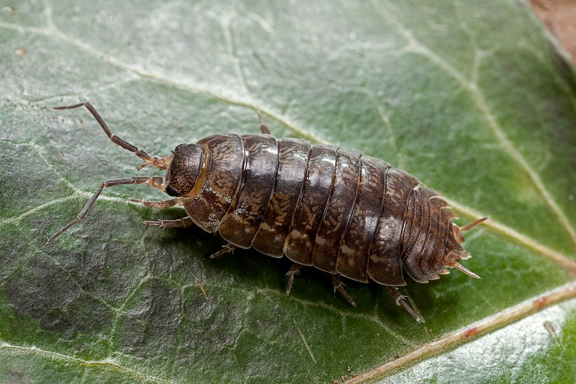

VS

Scientists: Jacob, Lyeke, Fernando, Josh

Habitat Page:

Wood bugs can be found underneath things so that it provides them darkness and even moisture. Places like this can be rocks, dead leaves and of course tree bark. Wood bugs are usually in grasslands, forests and rainforests. They can also be found around the seashore. Once awhile you can find them indoors of you have a damp basement. wood bugs breathe through gill-like structures and must live in moist places.
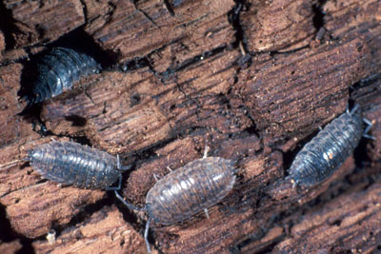
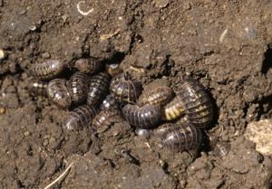
Question:
Do wood bugs prefer a dirt and wood environment or a dirt and plants environment?

Hypothesis:
IF the wood bugs have a decision to choose a dirt and wood environment or a dirt and plants environment, THEN they will choose the dirt and wood environment.

Materials:
4-8 Wood bugs, Dirt, Plants, sticks/branches, Tray.

Procedure:

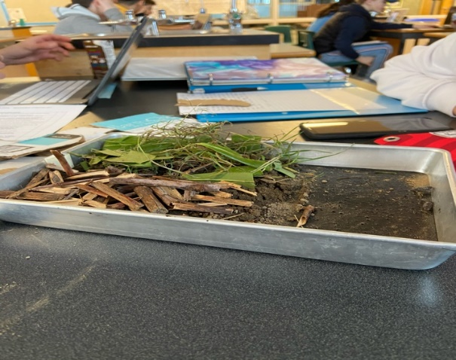
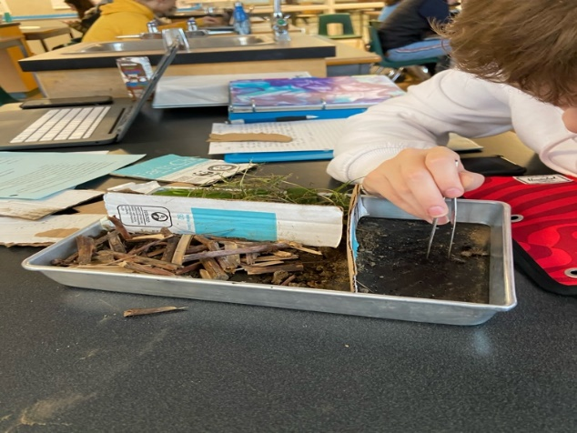
Place Wood bugs on one half of the tray. On the other half, we have two different habitats-dirt and wood, and dirt and plants. Our conclusion will be determined by how many Wood bugs go into the dirt and wood environment, and how many bugs go into the dirt and plants environment.

Data (Quantitative)

Trial | Dirt and wood environment | Dirt and plants environment
1 | 2 | 2
2 | 2 | 1
3 | 2 | 1
4 | 2 | 0
5 | 1 | 3
6 | 4 | 0

Data (Qualitative)
We noticed that in most trials, there was a wood bug that would go into the dirt and plant environment very quickly, and much faster than the other bugs. For some trials, the wood bugs wouldn’t go into an environment, and just stay on the empty half.

GRAPH:
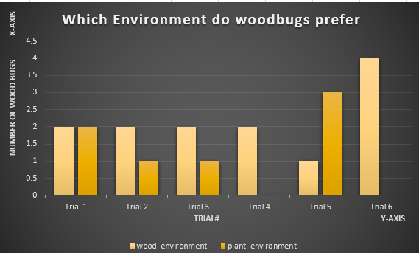
Conclusion:

The data that was collected from our experiment shows that when doing the first trial, the wood bugs were undecided on what environment they preferred. However, by the last trial, all four wood bugs went to the wood environment. This data somewhat supports our original hypothesis. A source of error that could have happened was that this was only four wood bugs. So, when collecting data, it might be hard to say that all wood bugs prefer a wood environment when only having such a small amount. If we were to do another experiment, we would make sure that we would have a greater amount of wood bugs and see if our hypothesis was truly correct.

