Digital Literacy 10 Mr. Aitken/Mr. Castonguay
Working With MS Sway
Microsoft Sway is a new and easy-to-use online presentation tool that is part of the suite of programs in Office 365. There are several features in Sway that make it easier to use, and more visually appealing than PowerPoint. The following guide should provide you with a few tools to help you design your first Sway and experiment with the platform.
When you first open Sway you will see a screen such as this one below. There are a number of things that you can do at this point to get started.
- Watch a Tutorial – Clicking on this tab will redirect you to YouTube where you can watch a series of introductory tutorials about Sway.
- Start from a Document – You can import a Word or PowerPoint Document into Sway and it will automatically create a Sway from it. You then need to just add media and play around with the layout/design.
- Create New – Create a Blank Sway and start from scratch.
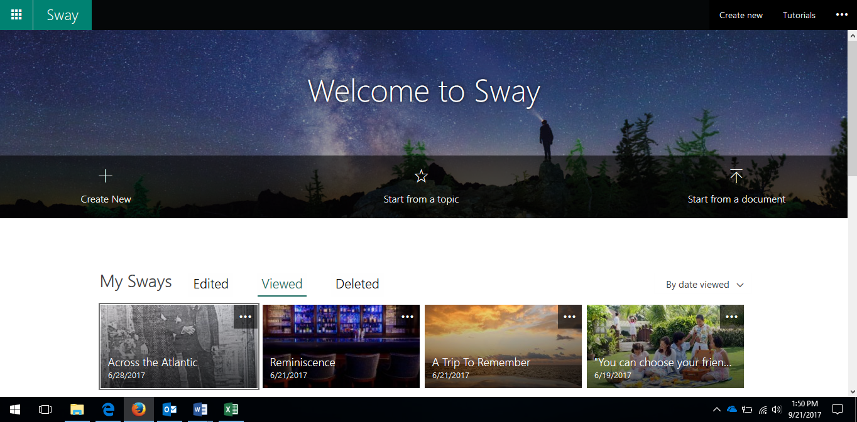
- Start from a Topic – You will enter a topic (dinosaurs for example) and Sway will locate relevant information and establish the basics of a presentation for you.
1
4
3
2

Once you have decided upon the option that you would like to start with you are now ready to create your Sway. The Sway platform is based around cards. You can drag and drop various cards from the side menu to create your presentation. There are three types of cards – text cards, media cards and group cards.

- Text Cards – Allow you to add text and headings to your presentation.
- Media Cards – Allow you to add images, videos, tweets (yes, tweets) and audio to your presentation.
- Group Cards – Allow you to organize your presentation and group similar items together.
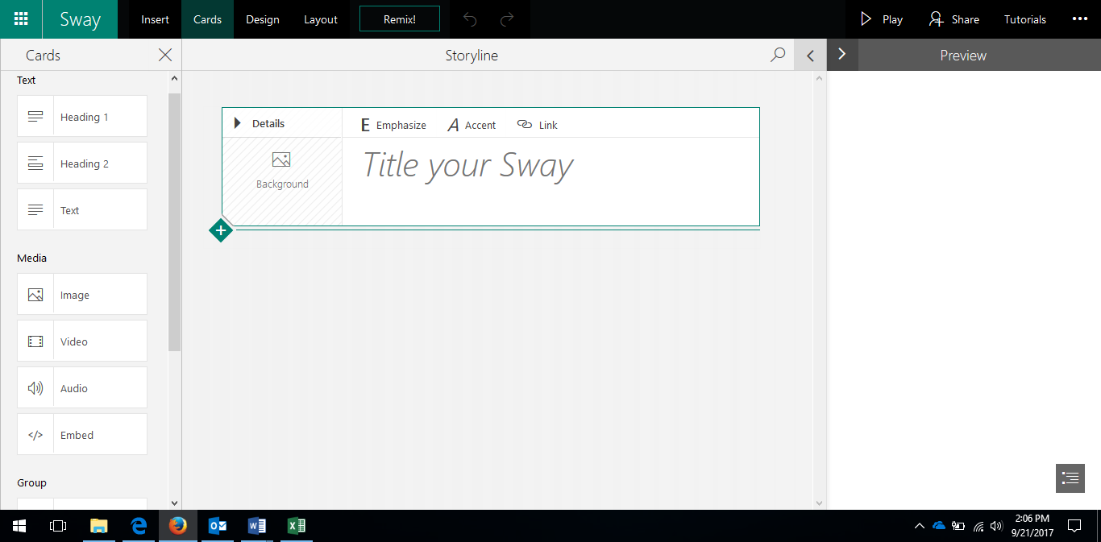
Your Text Card will allow you to add links, emphasize content and accent content for effect. The images that are associated with the card are located on the left hand side. Drag additional text cards for headings or content.
3
2
1
Adding images is easy with Sway too. You can add images from your device, from OneDrive or choose from a compilation of images provided by Bing (Microsoft’s Search Engine). You have the option of selecting only creative commons pictures or allowing all content from the internet to be able to be seen and selected from. If you elect to use content from the internet you will need to provide appropriate citations for that content.
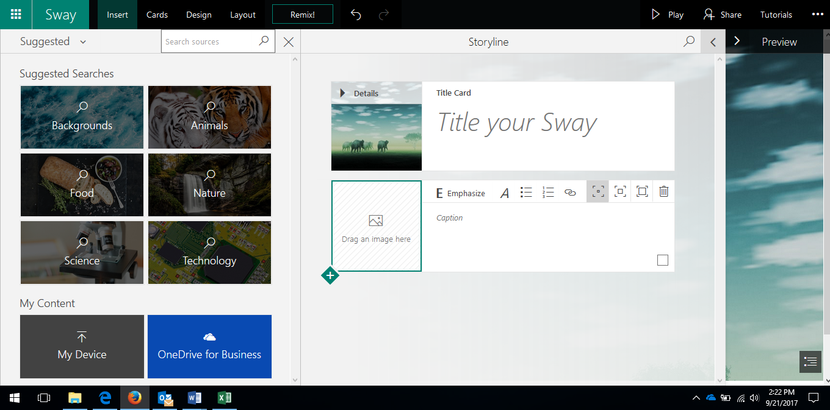
Click on the Insert Tab (1) at the top of the page or the box on the left-hand side of the image card (2) to add content. Once you have selected a picture from the menu you can also drag and drop it into your presentation.
3
1
2

You are also able to add content from outside sources such as Flickr, YouTube (mainly for video’s) and Pickit by clicking on the suggested tab (3). It is important to remember to cite your sources appropriately. The same principle applies when adding video’s – you need to look for the film icon and then simply drag and drop it into your presentation.
Added Extra’s
Embedding
Embed codes can be found on many sites – YouTube, etc. and you can embed this content into your Sway presentation (at present you are not able to embed the content from some sites). You can also embed content from Microsoft Forms, Microsoft Word and Twitter and even another Sway Presentation.
Your completed Sway can also be embedded into other places, including your blog, allowing you to showcase your work. To embed your completed Sway click the Share tab (1) and a drop down menu will pop up. Here you can share your work with others by providing them the link (2) (make sure you select view or edit) or you can use the embed code (3) to embed your assignment into other sites.
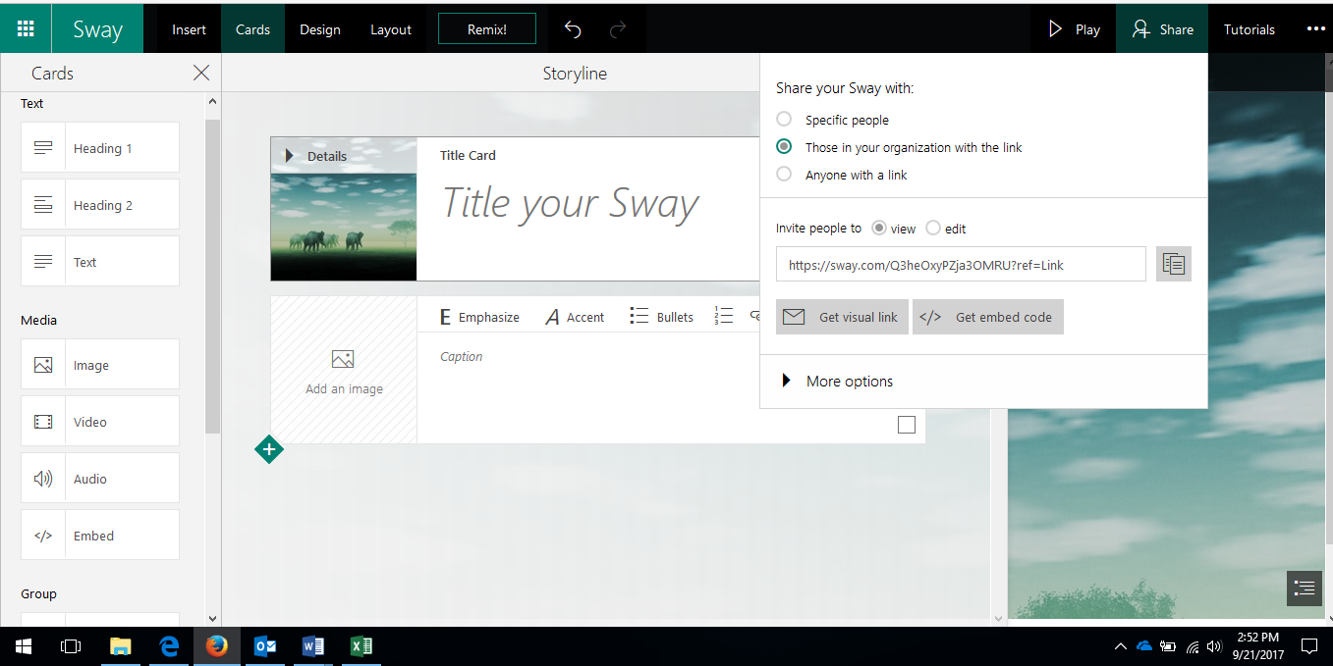
1
3
2

You can also embed content from Twitter into your Sway presentations. Simply click on the tab at the side of a tweet (1), select the embed code (2), a pop up menu will appear with the selected tweet and the embed code – you then need to paste the code into your embed card on Sway. You may or may not want to embed content from Twitter –you need to be aware of its accuracy and legitimacy.
2
1

