Blog Checklist

Assignments from Grade Nine
New students should establish a blog and complete the introductory assignment – You will not be required to post content from Grade 9 but will be required to continue to develop your blog.
- Digital Literacy Assignments
  - About Me
  - Digital Footprint
  - Infographic Assignment
- Science and English Assignments
  - Three assignments (2017) from English and Science Posted to your blog with reflections based on the core competencies.
- Core Competency Reflection Sheet for Grade 9
Assignments from Grade Ten
- Post content from your Grade 10 classes (two items per class) with short reflections connecting to the core competencies.
  - Science
  - English
  - Social Studies
  - Math
  - Electives
- This should be a reflection of your best work – work that you are most proud of or that shows improvement in areas of the core competencies.
Themes – Header Image
Personalize your blog. No one wants to see the same theme and header image for all of the blogs. You are unique and your blog can be a reflection of that. You can add header images to your blog and personalize it.
If you still see something like this…it may be time to personalize your blog.

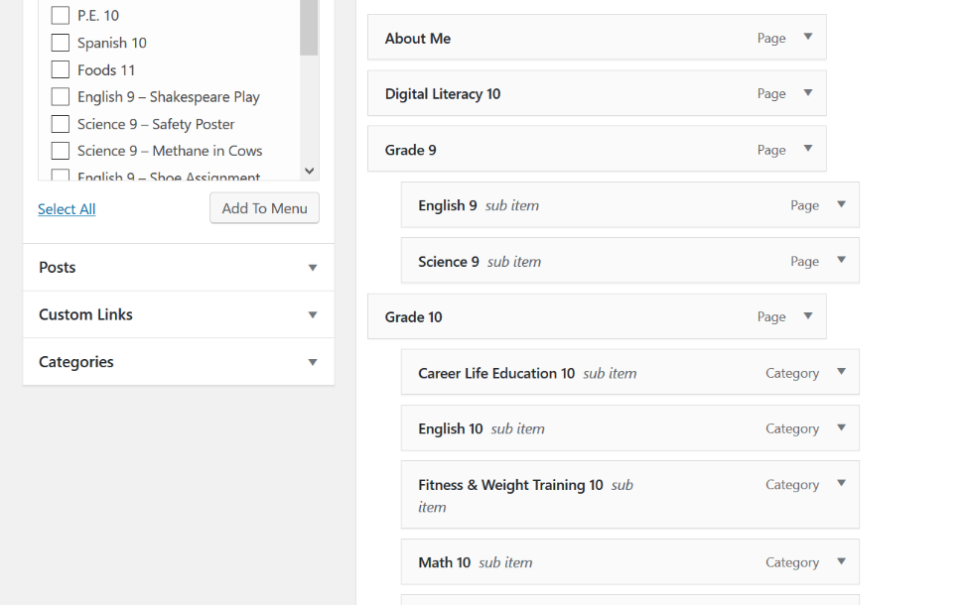
Menus/Pages/Categories
You should ensure that your menus are up to date. All grade ten items should look to be done as posts with categories. This is a little different from last year. You can still continue to use pages if you feel more comfortable with this but should continue to add these to your menu.
- Add your categories under pages and they will appear here
- Put them into your menu – sub-items will become a drop down menu when displayed on your blog.

- Continue to use your pages beginning with grade (ie. Grade Nine, Grade Ten) as placeholders for your drop-down menu’s.

Embedding Content
Make sure that you are adding content to your blog that is visible. Links should only be used as a last resort – they force a reader to be directed to another site.
Ensure that you are adding Word, Excel or PowerPoint files using the ‘Add Any Document’ tab. If you don’t see that tab you will need to activate the Embed Any Document plugin. Content created on websites or on programs such as MS Sway should be embedded into your blog – using the ‘Add Media’ tab.
Add Category – Extra-Curricular
You should look to document your extra-curricular activities as this highlights your ability to be a well-rounded student who contributes to your school and community.
For example: If you were part of the basketball team you may want to write a short post (500-2000 words) detailing what the team did during the season, but more importantly the intrinsic values you have learnt by being part of that team. Qualities such as teamwork, leadership, commitment, setting goals etc. are all things that can be documented and can enlighten people as to the person you are.
Add Capstone Page
Part of the graduation requirements involves students creating a capstone project. This project and the form that it takes will vary from student to student depending on their interests and the way in which they would like to demonstrate their learning and ability. Students are required to set up a page on their blog entitled ‘Capstone’ and add it to their menu.
Use Images and headings in your posts
Make your posts attractive and welcoming to readers. To do this think about using the following techniques.
- Ensure that your posts/pages make use of Headers
  - Your post/pages title and subtitle will be Heading 1
  - Your main points will be Heading 2/3
  - Your subpoints, under your main points will be Heading 4/5

- By clicking on the arrow next to paragraph in your editing page you should see all of the heading options.
Share Your Work
Your blogs are in the public domain and as such can be accessed by anyone who knows the URL. You are encouraged to share your work with your parents and assess the extent to which you meet the rubric below. It is expected that, by the end of grade 12, all students will be meeting the ‘basic’ level of this rubric.
Developing | Basic | Competent/Professional
Student is working towards developing their online portfolio. Items from classes may have been uploaded but some of these uploads may not be done correctly and the pages/posts do not include reflections based around the core competencies. The student’s blog has not been personalized and menu’s may not be up to date. | Student has demonstrated proficiency in an online environment and in regards to establishing their portfolio. The blog may or may not be personalized but the menu’s are up to date and content from their various classes has been embedded properly on to their blog. Reflections are present but do not always fully address the core competencies. The students may or may not have started to use their blogs to hightlight their activities and service to their school and community. | Student demonstrates exceptional skills in an online environment. Their blog is personalized, and menu’s are up to date. The content from their various classes has been embedded properly onto their blog and reflections based on the core competencies are attached to their assignments. Additionally they have used their blogs to highlight their activities and service to their school and community.

