How to Use Piktochart

So you need to make an infographic. Piktochart is a great and easy way to create an infographic to share your information with text and images.

- Be sure to sign up at www.piktochart.com – use your school email and a password you will remember. It will ask you for organization size etc. You can put down education and say you are a teacher – it is fine.
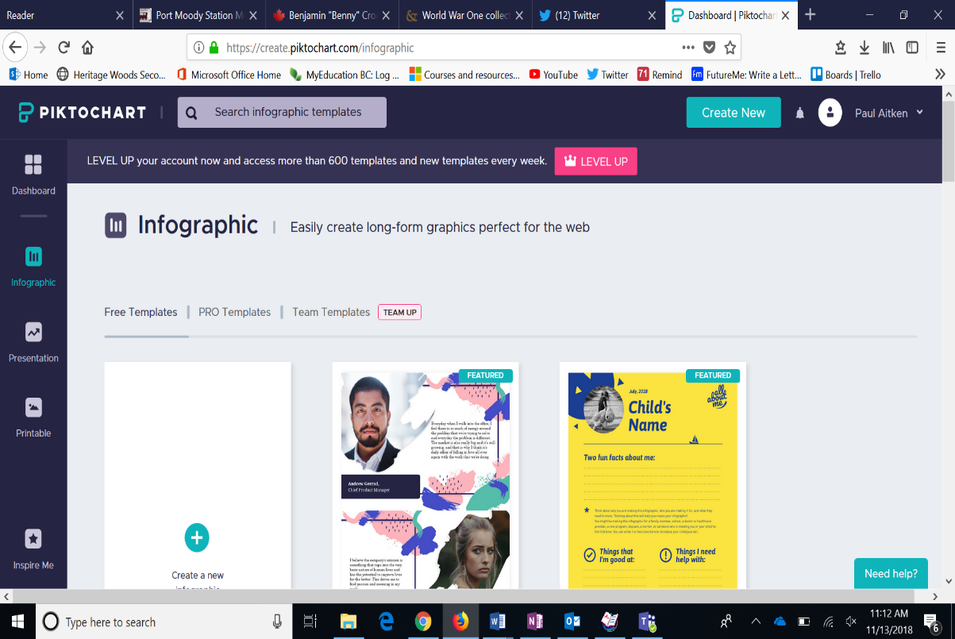
- Select infographic to start making your infographic.

- You can start with a template (means you will need to delete the content already there and write in your own. You can also select Create a New infographic to start with a blank canvas. Well, almost blank – there is one thing you need to delete.

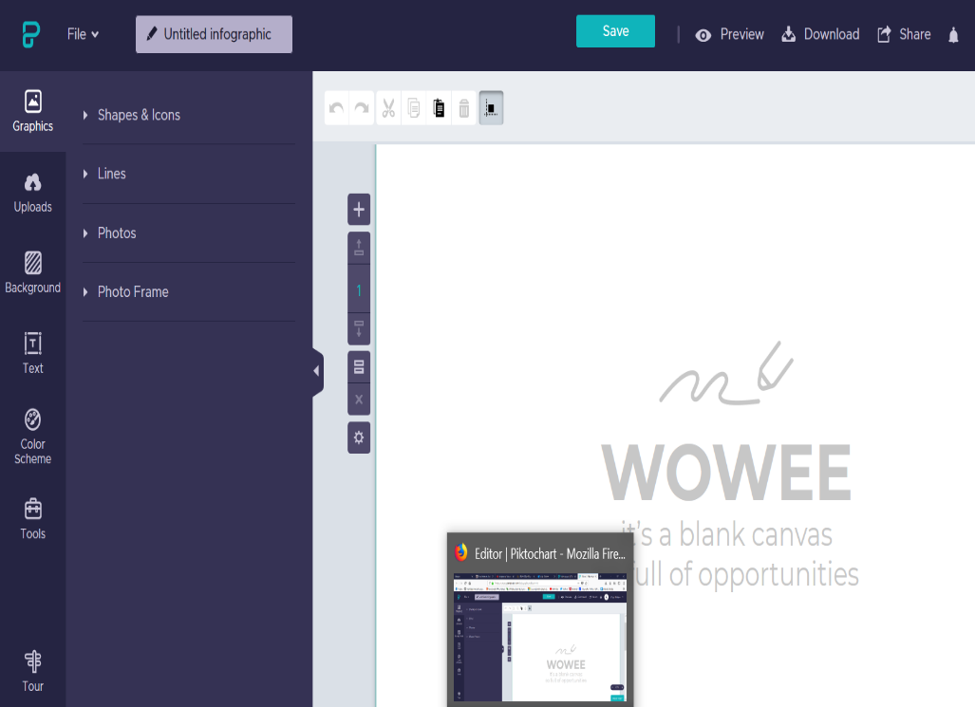
- You will now be taken to the Editing screen. From here you can do everything you need to make a great project. Along the left hand side of the editing screen you will see a number of options.
  - Graphics – allows you to add lines, photo frames, shapes and icons etc.
  - Uploads – allows you to add your own content – it is this button that you will use to add your own pictures – be sure to cite your sources.
  - Background – fairly self explanatory – change your background.
  - Text – Use this to add the text to your project – you can change the font size to make the text bigger.
  - Tools – allows you to add maps, charts and video’s to your project.
- There is also a SAVE button on your editing screen – be sure to hit this button frequently when working – this does not save the content automatically. YOU WILL LOSE ALL OF YOUR WORK IF YOU DON’T SAVE.

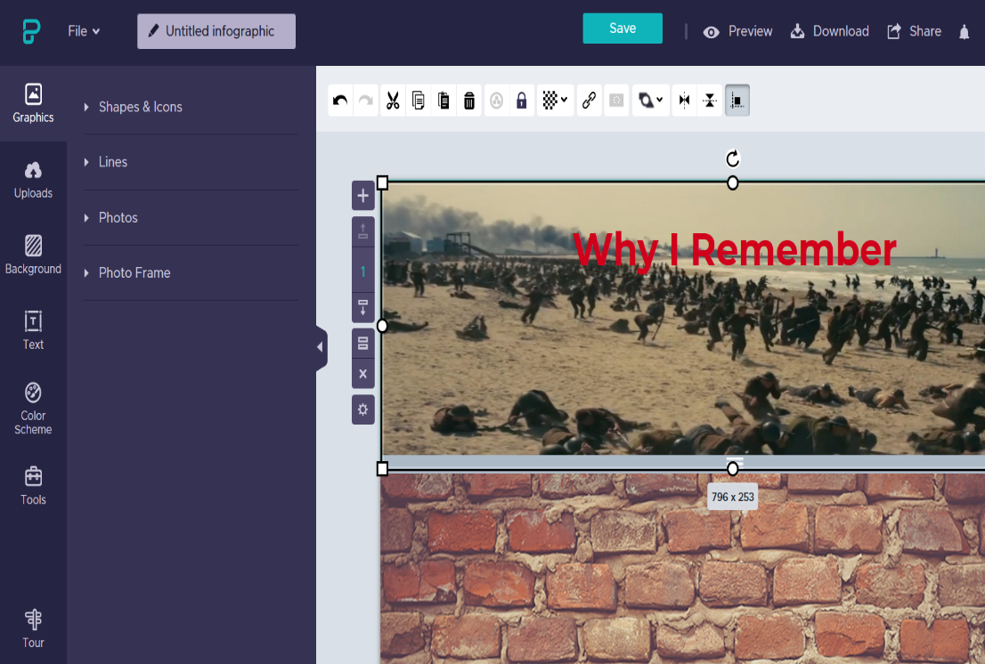
- A few other notes – when you select each of the various screens – in this case graphics – you will see a toolbar at the top of the screen. This is where you will edit aspects of your infographic.

  - When adding pictures of text be sure to use the bring to front option to ensure that they are at the front of your infographic.
  - Along the side you will also notice a ‘+’ icon – this allows you to add sections to your infographic – you can use a number of sections without worrying about printing as you will be adding this to your blog.

- When you have finished your infographic you are ready to embed the content into a PAGE or a POST. If you are completing your infographic Assignment for Digital Literacy it should be completed as a PAGE or placed onto your Digital Literacy PAGE.

- For a Post: be sure to set up your post with a correct TITLE, TAG and CATEGORY. You will then need to use the Add Media tag in order to properly embed your infographic. To upload your infographic you will need to do the following:
- Adding your Infographic to a PAGE or a POST
  - Select the Share button in the top left hand corner of your editing screen in Piktochart.
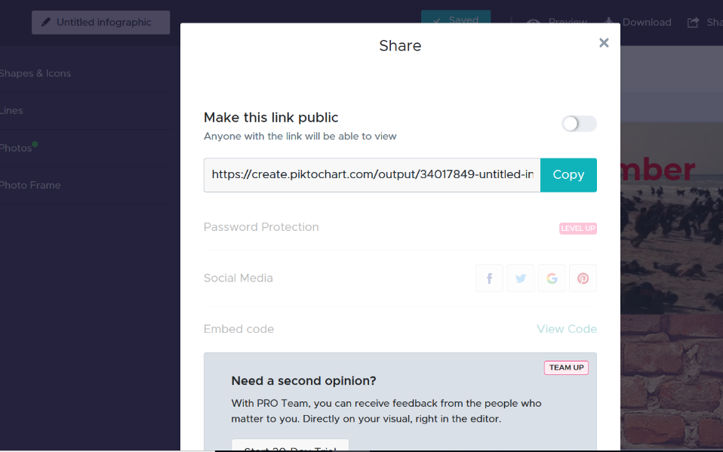
  - You will now see a pop up like this

  - Change the “Only I can view the sharing link” to read “Anyone can view the sharing link”

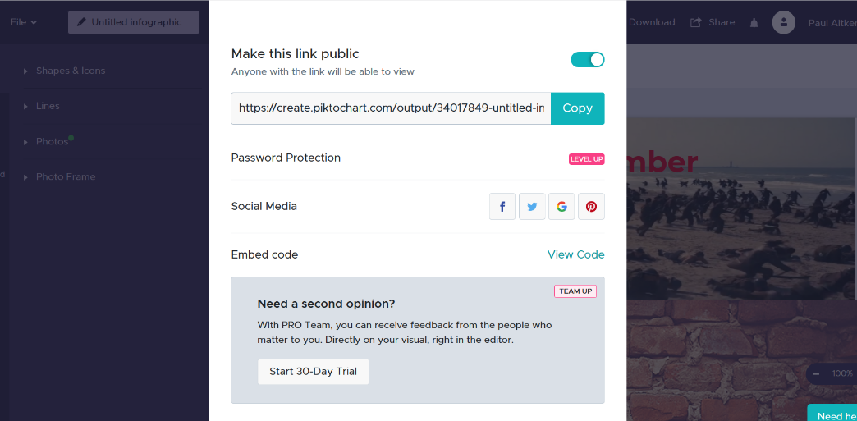
  - This will change the pop up window. You will now be able to find your Embed Code <>

  - You are now ready to copy the embed code that appears – use the shorter version. And embed it into your blog.

  - Once you have embedded your Piktochart project be sure to write your reflection and add it to the Same post (if it is for a class assignment – no reflection needed for Digital Literacy Assignments).

