Making Maps Using Google My Maps

Google My Maps is your way to keep track of the places that matter to you. Easily make custom maps to remember your favorite places, explore new cities, or plan great vacations. You can also use this for your assignments as well. Creating maps for novels, retracing historical events and places etc.
You are also able to view these maps on your phone or tablet (with IOS) or create them on your phone (Android).
You will need a Google Account to be able to use Google My Maps. You should sign up for a Google account before proceeding through the following guide.
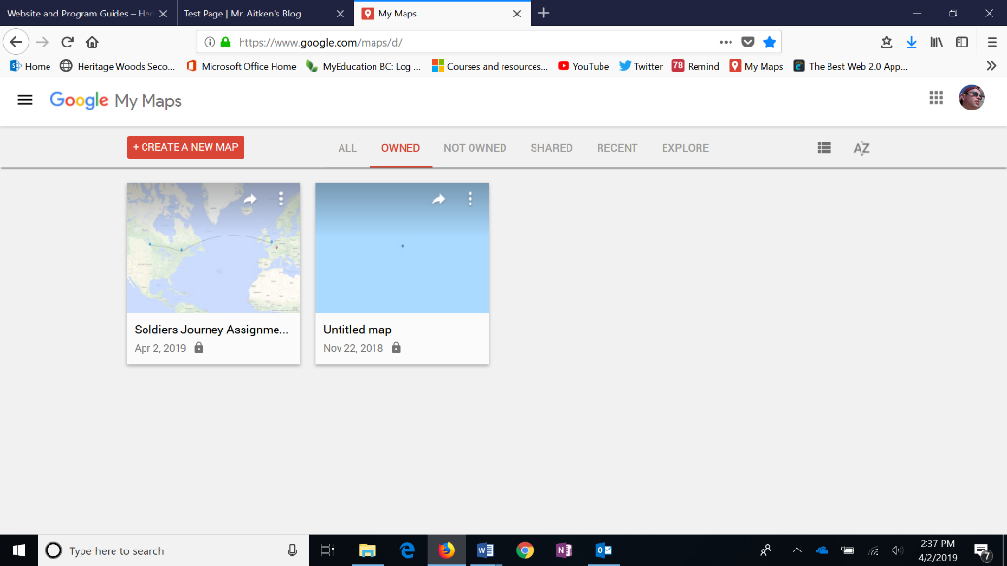
- To start creating your own maps go to https://www.google.com/mymaps - If you are logged into your Google account you will see a site like this.
All of the maps that you have created will be displayed here. You can also explore maps created by other users and see maps that have been shared with you.

- To start a New Map click on the “Create a New Map” Button.
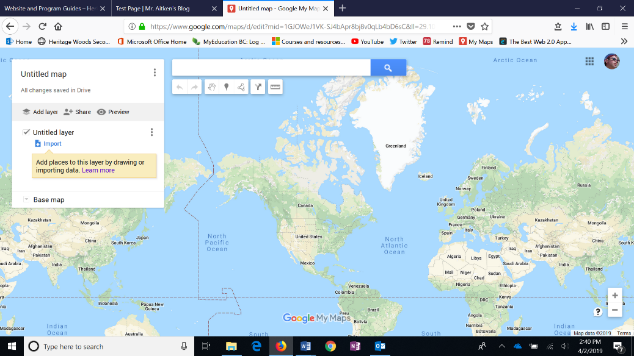
- You can start by giving your map a title.
You will also be able to add layers to your map. You can have one layer for attractions, another for coffee shops (if you drink coffee) and so on. You can title your layers here.

You can also change the look of your map by clicking on the “base map” options. This will allow you to change the look and overlay of your map. You have a number of options to choose from to customize the look of your map.
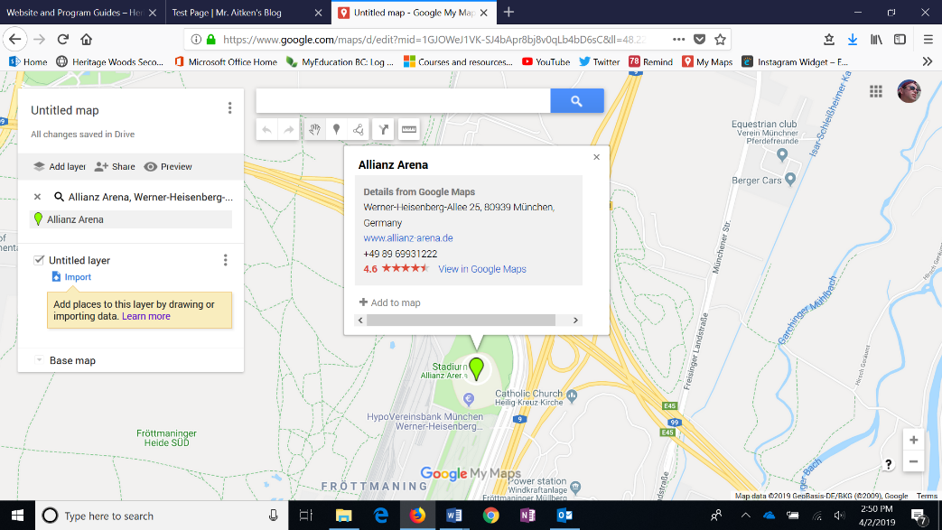
- Now you are ready to start adding places of interest to your map. For arguments sake lets say you would like to make a map of all of the major football stadiums in Europe. You can search for a place the same way you would in Google Maps (using the search bar).
This will then direct you to the location. (In this case we have searched for the Allianz Arena – home to Bayern Munich).

Once you have found the place that you were searching for you can add your own tag by clicking on the teardrop icon (circled).

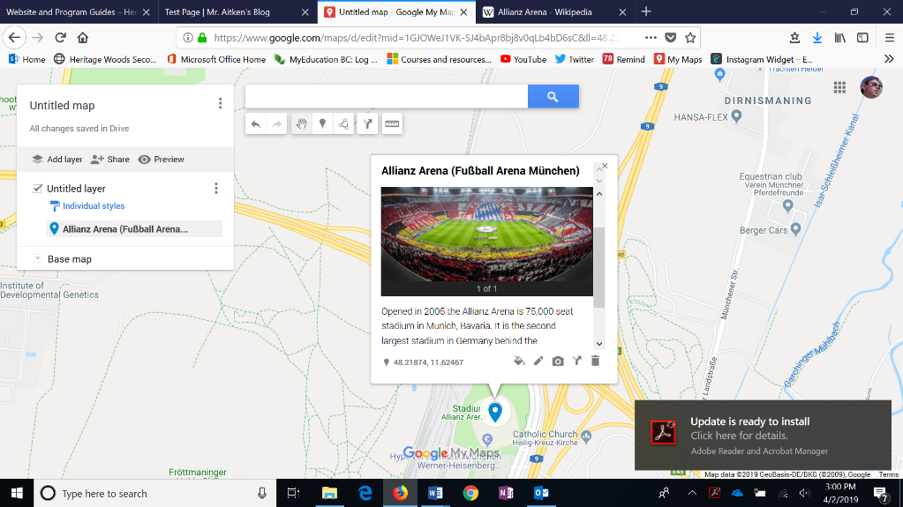

- You are now able to edit the point that you selected. You can write a caption as well as insert images into the card by clicking on the edit button.

You are also able to change the look and colour of the icon for each of your places. Click on the paint can in order to do this.

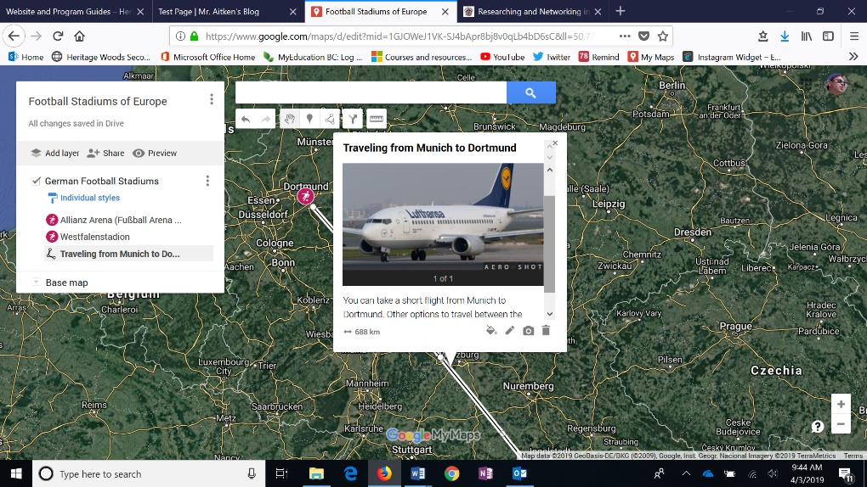
- You may want to map out a trip to various places that you have been to and add information about your journey along the way as well. Google My Maps allows you to add lines between places and also allows you the chance to add information about the journey too.

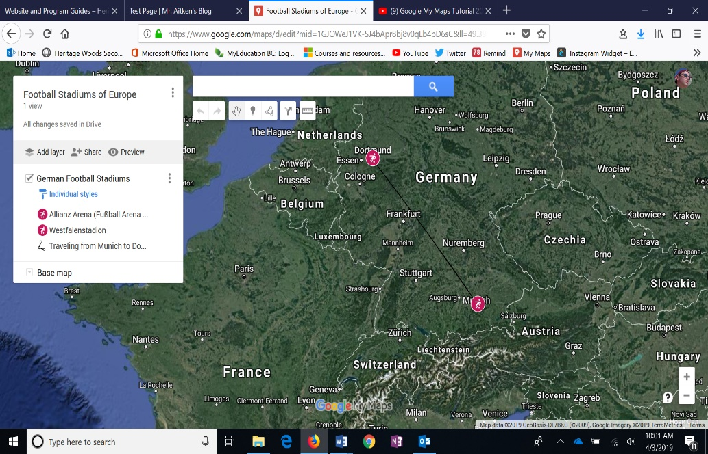
To add a line click on the line icon (circled) and then draw your line. When you have finished your line you can add additional information about the line (or journey) by clicking on the line. This will bring up an info box that you can then edit.

- If you need to you can look to add directions to a place or measure the distances between places using My Maps. The two icons in the toolbar (circled) will help you to do this.

- When you have finished your My Map you are ready to share it. You will need to select the share button which will then bring up the menu for privacy settings etc.

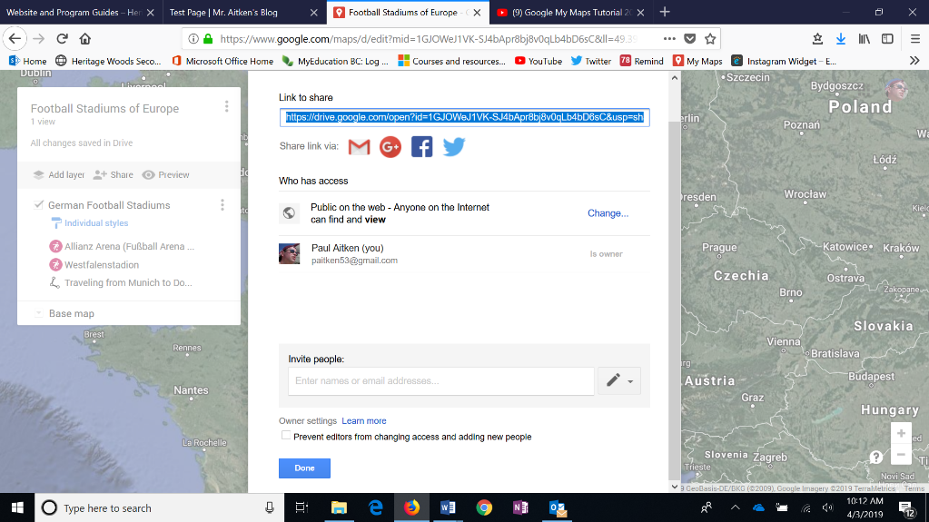
- Ensure that your map has been made public and that it is set to public on the web – this will only allow other people to view your work and not to edit.

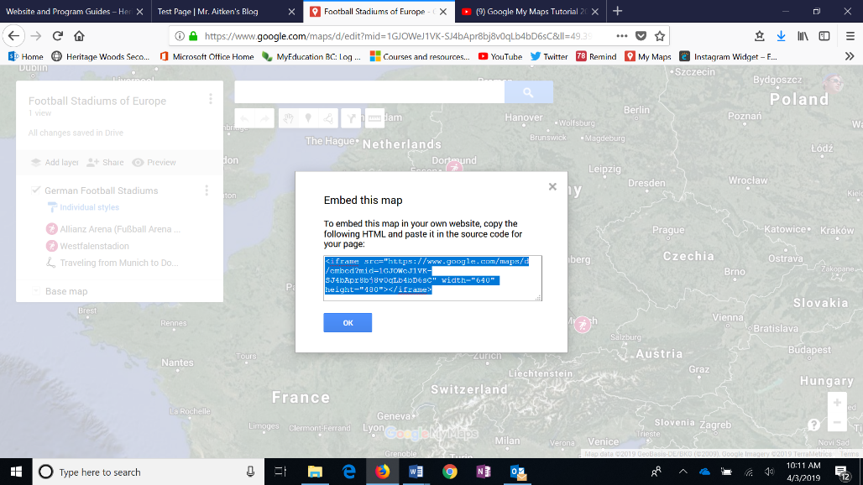
- Now you can click the three buttons next to your title and select the option to embed the map onto your site. This will bring up the embed code. Copy this and paste it into your blog.

There are more things that you can do with Google My Maps as well. This short tutorial - https://www.youtube.com/watch?v=fLhyr5MGi2g - will cover some of the things that are mentioned here as well as extend this and help you with other tools that the site provides.

