Making Podcasts Using Anchor.fm

Anchor.fm is an online and mobile tool that enables you to create podcasts easily. To use Anchor.fm on a browser or mobile device, you can use the video guide or the step-by-step guide below. You will need to use both the online and mobile tools to create your podcast.

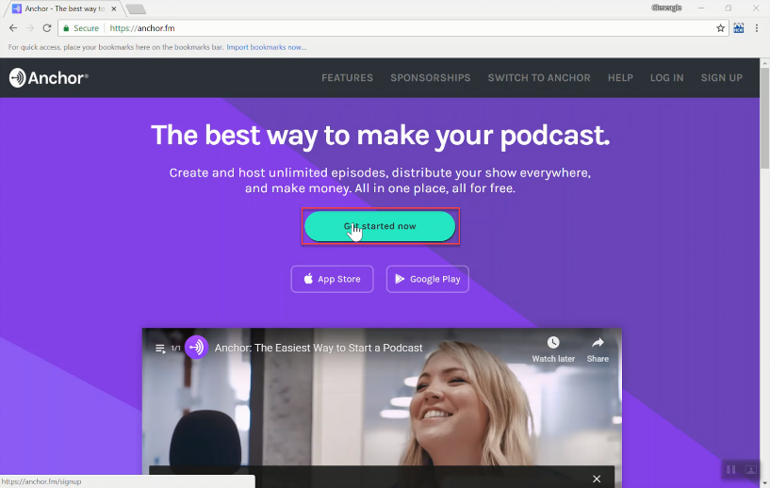
Go to anchor.fm and click on "Get started now" along the top.

Sign up for Anchor or log in if you have already created an account.

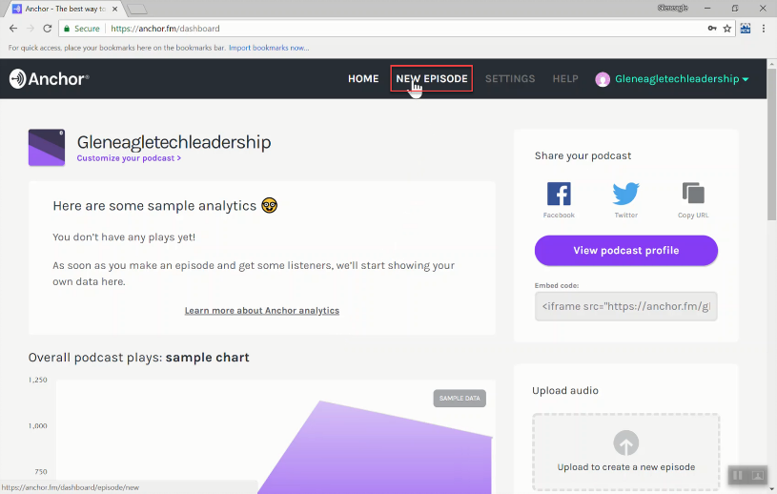

Once signing up or loggging in, you will be taken to the dashboard. To begin your first episode, click "New Episode" in the top menu.

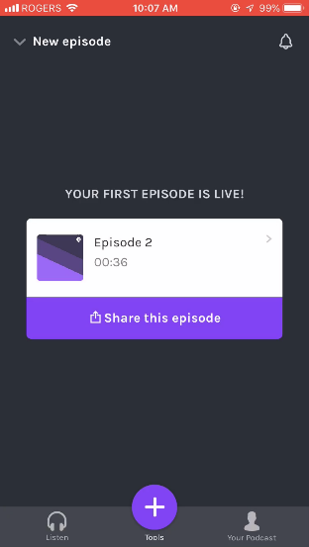

Go to anchor.fm from your mobile device and download the Anchor mobile app and open it. Log in with the same account to get to the landing page. Click on "Tools" at the bottom to get started.

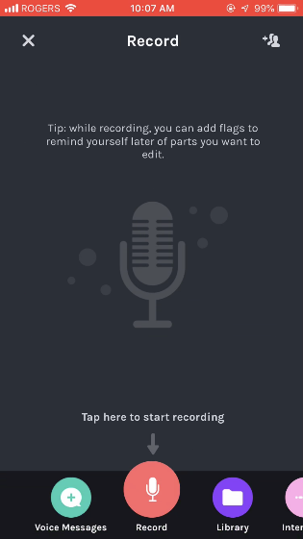
The only option we will use on the phone is Record. Click "Record" to begin recording segments of your podcast.

When recording, make sure you are in a quiet area with minimal background noise.

Face the microphone (normally on the bottom of the phone) towards your mouth(s). Don't put the microphone too close to your mouth as the audio quality can get worse.

Speak slowly at a consistent volume.

If you make a mistake when speaking, you can stop and repeat the last sentence and trim the audio later.

You don't need to say your entire podcast at once, it is better to record in segments and the put them together later. When you are finished recording a segment, press "Stop".
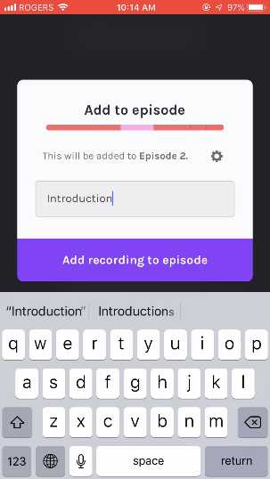

After recording a segment, make sure to name it. After naming it, click on the small gear icon to find a save location.

Save your segments to your library. When you have finished recording all your segments and put them in your library, go back to the website version of Anchor on a computer.

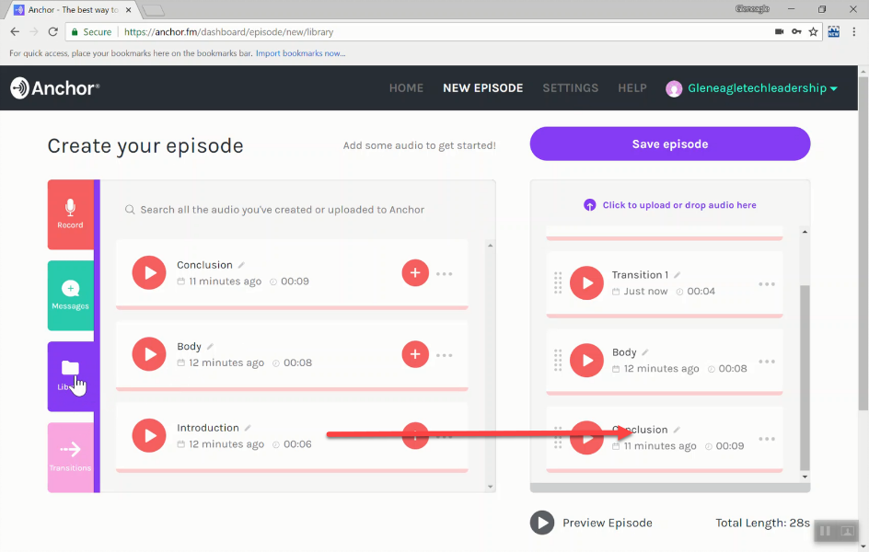
Click on library and begin dragging your recorded clips into the new episode in the correct order.

There are already some transitions for you to use as well. Take advantage of them!

When you are done, preview your podcast with the preview button in the bottom right.

When you have finished all of the audio for your episode be sure to click the save button.

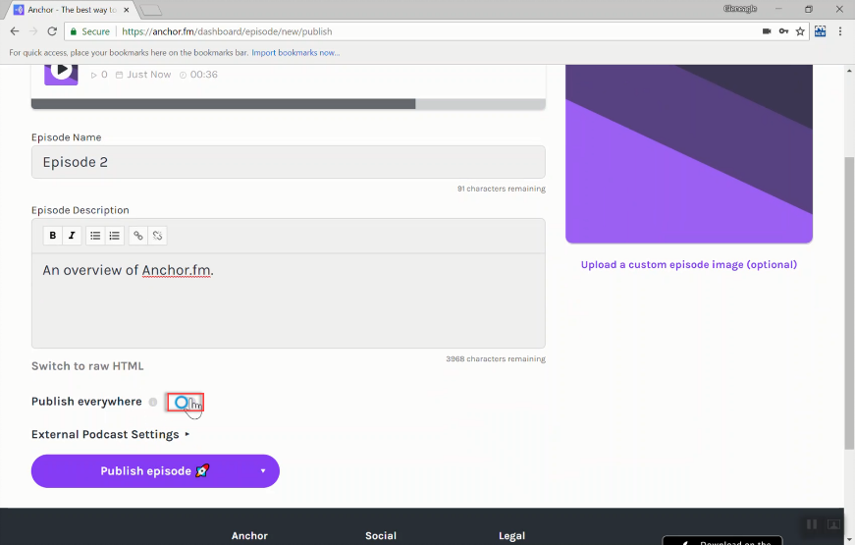
You're almost done! Add a title and description to your episode and then make sure to disable "Publish everywhere." Once you've done that, click publish episode.

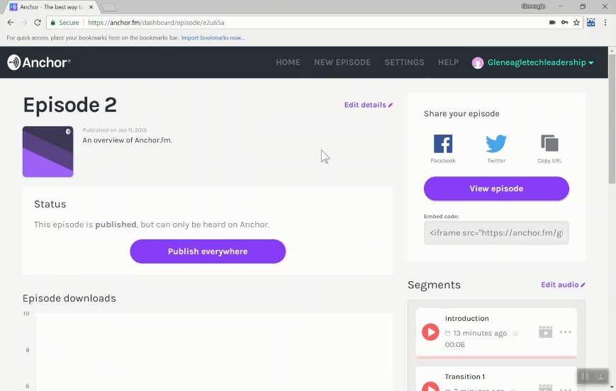

Now you are ready to take your finished podcast and add it to your blog.

You will need to copy the embed code that is provided and then add that into your blog in the same manner that you have added other embed codes.

Thank you to Mr. Gilbar at Gleneagle Secondary for the images/screenshots used in this document.

