Assignment 7 – Excel Graphing

Objective: In this assignment, you will be learning how to create graphs using data you have input on Microsoft Excel. You will create 3 different types of graphs and understand which to use depending on the type of data.

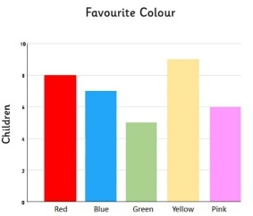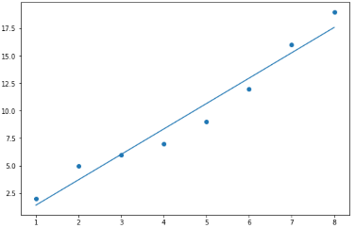

Before You Begin…
- Create a new Edublog Post
  - Log into your Edublog and go to your Dashboard
  - Click Posts Add New
  - Title: Assignment 7 – Excel Graphing

- Open a new Excel blank workbook
  - Make sure to save this file with an appropriate name in your DL10 OneDrive folder
  - For each new type of graph (parts 1-3 of the assignment), create a new Sheet in your spreadsheet (tutorial: https://www.youtube.com/watch?v=dyY2bTcwhoc); make sure to name your 3 sheets appropriately.
  - The online and desktop versions of Excel are a little different. We recommend you use the DESKTOP version for your assignments.

Sheet 1: Pie Graph
A pie graph is used to show percentages of a whole. It compares categories with different number values.

Watch & Read | - How To Create A Pie Chart In Excel by Steven Bradburn https://www.youtube.com/watch?v=0WNJkBXywMU  - Pie Charts by Tableau  https://www.tableau.com/data-insights/reference-library/visual-analytics/charts/pie-charts
Type of Data | For your pie graph, use data from your own daily life, such as:  - Breakdown of minutes spent on different social media platforms in a week  - Ingredients in a baking recipe you tried  - Your spending categories over a month  - Time allotted to different activities in your day
Tips & Tricks | - Each “slice” of the pie should be labelled with percentages  - A descriptive title and legend should be included  - Do not complicate the visual display of the graph; the simpler the better  - Pie graphs work best for showing data with 5 categories or less

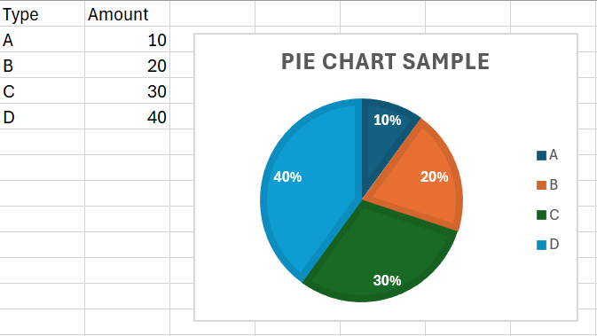
Add a screenshot of your data and graph on your Edublog post. Write a 2-3 sentence description about it underneath.

Sheet 2: Bar Graph
A bar graph is used to compare different groups easily. The x-axis is non-numerical, and the y-axis is numerical.

Watch & Read | - How to Make a Bar Graph in Excel by Excel Tutorials by EasyClick Academy  https://www.youtube.com/watch?v=fk-iFv5_Rdo  - Bar Graph by SplashLearn  https://www.splashlearn.com/math-vocabulary/geometry/bar-graph  - A Complete Guide to Bar Charts by Mike Yi  https://chartio.com/learn/charts/bar-chart-complete-guide/
Type of Data | For your bar graph, survey a group of at LEAST 10 people (e.g. your friends, family, classmates, tech leaders, teachers). Sample survey questions include:  - What is your favourite candy?  - What month is your birthday in?  - What mode of transportation do you take to school?
Tips & Tricks | - For this assignment, create a vertical bar graph, NOT horizontal  - Make sure your axes are appropriately scaled (data fills up the graph and limit blank space)  - EXTENSION FOR BONUS MARK: Create a Microsoft Form to digitize your survey. Include the QR code or link to your survey in this sheet below your graph.

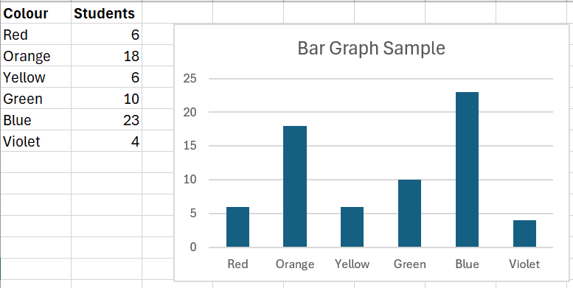
Add a screenshot of your data and graph on your Edublog post. Write a 2-3 sentence description about it underneath.

Sheet 3: Line Graph
A line graph is often used to track changes over time or visualize relationships between two variables. Both the x-axis and y-axis are numerical. Series of data points are plotted, and they are connected or a line of best fit is drawn (also known as “trend line”).

Watch & Read | - Making Scatter Plots/Trendlines in Excel by BurkeyAcademy  https://www.youtube.com/watch?v=kLROcLFzH8o  - How to Make a Scatter Plot in Excel  https://www.youtube.com/watch?v=MfEAEmdFOBo&t=21s  - Scatter Plot vs. Line Graph by ChartExpo  https://chartexpo.com/blog/scatter-plot-vs-line-graph#
Type of Data | For your line graph, you will get your data from one of the following websites:  - Compound growth calculator: https://mdm.ca/learn/compound-growth-calculator?fixed=fixed  - Growing Plants: https://gizmos.explorelearning.com/find-gizmos/launch-gizmo?resourceId=615  - Bacteria growth calculator: https://www.omnicalculator.com/biology/bacteria-growth  You can use other websites that you have found, collect your own data, or use old data from a previous course. Just make sure that both your variables are numerical.
Tips & Tricks | - For our course, a scatter plot and line graph mean the same thing, because you will be adding a trendline to your scatter plot.  - Label all your axes well with appropriate scales

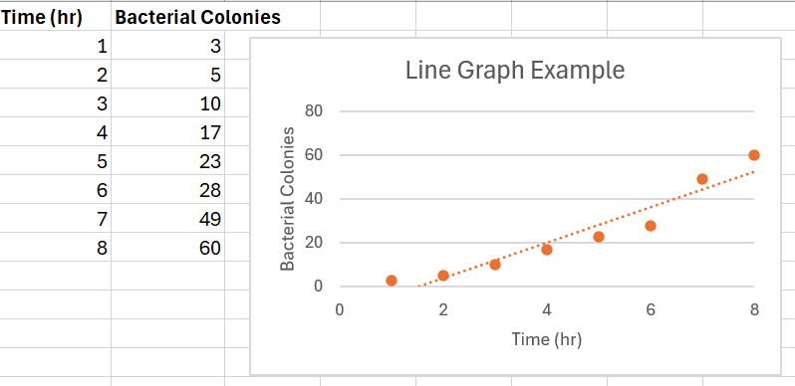
Add a screenshot of your data and graph on your Edublog post. Write a 2-3 sentence description about it underneath.

Add your final Excel spreadsheet document at the end of your Edublog post. You can do this by clicking “Add Document” and uploading your file.

Instructions for Submitting this Assignment

- Make sure ALL SECTIONS and details are checked, edited, and thoroughly completed.
- Upload your Excel file on a new Edublog post under “DL 10” category. View the post and double check that your spreadsheet has been attached properly.
- Copy the direct link of your post to submit to TEAMS (NOT just your homepage link- it MUST be the DIRECT link to your Assignment 7 post) If your link contains the words “admin” or “preview”, teachers will not have access to it!

