Assignment 8 – Final Edublog Presentation

Objective: For this assignment, you will be showing off all the digital skills you have learned on the Edublog platform, such as customizing, creating posts, and embedding. Go through the checklist below carefully and make sure that you have everything included on your blog page for full marks.

Assignment Checklist
- Blog Basics
- I know my personalized Edublog link (Format is generally https://kodiaks.sd43.bc.ca/firstnamelastinitial)
- My blog is customized to represent me. This could be any individual changes including:
  - Changed theme
  - Changed blog name
  - Changed background image
- My blog does not have violate FOIPPA
  - Never use full legal names
  - Never post pictures/videos of your face
  - Never publish photos of other people in your life without written consent
  - If you must, make posts password protected and not public (Edublog’s default setting on posts is public!)

- Assignments
- All my DL10 assignments have been posted and embedded properly under the DL10 category:
  - Assignment 2 – Digital Referencing and Citations
  - Assignment 3 – TOKW Reflection
  - Assignment 4 – Digital Citizenship Video
  - Assignment 5 – Sway Multimedia Project
  - Assignment 6 – Core Competency Portfolio
  - Assignment 7 – Excel Graphing

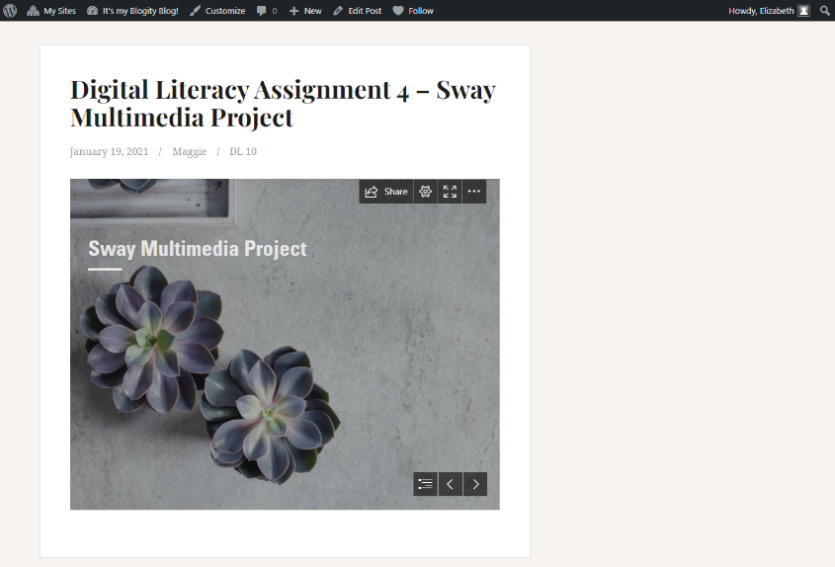
What does a GOOD post look like?
  - Title includes assignment number and name
  - Assignment is public and accessible by others (if you opt to make your post password protected, this password must be shared with your DL10 teacher)
  - Embedded preview of assignment can be seen within the post (see image to the left)
  - Easily accessible (posted under DL10 category)

Instructions for Submitting this Assignment

- Make sure ALL SECTIONS and details are checked, edited, and thoroughly completed.
- Copy the direct link of your main Edublog page to submit to TEAMS “Assignment 8 – Final Edublog Presentation”. If your link contains the words “admin” or “preview”, teachers will not have access to it! Should be https://kodiaks.sd43.bc.ca/___________________.

