Do wood bugs prefer hot or cold climate?
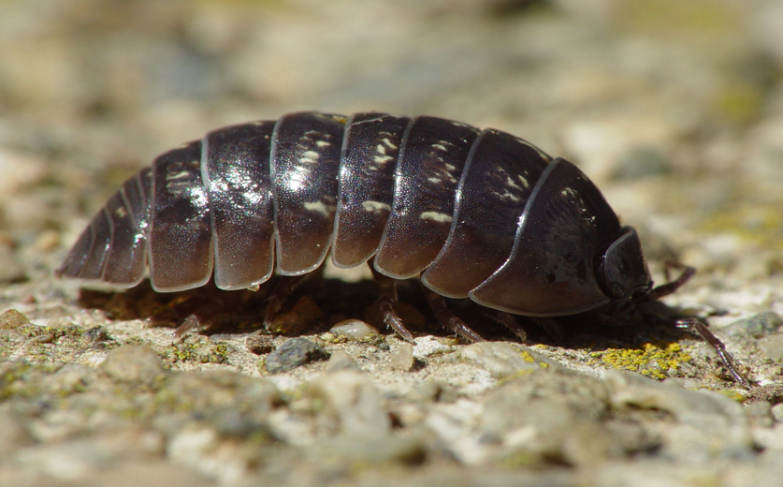

The wood bug is the only crustacean that 100% adapted to spending its life on land. Wood bugs are also referred to pill bugs, rolly pollies, woodlice. They are widely known as this because wood bugs can curl up into a ball protecting themselves in their outer shell in a pill like shape. Wood bugs live in cool damp areas underneath logs and other decaying objects. You can find these wood bugs all around the world however, they are most commonly found in largely forested countries.
Scientists: Ethan, Hitansh, Georgia, Natalie (Block 2)

Welcome to the Professional Wood Bug Science Experiment

Hypothesis: If wood bugs had the option to stay in a warmer or colder environment, they would prefer to stay in the colder climate due to its cool and damp area provided.
Material List:
          - Water 4 cups
          - Ice 200 grams
          - Kettle (boiled water)
          - Thermometer
          - Lego 20 pieces
          - Cling Wrap
          - Dirt 300 grams
Wood Bug Observations:
Wood bugs are crustaceans in the crustacea class making them closely related to shrimp. Since they are crustaceans, they have gills. These gills have adapted overtime to allow them to breathe on land. However, they still require damp environments to survive because their gills still need a small amount of moisture to breath. Since they still need a damp environment to survive, they prefer to live beneath logs, damp basements, leaves, boards, stones, pots and bricks. Wood bugs are a part of the food chain, they eat decomposing or dead plants, soft decaying plants like grass and occasionally decomposing copper, zinc or lead in soil. Wood bugs are hunted by frogs, newts, lizards, spiders, centipedes, millipedes and birds. Since the wood bug habitats relatively cool areas, they cannot stand extreme temperatures above 37 degrees Celsius for an extended period of time. This is because under these conditions, the wood bug tends to move at a very fast rate and when brought back to cooler temperatures below 0 degrees Celsius, they will bring their speed to a halt moving very slowly.
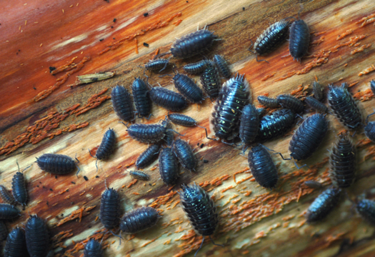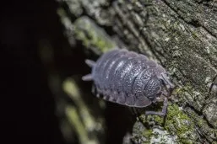
Fun Facts:
- Pill bugs don’t urinate, they have an amazing ability to tolerate ammonia gas, which they then pass though their exoskeleton.
- When pill bugs are sick, they turn bright blue or purple.
- They came from Europe most likely from the lumbar trade.
- If it’s very humid above 87 percent, they can absorb the water and stay hydrated for longer.
Procedure:
- Create a rectangular box out of Lego.
- Place plastic rap on the bottom of the container so the water does not leak out.
- Add five tablespoons of dirt to each side of the container
- Pour one tablespoon of water heated to 25-degrees Celsius into one side of the container and add one ice cube in to the other. Also, add one tablespoon of 8-degree Celsius water into the side with the ice.
- Cover the middle of the container with a 5 cm layer of slightly damp, room temperature soil.
- Wait 3 minutes for each box and its soil to get to its appropriate temperature.
- After 3 minutes, start placing wood bugs one at a time on to the middle of the box and record which side they go towards.
- After all wood bugs are in, observe and record results for 10 minutes
- During the 10 minutes, make sure to maintain the temperature of the two dirt sources.

Procedure Picture:
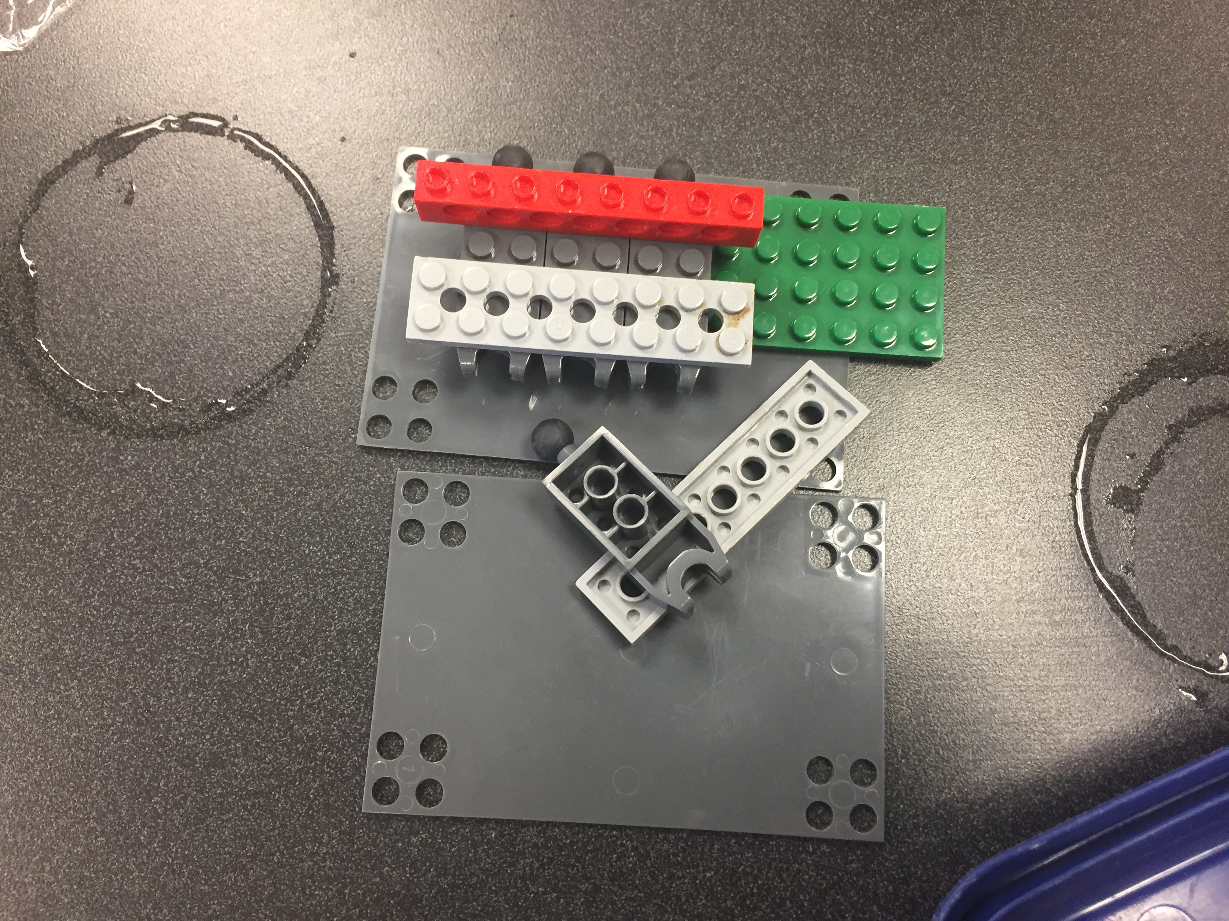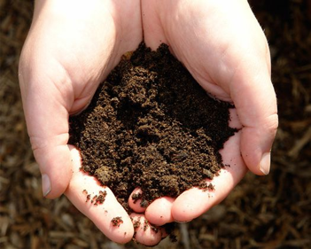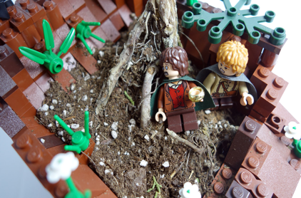
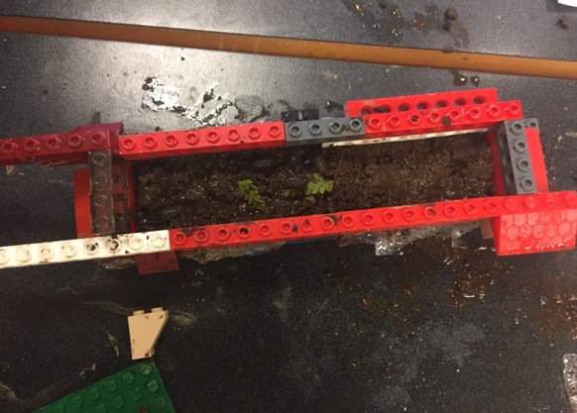

Data Collection & Wood Bug Graph:
Temperature of Climate | Number of Wood bugs
Warmer (50 Degrees Celsius) | 1
Cooler (20 Degrees Celsius) | 2
Neutral (35 Degrees Celsius) | 3
Escapees | 2
Wood Bugs Moving Fast | 1
Wood Bugs Moving Slow | 5
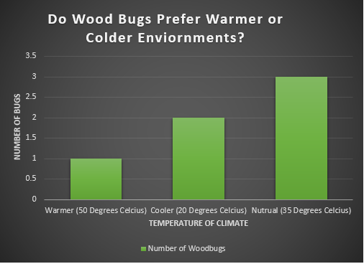

Qualitative Observations:
During the experiment, we decided to start by adding the wood bugs into our professional Lego structure specialized to hold the cold water to the left side and the warm water to the right. Once that was done, we watched the small critters make our experiment come to life. While placing the bugs in one at a time, they all seemed to curl up in our hand when we picked them up and always landed on their backs when dropped into the testing box. At first, bug #1 went towards the warm dirt as the five other bugs moved very slowly in the cooler dirt. This was because of their reaction to the different temperatures to allow their body to fit the type of environment. After about 1 minute and 32 seconds in, we noticed the largest wood bug of them all start to move towards the left side where the cold laid. Next at the time 3 minutes and 20 seconds, the 2 bugs were to the left. We noticed that the wood bugs all moved relatively at the same speed however, the ones trying to escape were moving the fastest. Throughout this experiment, the wood bugs continued to roll up in curled balls, others flipped each other on their backs, and a couple somewhat dug themselves into the dirt. After about 9 minutes, the experiment was almost over until we noticed that all the wood bugs had tried or did escape at least once. We figured they did not like the unnatural small Lego structure we had built for them. After all, it clearly was very stressful for all the critters.

Conclusion:
We were curious if wood bugs liked warmer or colder environments and decided to conduct our experiment on this. Our hypothesis was that if wood bugs had the option to stay in a warmer or colder environment, they would choose to go to the colder environment. Once we conducted the` experiment we found that our hypothesis was incorrect and that most of the wood bugs stayed in the middle where the temperature was 35º. This was most likely because it is the closest to their natural habitat’s temperature. The wood bugs were moving towards the warmer soil at the start then afterwards they started to move towards the colder soil, this is when a few of the wood bugs started to move and get settled in the climate they found more comfortable. Some of the wood bugs also moved towards the middle to make their body temperature stable. After a few minutes near the end of our experiment we started to have some troubles and notice most of the wood bugs had or were trying to escape. All this evidence shows that our hypothesis was incorrect because most of the wood bugs preferred moderate temperature, the second preference was the cooler environment. What we are interested in further investigating is how the wood bug lives its life cycle and how strong their shells can be. It would be interesting to find out how such creatures protect themselves and live in some harsh environments especially during the cold winter season.

Our experiment was quite successful but, had we had few errors which could be fixed and might have affected our results. One of our errors was making the box out of Lego because the soil and water would leak out and the wood bugs were able to crawl out. If we could change what the box was made from, we would use plastic or use Lego without holes and use 2 layers of Lego for the walls. Another error we had was the way we heated up the soil, we put a beaker with hot water on top of the soil which took a while to warm up the soil and it didn’t get it warm as we would’ve liked. Other ways to warm it up is to use a light that gives off high amounts of heat or warm up the soil in a glass on top of a Bunsen Burner which would create a very high temperature. The third big error we had was making the box to small and that just didn’t give enough space for the wood bugs to move around. This could be easily solved by using more Lego to extend the wall. Errors aren’t the only thing that can affect the results and the conditions we conducted our experiment was a factor in our results. The temperature in the room is warmer than then the temperature that wood bugs are accustomed to in their natural habitat and if they adjust to the room’s temperature the wood bugs might find the cold temperature (20ºC) even colder than if they were out in their natural habitat. We had a successful environment although there were errors that we would change next for next time and external factors like the conditions we conducted the experiment in, all these factors may have affected our results.

Experiments are never perfect and can always be improved with this experiment being no different. This experiment can be taken further by adding more extreme temperatures to each side, adding more wood bugs or creating a whole environment for the sides with sticks and leaves to intimidate their natural habitat. You could also conduct a similar experiment with habitats or food. Habitats and food are great to do because they are easy, fun to do and still provide helpful insight. We would make sure to fix our errors with the necessary fixes necessary to be made. The experiment we conducted with different soil temperatures was one of many that could be completed meaning the experiment ideas are endless and we only conducted one of many ideas that could be completed.

