The Nova Scotia Weekly
By: Georgia Hinrichs

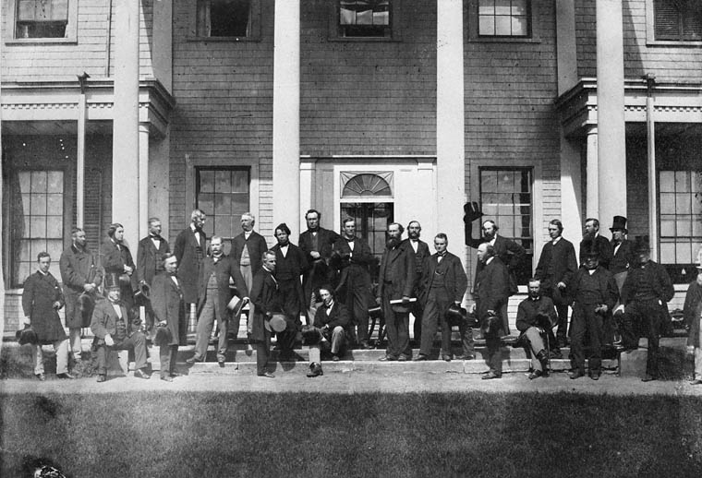

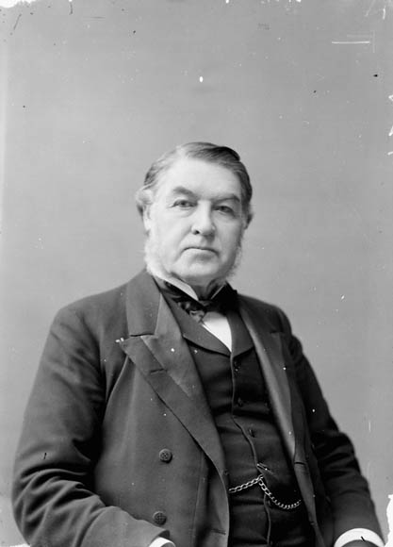

The Nova Scotia Weekly
Tuesday July 2, 1867

The province is divided but the efforts of our prime minister Sir Charles Tupper have paid off. Yesterday Nova Scotia became part of the Dominion of Canada along with the three other provinces, New Brunswick, Quebec, and Ontario. Our province is divided, people in the northern areas of the mainland in Cape Breton are for the new system. Along the south shore and in the Anna Polish Valley people do not like the new ways and ideas. Our economy is made up of fishing, shipping, shipbuilding, agriculture, and natural resources such as timber. People don’t want those to change, and that is one of the main reasons people along the south shore are agents joining the nation. Sir Charles Tupper was motivated to become part of the Dominion of Canada, so that we could have access to a railway that will go across Canada. The process of joining the Dominion of Canada has been a long and tiring, our leader has been working since 1864 when the colonial politicians met and started negotiated terms. Even though not everyone is happy, this is a huge step for us as a nation and we will forever be grateful to Sir Charles Tupper, and everyone else who made this possible.

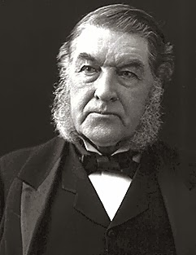

Sir Charles Tupper

Weather

Today the we have a high of 19 and a low of 11 with strong winds coming at 5pm. The weather coming up this week in Cape Breton looks like it’s going to be warm. On Wednesday we have a high of 23 and a low of 15, Thursday high of 20 and a low of 13, Friday theirs a high of 25 with a low of 17, Saturday is a high of 24 and a low of 17, and on Sunday it’s it looks like there is a chance 70% of rain with a high of 15 and a low of 7.

Work Cited
Archives Canada. “Nova Scotia (1867).” Library and Archives Canada, Government of Canada, 5 May 2016, www.bac-lac.gc.ca/eng/discover/politics-government/canadian-confederation/Pages/nova-scotia-1867.aspx.
Farr, D.M.L. “Sir Charles Tupper.” The Canadian Encyclopedia, The Canadian Encyclopedia, 21 Feb. 2008, www.thecanadianencyclopedia.ca/en/article/sir-charles-tupper.
“Nova Scotia - History and Culture.” Adventure Tourism - Experiential Travel Guides, IExplore, www.iexplore.com/articles/travel-guides/north-america/canada/nova-scotia/history-and-culture.
Waite, P.B. “Confederation.” The Canadian Encyclopedia, The Canadian Encyclopedia, 22 Sept. 2013, www.thecanadianencyclopedia.ca/en/article/confederation.

