COMMUNICATION: Collaborating - What strategies do you use when collaborating with others?
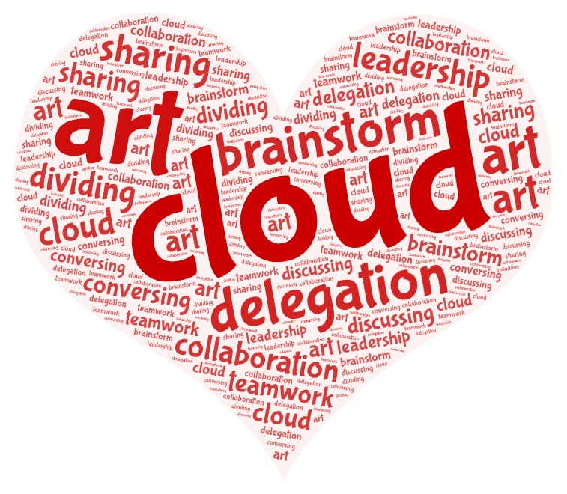

THINKING: Creative Thinking - What helps you to get new ideas or try something new?

PERSONAL AND SOCIAL: Personal Awareness and Responsibility - What do you do to help yourself when you are feeling a bit discouraged about your work?
